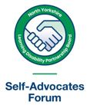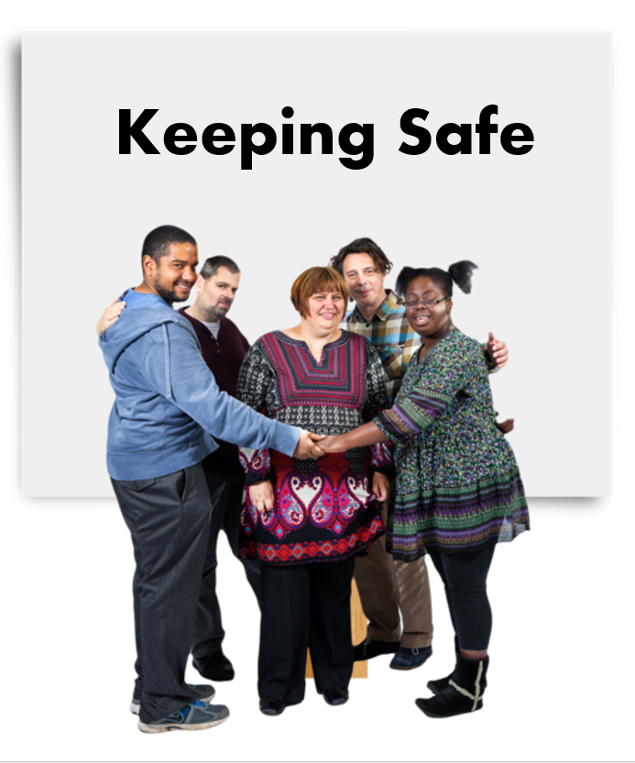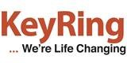
Keeping safe

Can you tell which of these questions is true or false? Read the questions carefully and then think if the question is true or false.

 | Question | True or false?
1 | Abuse is when someone treats you badly or hurts you on purpose
2 | Everyone has the right to be safe
3 | Only someone you don’t know can abuse you
4 | Everyone on Facebook is the person they say they are
5 | People sometimes lie about who they are on the internet so they can take money from you
6 | You can report abuse if you or someone you know has been abused

 | Question | True or false?
7 | If you are not sure about buying something on the internet you should speak to someone you trust
8 | It’s okay to give your bank details or PIN number to someone if they phone you and ask for this
9 | Hate crime is when someone says or does something bad to you because of your disability
10 | You can phone 101 if you need to speak to the police but it is not an emergency
11 | If you are a victim of hate crime, you do not have to report it or tell anyone
12 | You should not give your personal details, for example, your name and address to people you don’t know
13 | It is not possible to block people you don’t want to talk to on Facebook
14 | A scam is when someone tricks you into buying something or taking money from you
15 | You should let anyone in to your home if they knock on your door
 | Question | True or false?
16 | H You should have a smoke alarm in your home and check it regularly
17 | If someone tells you they are being bullied, you should ignore them
18 | Safeguarding is about working together to make sure everyone is safe
19 | You should always ask someone for their I.D. before you let them in to your home
20 | Mate crime is when someone pretends to be your friend so they can take things from you

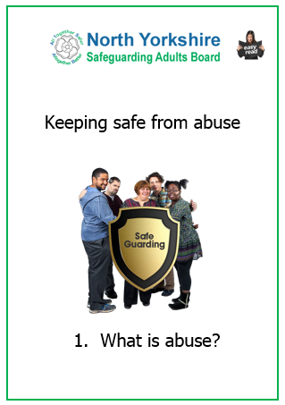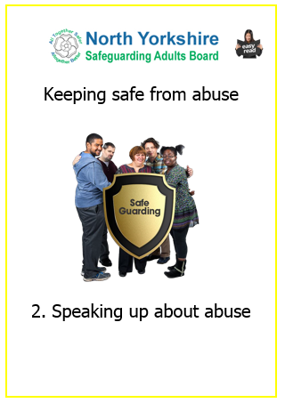 | If you would like more information on Keeping Safe, you can read these guides by the North Yorkshire Safeguarding Adults Board.  The are in Easy Read and were written with self-advocates from the North Yorkshire Learning Disability Partnership Board.  Visit https://safeguardingadults.co.uk/keeping-safe/easy-read-guides/ for your free copy.

