Keeping Safe

May 2020
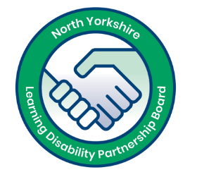 | This pack is from the North Yorkshire Learning Disability Partnership Board.
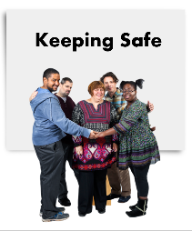 | It has some useful information and some fun activities all about Keeping Safe.
 | We think everybody has a right to a good life and be safe from abuse. This pack will help you to understand what abuse is and how to stay safe.
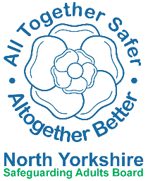 | It includes three books. They were written by the Safeguarding Adults Board with help from self-advocates with a learning disability.
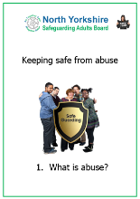  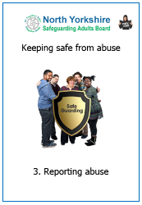  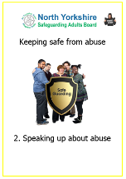 | - Book 1 is about different types of abuse that can happen.  - Book 2 is about telling someone about abuse that is happening  - Book 3 is about making a report to the North Yorkshire Safeguarding Adults Board
 | You can read them on your own or with someone to support you.
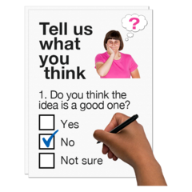 | After you have read the books there are some easy questions to help you think about being safe. Talk about your ideas with other people and write them down.
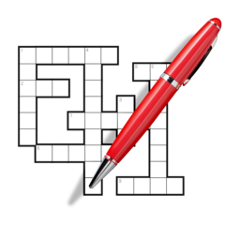 | There are also some puzzles to remind you of some of the words in the books.
 | If you need more copies of the books or the puzzles you can visit this website: safeguardingadults.co.uk/keeping-safe/easy-read-guides/
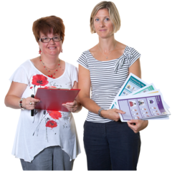 | We hope that you find this Keeping Safe pack interesting. Take care and stay safe!
