 | North Yorkshire
Monday 22  Themes: Tell us your concerns & Domestic Abuse | Are you concerned an adult is at risk of abuse or neglect? Contact @northyorkscc on 01609 780 780 and #TellUsYourConcerns If you think an adult is in immediate danger, call the police on 999. Further information can be found here: www.northyorks.gov.uk/safeguarding | Are you a volunteer and have seen something that concerns you? See our One Minute Guide & #TellUsYourConcerns on 01609 780 780  https://safeguardingadults.co.uk/wp-content/uploads/2020/05/Volunteer-for-Covid-19-safeguarding-volunteers-OMG-v1-20200512-001.pdf  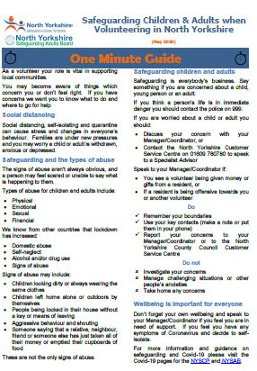  If you are experiencing domestic abuse see the @anncrafttrust Domestic Abuse guide for advice and #TellUsYourConcerns on 01609 780780  https://safeguardingadults.co.uk/wp-content/uploads/2020/06/The-Portal-Easy-Read-Domestic-Abuse.pdf  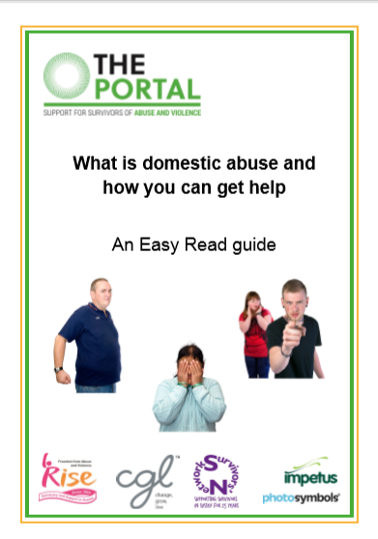  If you are working with someone who is experiencing domestic abuse see our one minute guide for Stalking Protection Orders and #TellUsYourConcerns on 01609 780780  https://safeguardingadults.co.uk/wp-content/uploads/2020/06/Stalking-Protection-Orders-2020-06-16.pdf  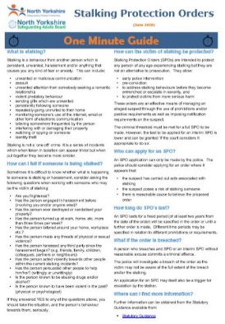  IDAS Communications:  If you are experiencing domestic abuse and need support @IDASfor100 is a local service that can provide this much needed support. For more information, visit idas.org.uk #safeguarding and #TellUsYourConcerns on 01609 780780  When families flee to the safety of a refuge, children often leave everything behind. IDAS children’s workers are supporting young people creatively at this time to ensure that they settle into refuge. Contact IDAS on info@idas.org.uk (link to video - https://vimeo.com/105479719)  Are you a professional working with Domestic Abuse, talk to the IDAS Live Chat for Professionals Monday to Friday 10-12. If your concerned about an adult #TellUsYourConcerns on 01609 780780  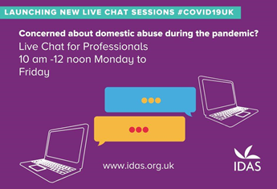
Tuesday 23 Themes:  Tell us your concerns &  Keeping Safe Online: Be aware of  Scamming and online abuse | Are you concerned an adult is at risk of abuse or neglect? Contact @northyorkscc on 01609 780 780 and #TellUsYourConcerns If you think an adult is in immediate danger, call the police on 999. Further information can be found here: www.northyorks.gov.uk/safeguarding | If you are a professional using social media, please see our One Minute Guide for advice on use of social media https://safeguardingadults.co.uk/wp-content/uploads/2020/06/Social-Media-OMG-2020-06-16.pdf #TellUsYourConcerns  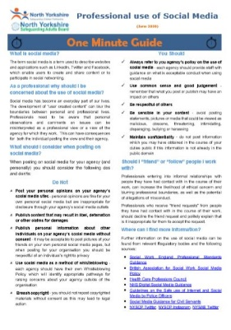  Online Fraud / Scamming  https://www.friendsagainstscams.org.uk/article/505/beware_of_covid_19_scams  Be aware of people offering or selling items to test for/cure coronavirus. These are not currently available to purchase #ScamAware #Coronavirus @nyccts #TellUsYourConcerns on 01609 780780  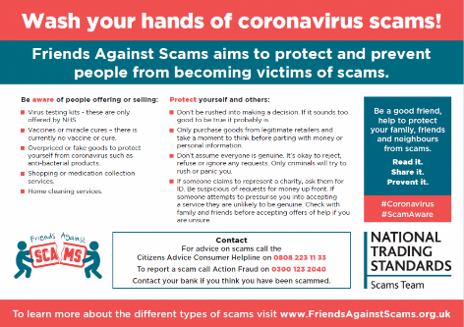  Age UK computer training courses explain things clearly in plain English to help you get online for more information visit https://www.ageuk.org.uk/services/in-your-area/it-training/ #TellUsYourConcerns on 01609 780780
Wednesday 24  Themes:  Tell us your concerns & Radicalisation | Are you concerned an adult is at risk of abuse or neglect? Contact @northyorkscc on 01609 780 780 and #TellUsYourConcerns If you think an adult is in immediate danger, call the police on 999. Further information can be found here: www.northyorks.gov.uk/safeguarding | Links to guides:  Are you a volunteer and have seen something that concerns you? See our One Minute Guide & #TellUsYourConcerns on 01609 780 780  https://safeguardingadults.co.uk/wp-content/uploads/2020/05/Volunteer-for-Covid-19-safeguarding-volunteers-OMG-v1-20200512-001.pdf  If you are a professional and need more information, please see our One Minute Guide for on Prevent – Extremism and Radicalisation https://safeguardingadults.co.uk/wp-content/uploads/2020/06/Prevent-Extremism-and-Radicalisation-OMG-2020-05-12.pdf  #TellUsYourConcerns on 01609 780780
Thursday 25  Themes:  Tell us your concerns & County Lines/ Cuckooing | Are you concerned an adult is at risk of abuse or neglect? Contact @northyorkscc on 01609 780 780 and #TellUsYourConcerns If you think an adult is in immediate danger, call the police on 999. Further information can be found here: www.northyorks.gov.uk/safeguarding | Links to guides/resources:  For information on County Lines and Cuckooing please see our One Minute Guide https://safeguardingadults.co.uk/wp-content/uploads/2020/06/County-Lines-and-Cuckooing-OMG-2020-06-15.pdf If you are concerned about an adult #TellUsYourConcerns on 01609 780780
Friday 26  Themes:  Tell us your concerns & Mental Health & Wellbeing | Are you concerned an adult is at risk of abuse or neglect? Contact @northyorkscc on 01609 780780 and #TellUsYourConcerns If you think an adult is in immediate danger, call the police on 999. Further information can be found here: www.northyorks.gov.uk/safeguarding | Links to guides/resources:  Every Mind Matters – Covid / Mental Health  Looking after your mental health & wellbeing is really important. #EveryMindMatters have created 12 simple, practical top tips for improving your mental wellbeing whilst staying at home. You can view them online & share with friends https://nhs.uk/oneyou/every-mind-matters/coronavirus-covid-19-staying-at-home-tips/  TEWV – Mindfulness for mental health  #TEWV are offering free online mindfulness taster sessions & course for those who may be feeling overwhelmed or stressed. For more information and to express an interest email tewv.mindfulness@nhs.net or visit https://www.tewv.nhs.uk/services/mindfulness/  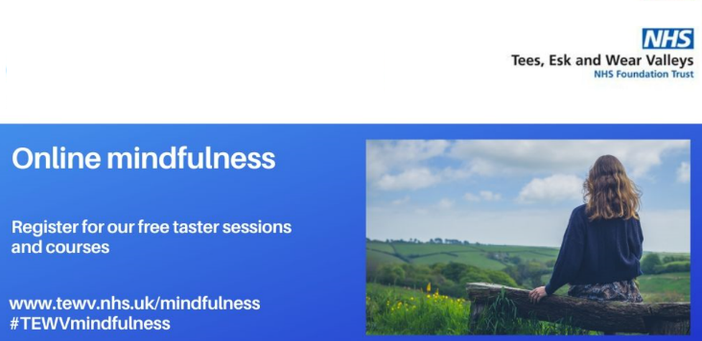  North Yorkshire Sport – Wellbeing / Staying Active Health  #NorthYorkshireSport have useful tips on how to get active when you're at home. Staying physically active can have a really positive effect on your mental health & wellbeing. Visit  https://www.northyorkshiresport.co.uk/stay-active-at-home for more details  