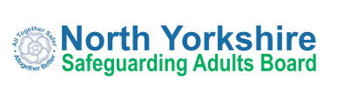

Annual Report 2019/20
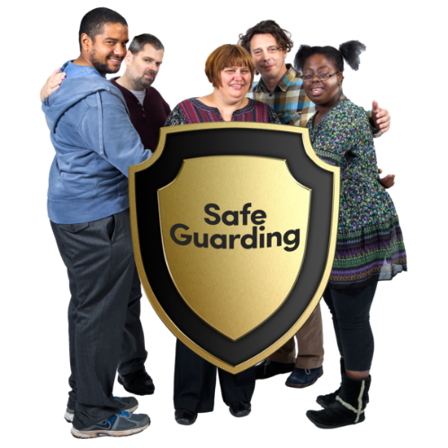

Easy Read Summary
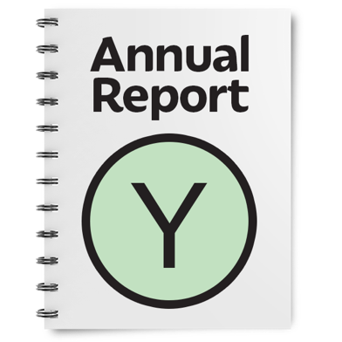 | This is the easy read summary of the annual report of the North Yorkshire Safeguarding Adults Board (NYSAB)
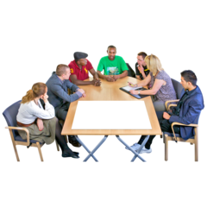 | This annual report tells you about the work that the NYSAB has done between 1st April 2019 – 31st March 2020
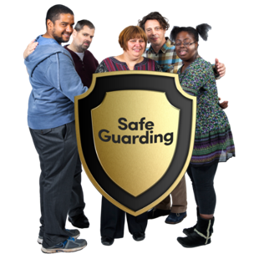 | The NYSAB works with other organisations in North Yorkshire to make sure that adults with care and support needs are kept safe
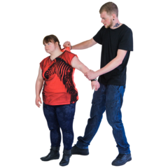 | Abuse is when someone does or says things that frighten you or cause you harm  Neglect is when your care and support needs are not being met
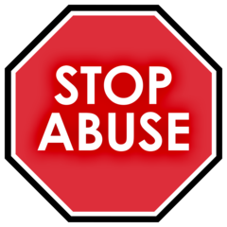 | Safeguarding means protecting people from abuse and neglect
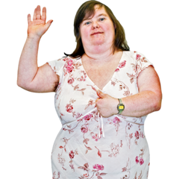 | People should be as independent as possible and make choices about how they want to live and still be safeguarded
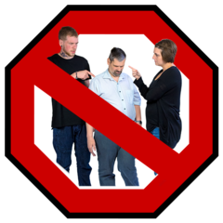 | Abuse and neglect are wrong
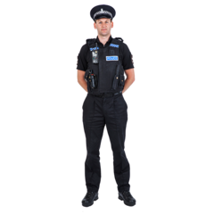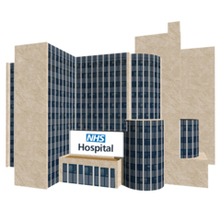  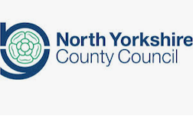  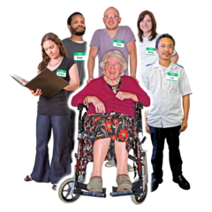 | The NYSAB is made up of lots of different organisations including the Police  Hospitals  North Yorkshire County Council  Health and care providers
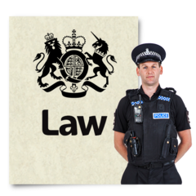 | The Board also has legal responsibilities – things they must do
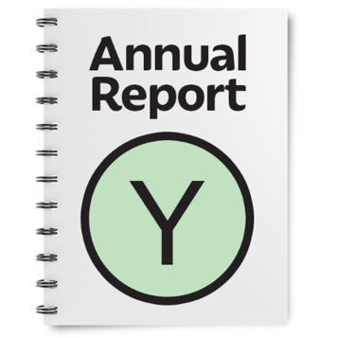 | One of these things is to write a report every year about what it has done. This is called an Annual Report.
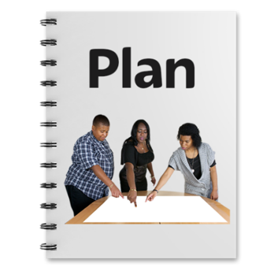 | The Board must also have a plan for what it will do for the next year to keep people safe.
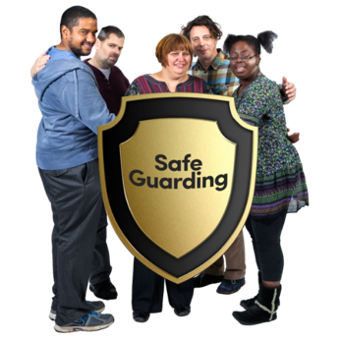 | All organisations have a duty to work together to keep people safe from abuse
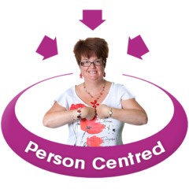 | We also want to make sure that adults who are abused or neglected are asked how they want to be kept safe in the future.  This is called ‘Making Safeguarding Personal’.  We want all of our partners to work this way

What the Board has done in 2019 / 20
Development Day
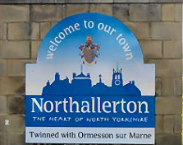 | In November 2019 we held our development day at the Evolution Centre in Northallerton
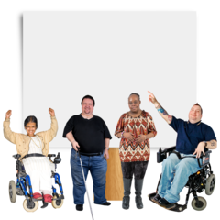 | At the development day members of the NYSAB spoke about support for people with learning disabilities.
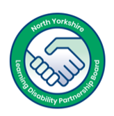 | Two self-advocates from the Learning Disability Partnership Board (LDPB), Sam Suttar and Christopher Porter also attended the development session  Sam and Christopher told the NYSAB all about the work that the LDPB had done.  They also provided information from their own experience and told the NYSAB it is important that they listen to the voice of people with learning disabilities.  It is also important that people with learning disabilities are involved with the work of the NYSAB
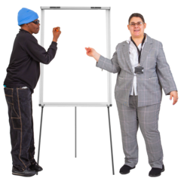 | Sam and Christopher said that the LDPB have asked that the NYSAB focuses on two important areas:  1) Sharing the new easy read guides to keeping safe and to work with the LDPB to develop alternative information formats, such as videos.  2) To develop training, both for professionals and the public which is co-delivered by people with learning disabilities and autism.
What are we doing about the things people told us?

We have co-produced keeping safe guides with the self-advocates and they are now available on the NYSAB website, http://safeguardingadults.co.uk/keeping-safe/easy-read-guides/

We will work with the self-advocates to co-produce more accessible keeping safe information

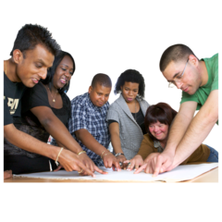 | The NYSAB are going to look at developing training for members of the public  They will also look at how self-advocates can help to co-produce this
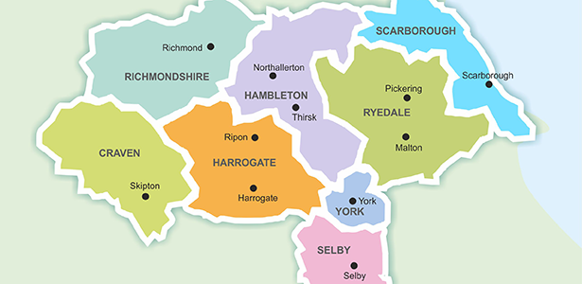  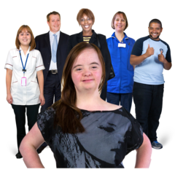 | In 2020 and 2021 the Board will carry out an engagement project across North Yorkshire  They will engage with lots of people such as:  - Adults with care and support needs;  - Families, friends and carers  - Advocates;  - People who work in care and support;  - Care home staff and residents;  - Local communities and;  - People who are hardest to reach
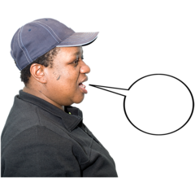  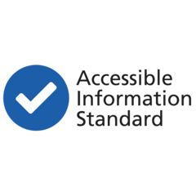 | The NYSAB wants to find out what people want to hear from us and how they want to hear from us  But we also want to find out what people want to tell us and how they want to tell us  We hope by engaging with lots of people we can do a number of things:  - Update the information we share with people so they know how to keep themselves and others safe  - Continue to look at ways we can work together to co-produce accessible information for all  - Strengthen our engagement across North Yorkshire  - Make sure our engagement is meaningful  - Listen to what people want and act on it

Safeguarding Week 2019
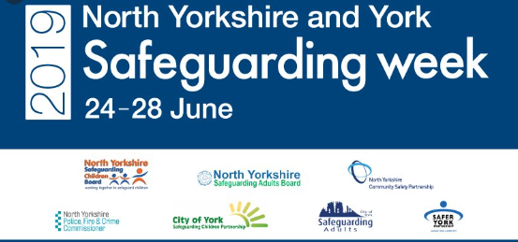 | Safeguarding Week took place in June 2019
 | Safeguarding week raises awareness to help people keep themselves and other people safe from abuse and neglect
 | Lots of events went on across North Yorkshire
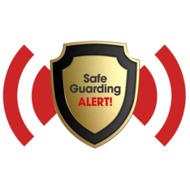 | People from the local authority, health, police and many others gave advice on what you should do if you or someone you know has been abused or neglected
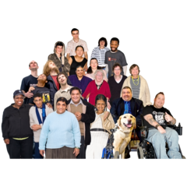 | Lots of people attended the different events and said that they were very useful and there was a lot of helpful information
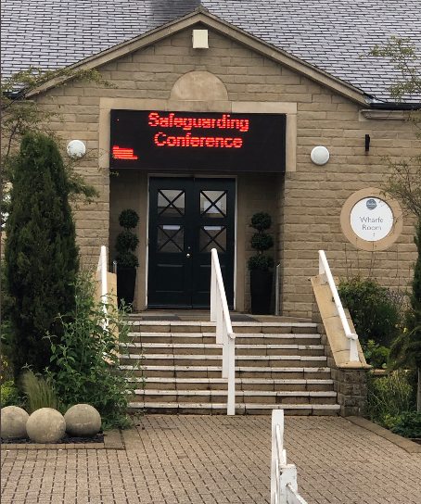 | A safeguarding conference took place at the Pavilions in Harrogate  Lots of people attended the conference including people who work in social care and people with care and support needs and their families & carers
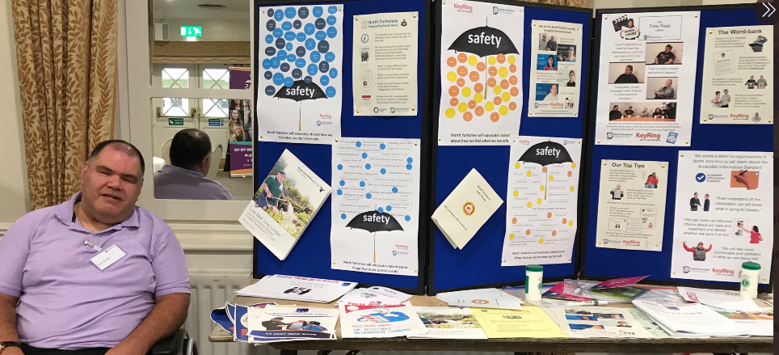 | Self-advocates Sam Suttar and Natasha Nathan had a stall with Karen Murray to tell people all about self-advocacy and the work they had done
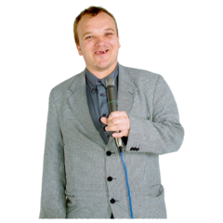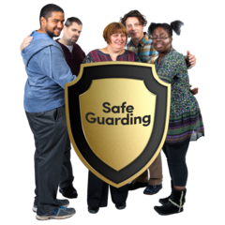 | During the day people gave talks about different things to raise awareness and what to do to keep safe
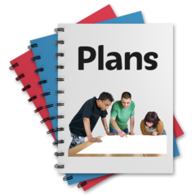 | The self-advocates told us they thought the day was really good and they thought it would be a good idea if they were involved in planning the next safeguarding week

What else did the North Yorkshire Safeguarding Adults Board do last year?
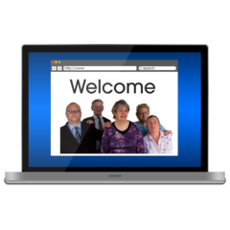 | We have created a webpage full of information and advice on how to keep safe during the coronavirus  https://safeguardingadults.co.uk/keeping-safe/information-and-guidance-relating-to-covid-19-corona-virus/
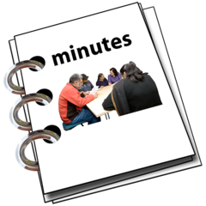 | We have started to produce our NYSAB meeting minutes in easy read format  This way more people can access what the NYSAB are working on  People told us they like the minutes in easy read format  We hope this encourages other organisations to put make their minutes and information accessible too
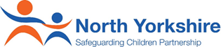 | We have worked really closely with the North Yorkshire Safeguarding Children’s Board and Community Safety Partnership
 | Working together means we can share ideas and information with each other to help keep people safer in their areas
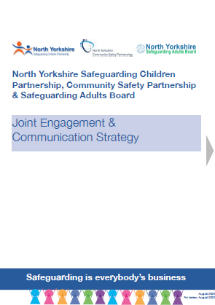 | We are working together to create a Joint Engagement and Communication strategy  This strategy will tell people why we are working together  It will also tell you how we will work together on engagement and communication and what we need to do to make it happen  It also tells you who will be involved in carrying out engagement and communication across North Yorkshire

In 2020 / 21 we will:
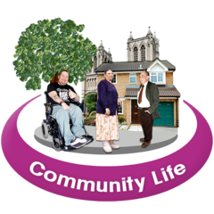 | Continue to work closely with communities in North Yorkshire to keep people safe
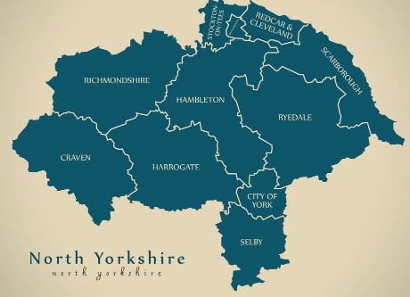 | Carry out an engagement project across the whole of North Yorkshire to find out what people want to know from the NYSAB and what they want to tell us
 | Find new and accessible ways to share information with people to keep themselves and others safe from abuse and neglect.
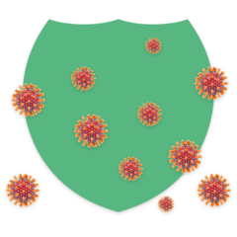 | We will be doing a lot of work to keep people safe and support organisations following the coronavirus

How to contact us about this report
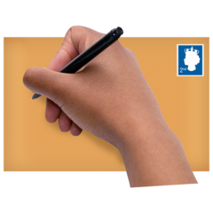 | North Yorkshire County Council, County Hall, Northallerton DL7 8DD  Email: nysab@northyorks.gov.uk  www.safeguardingadults.co.uk
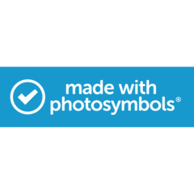 | This easy read summary was made using Photosymbols

Copyright © 2020 North Yorkshire Safeguarding Adults Board

