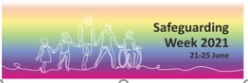
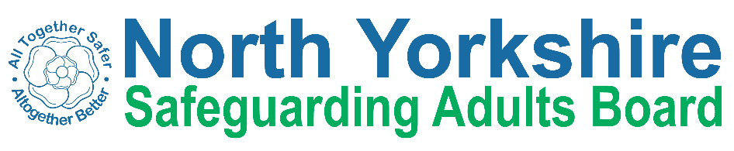

Social media messages

Safeguarding Week 2021 #SafeguardingIsEverybodysBusiness

General

This week is #SafeguardingWeek2021. Are you concerned an adult is at risk of abuse or neglect? Contact @northyorkscc on 01609 780 780 and #TellUsYourConcerns If you think an adult is in immediate danger, call the police on 999.

It's #SafeguardingWeek2021 & our key message is #SafeguardingIsEverybodysBusiness It’s important that we look out for each other & keep ourselves, friends, family & communities safe. If you're worried about someone’s safety please #TellUsYourConcern by calling 01609 780 780

It’s been a tough year, but we’ve seen some amazing examples of people coming together to look after each other and the wider community. That’s what safeguarding is, looking out for each other, especially those who are most at risk. Because #SafeguardingIsEverybodysBusiness

If you have concerns about an adult at risk please #TellUsYourConcern. You can report it to police on 101 or call 01609 780 780.
For more information on how to raise a concern visit: https://safeguardingadults.co.uk/working-with-adults/one-minute-guides-omg/raising-a-safeguarding-concern/
#SafeguardingWeek2021 #SafeguardingIsEverybodysBusiness

Start of the week

It's the start of #SafeguardingWeek2021! We've got a packed week of events being delivered via our virtual conference. There's still time to sign up for the free sessions later on this week. Visit www.nypolice.eventbrite.com and book your space ! #SafeguardingIsEverybodysBusiness

End of Week

As #SafeguardingWeek2021 ends thank you to the agencies who have been involved in our virtual conference. The end of the week doesn’t mean that safeguarding stops. We’ll continue to work hard to keep people safe so please #TellUsYourConcern -#SafeguardingIsEverybodysBusiness

Monday (theme - domestic abuse)

Do you work with victims of domestic abuse? We have a FREE virtual session running on Friday 25 June at 9.30am where the challenges faced by victims in rural communities is being discussed. Sign up now at www.nypolice.eventbrite.com

If you are experiencing domestic abuse see the @IDASfor100 easy read guide ‘ What is Domestic Abuse’ for information and advice https://safeguardingadults.co.uk/wp-content/uploads/2020/06/What-is-domestic-abuse-easy-read.pdf and #TellUsYourConcerns on 01609 780780

Tuesday (theme - keeping safe online)

Day 2 of #SafeguardingWeek2021 and we’re looking forward to another packed day of events with our virtual conference. There’s still time to sign up for sessions taking place on Thursday and Friday. Why not visit www.nypolice.eventbrite.com check out the programme and sign up quick!

So much of our lives takes place online now - shopping, banking or catching up with friends. It’s important we know how to keep ourselves and our families safe online. www.getsafeonline.org has lots of advice and resources to help you stay safe. #SafeguardingWeek2021

Wednesday (theme - Prevent)

It’s #SafeguardingWeek2021 and today we’re focusing on Prevent. If you are worried about a friend or relative who is at risk of being radicalised please #ActEarly and #tellusyourconcern. Visit www.actearly.uk for more information #SafeguardingIsEverybodysBusiness

Keeping each other safe and looking out for friends and family is safeguarding in its simplest terms. If you're concerned that a friend or family member is at risk of being exploited by extremists #ActEarly and visit www.actearly.uk #SafeguardingIsEverybodysBusiness

Today is the last day to register for Friday’s free #SafeguardingWeek2021 virtual learning sessions. Visit www.nypolice.eventbrite to see what’s on offer because #SafeguardingIsEverybodysBusiness

Thursday (theme - exploitation)

Exploitation is when a person is targeted because of a vulnerability, for another person’s gain. If you think someone is being exploited #TellUsYourConcern and report it to @NYorksPolice. Because #SafeguardingIsEverybodysBusiness

Mate crime is when somebody says they are your friend but they do things to take advantage of you. They may ask you for money, steal from you or make you do something you don’t want to. If you think you are a victim of mate crime report it to @nyorkspolice and #TellUsYourConcern

Friday (theme - mental health)

It's the final day #SafeguardingWeek2021 and we’re focusing on mental health. There are a number of agencies who are ready to help if you or a person you know needs support. This film shows just a few of those orgs who can help, care and support https://youtu.be/P7uSc9LfWFI #SafeguardingIsEverybodysBusiness

