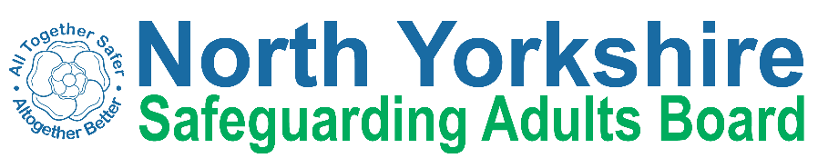
North Yorkshire, City of York & East Riding Safeguarding Week
21 – 25 June 2021
To book your place on these events visit: www.nypolice.eventbrite.com.

Monday 21 June
09:30 - 10:30 | Self-Neglect Training | East Riding Safeguarding Adults Board
10:00 – 11:00 | Fire Safety Presentation | Humberside Fire & Rescue Service
11:00 – 11:30 | NYP – Prevent | North Yorkshire Police
12:00 - 13:00 | Babies in Lockdown | NHS Vale of York Clinical Commissioning Group, NHS North Yorkshire Clinical Commissioning Group
13:00 – 14:00 | Understanding the DA Bill and its impact on ‘hidden victims’ and those with unmet need | Safe Communities East Riding, SafeLives
14:00 – 15:00 | Reducing Loneliness and Isolation | East Riding Safeguarding Adults Board, East Riding Council
15.30-17.00 | The impact of parent/ carer mental illness and introduction to the PAMIC Tool | Tees, Esk and Wear Valleys NHS Foundation Trust

Tuesday 22 June
09:30 – 10:00 | An introduction to the Youth Engagement Activities we have to offer | North Yorkshire Fire & Rescue Service
10:00 – 11:30 | Domestic Abuse Charter- Supporting the Workforce Affected by Domestic Abuse | North Yorkshire Community Safety Partnership
10:00 – 11:30 | Modern Slavery - who it affects and what we can do collectively to tackle it. | East Riding Safeguarding Adults Board, Humber Modern Slavery Partnership
11:30 – 12:00 | Introduction to Safe & Well visits | North Yorkshire Fire & Rescue Service
12:00 – 13:30 | Employers Initiative on Domestic Abuse | Safe Communities East Riding, Employers’ initiative on domestic abuse
14:00 – 15:30 | Carers Panel – Keeping safe in care and support settings | North Yorkshire Safeguarding Adults Board
16:30 – 17:00 | An introduction to Safe & Well visits | North Yorkshire Fire & Rescue Service
17:30 – 18:30 | Child Exploitation | East Riding Children’s Safeguarding Partnership
19:00 – 21:00 | Using online banking in safety | HSBC, North Yorkshire Police

Wednesday 23 June
10:00 – 11:00 | Safeguarding in non-mobile children | York and Scarborough Teaching Hospitals, NHS Foundation Trust
10:00 – 11:00 | Fraud and Cyber Awareness Workshop | East Riding Safeguarding Adults Board, East Riding Voluntary Action Services
10:00 – 12:00 | Reducing Loneliness and Isolation | East Riding Safeguarding Adults Board, East Riding Council
12:00 – 13:00 | Fraud Prevention in Humberside | East Riding Safeguarding Adults Board, Humberside Police
13:00 – 14:00 | Suicide Prevention | North Yorkshire Safeguarding Adults Board
16:30 to 17:15 | Adverse Childhood Experiences | East Riding Children’s Safeguarding Partnership

Thursday 24 June
10:00 – 12:00 | North Yorkshire ‘Credibility Framework: How do we monitor community tensions effectively? | North Yorkshire Community Safety Partnership
11.00 - 13.00 | Hidden Harm | North Yorkshire Safeguarding Children Partnership
13:30- 14:00 | ‘Hard to Help’ Working with Perpetrators of Domestic Abuse | North Yorkshire Community Safety Partnership
14:00 - 15:00 | Fire Safety Presentation | East Rising Safeguarding Adults Board, Humberside Fire & Rescue Service
15:00 – 16:00 | NYP in partnership with HSBC | HSBC Bank, North Yorkshire Police
16:00 - 17:00 | The Impact of Domestic Abuse on Children and Young People | North Yorkshire Community Safety Partnership

Friday 25 June
09:30– 11:30 | Domestic Abuse in Rural Communities | Safe Communities East Riding, SafeLives, Domestic Abuse Consultancy Sarah Wigley Associated
11.00 - 11.30 | Homelessness and Safeguarding | NHS North Yorkshire Clinical Commissioning Group
12:00 – 14:00 | Mental Capacity Act: Across Key Lines of Enquiry (KLOEs) | East Riding Safeguarding Adults Board
13:30 – 14:30 | Hoarding – A safeguarding issue? | East Riding Safeguarding Adults Board, Humber Teaching NHS Foundation Trust
Professionals only session Police only session

