Training Courses and Online Learning Private, Voluntary and Independent Sectors

Health and Adult Services
Training and Learning Access

April 2020 – March 2021

Contents

Page2.
Course Index

Page3. Introduction

Page3.
Target Audience

Page3.
How to book Classroom Training

Page3.
Cancellation and Non-attendance charge

Page4.
Classroom Courses

Page13.
Online-Learning Courses

Page 18.
How to self-register for a Learning Zone login and How to get an organisation subscription Code

Course Index
Classroom Index:
- Deprivation of Liberty Safeguards (DoLS) – Registered Managers / Deputies / Team Leaders of care homes and hospitals
- Mental Capacity Act (MCA) Intermediate
- Moving and Handling of People Managers' Induction (Train the Trainer)
- Moving and Handling of People Managers' Refresher
- Safeguarding Adults Raising a Concern
(Formerly Safeguarding Adults Level 1 Alerter)
- Safeguarding Adults Level 2 Safeguarding Concerns Manager Training
(Formerly Safeguarding Adults Level 2 Responder / Referrer)
- Safeguarding Adults (Alerter) Raising a Concern Champions
- Safe Handling of Medicines - Domiciliary Care Staff (Private and Voluntary Sector)
- Supporting Individuals (age 16+) to make decisions within the Mental Capacity Act

Online-Learning Index:
- Autism Awareness
- Deprivation of Liberty Safeguards (DoLS)
- Food Safety & Nutrition in the Care Sector
- Mental Capacity Act
- Safeguarding Adults under the Care Act

Introduction
The training advertised in this booklet is for those working within North Yorkshire in the Private, Voluntary and Third Sector Organisations.

Target Audience
The following training is specifically for small and medium- sized businesses and non-profit organisations working within the Adult Social Care Sector in North Yorkshire.

How to book Classroom training
To request a place on a training course or to check dates and locations please log onto the NYCC Learning Zone.
If you are not registered on the NYCC Learning Zone, please see APPENDIX 1 page 13

Cancellation and Non- Attendance Charge
Training and Learning have a cancellation charge of £50 per person, *per course to all external partners accessing training. This will apply to those delegates that do not turn up on the day and those persons cancelling their place on a course with less than 1 weeks’ notice. If a substitute attends this charge will not apply. (*For courses of more than one days duration a charge will be made for each day not attended)

Classroom Courses – Descriptions

Deprivation of Liberty Safeguards (DoLS) – Registered Managers / Deputies / Team Leaders of care homes and hospitals
Overview
- The whole day is dedicated to Deprivation of Liberty Safeguards and the manager’s responsibilities for those who manage an adult setting. For example, the difference between a deprivation and a restriction, how to apply for an authorisation of a potential Deprivation of Liberty (including the forms to complete) case studies and other duties and responsibilities of managing authorities.

Is It Right For Me?
- The aim is to ensure that managers and team leaders of regulated settings have the skills they need to act in the best interests of those they support and to protect themselves by acting in accordance with the Mental Capacity Act & Deprivation of Liberty Safeguards.
- It is for managers and senior staff from registered residential & nursing homes, (including private and voluntary sector), and managers from hospitals within the private and statutory sector.
- Senior staff, including in the community, who require a working knowledge of DoLS may attend the morning, to gain an overview. The afternoon will focus on completing forms to apply for an authorisation under DoLS which is applicable to regulated settings only

What Will I Learn?
By the end of the day delegates will:
- Have demonstrated an understanding of the key concepts of the Mental Capacity Act 2005, in relation to deprivation of liberty safeguards (DoLS)
- Have an understanding of the difference between restrictions of liberty and deprivation of liberty.
- Have an understanding of what Managing Authorities (care homes and hospitals) should consider before applying for an Authorisation of Deprivation of Liberty.
- Be able to apply to ‘Supervisory Bodies’ for ‘Authorisation using appropriate forms.
- Know when authorisation can be reviewed and what happens when they end.
- Know how and when to apply to the ‘Court of Protection’ under the Deprivation of Liberty Safeguards.
- Be able to explain the role of the Relevant Person’s Representative and monitor their contact.
- Be able to understand the nature of any conditions attached to the DoL, and how these should be reflected in the care plan and care provision.
- Be able to inform appropriately the Care Quality Commission and the Coroner’s Office in line with their duties.

Mental Capacity Act (MCA) Intermediate
Overview
- This course will support social care coordinators/newly qualified to support Individuals (age 16+) to make decisions within the Mental Capacity Act with key decisions over and above day to day activities of daily living. This course will form part of the learning pathway for all assessment staff who will now be required to attend the intermediate course before the complex course.

Is It Right For Me?
- HAS Assessment staff (SCA/SCC/Mental Health/OT/Sensory/Direct Payments/Living Well and HAS/CYPS Transitions), Registered and LD Managers, Deputy Managers. Children’s Social Workers who have not yet undertaken the MCA Complex decision making course. Staff who have already done this need not do this one.

What Will I Learn?
At the end of the course delegates will:
- Understand how to and have the confidence to assess people’s capacity against a range of decisions.
- Have an understanding of how to make Best Interest Decisions.
- Have an awareness of the appropriate involvement of Advocates and IMPAs.
- Understand the difference between a Best Interest Decision and a Best Interest Meeting.
- Have the ability to complete Defensible recording of decisions.
- Have the ability to record decisions into support plans appropriately.

Moving and Handling of People Managers' Induction (Train the Trainer)
Overview
- This course will ensure that managers have a sound knowledge of relevant legislation and their responsibilities regarding the moving and handling of people, including biomechanics and efficient movement. It is also designed to ensure safe practice using a range of techniques and ensure managers have the necessary skills to cascade safe practice to others.
- There must be a training needs analysis to identify what is required. This may be informed by a health and safety audit process.
- Adequate policies must be in place to promote best practice and staff health.
- There must be management commitment and support for the training strategy and service delivery.
- There must be allocation of sufficient resources by management to develop, implement and deliver the service.

Is It Right For Me?
- This is a three-day course for managers who are new to NYCC Health and Adult Services Directorate provider services or to a management post within private and voluntary sector provider organisations to enable them to cascade moving and handling training to their staff, limited to 2 people per course from each wider sector establishment.

What Will I Learn?
- The following topics will be covered:
- Spinal mechanics and function
- Importance of back care and posture, risk factors for back pain
- Current relevant legislation/professional guidelines, where relevant
- Assessment of risks
- Of tasks (including the unexpected/unpredictable)
- Loads – both inanimate and human
- Environment and the importance of good housekeeping and maintenance
- Limits of individual capability (clients and staff)
- Local policies, and reporting of injuries
- Importance of an ergonomics approach
- Principles of normal human movement and promotion of client independence
- Safe management of inanimate loads
- Handling strategies for clients with impaired mobility
- Dealing with unpredictable occurrences
- Use of equipment, as required
- Problem solving

Moving and Handling of People Managers' Refresher
Overview
- There is a requirement for NYCC - HAS managers who have undertaken the Moving & Handling of People Managers Induction - Train the Trainer programme to regularly attend an annual refresher course in order to refresh and update their skills and knowledge in moving and handling. This will enable these managers to continue to cascade manual handling training which is up to date in terms of legislation, equipment and skills.

Is It Right For Me?
- This course is for all NYCC HAS managers only with responsibility for cascading Moving and Handling training to staff and have already completed the Moving and Handling of People Managers' Induction - Train the Trainer course.

What Will I Learn?
- On completion of the course participants will:
- Have updated knowledge of existing legislation and any relevant updates regarding moving and handling.
- Have updated knowledge of the equipment that is available to reduce the need and risk of moving and handling of service users including any new equipment that is available.
- Have refreshed their knowledge of how to apply the core principles of efficient moving and handling to the movement of service users, maintaining the individual's dignity and in line with legislation and agreed ways of working.
- Be able to demonstrate a sound knowledge of up to date practical skills in the moving and handling of clients in a care setting.

Safeguarding Adults Raising a Concern
Formerly Safeguarding Adults Level 1 Alerter

Overview
- This training for any person who has close and regular contact with adults (people over 18) to increase awareness of how the different types of abuse, how to safeguard adults from abuse, how to recognise signs and symptoms of abuse, work to prevent abuse occurring and action to take should you suspect abuse is taking place.

Is It Right For Me?
- This training is for all staff / volunteers / advocates etc. who have close and regular contact with adults at risk. Attendees are welcome from all sectors for example, the Private, Voluntary and Independent social care sectors, personal assistants etc.

What Will I Learn?
- By the end of the course participants will be able to (Safeguarding Adults Board competencies 1 - 9):
- Understand the definitions regarding adult safeguarding as defined by the Care Act 2014(DOH 2000)
- Understand the types of Abuse as defined by the Care Act 2014
- Understand the purpose of adult safeguarding as defined by the Care Act 2014
- Have an awareness of Making Safeguarding Personal
- Have an understanding of Abuse and Prevention
- Report and record alerts following the Safeguarding Multi Agency Policy and procedure (NYCC 2015)
- Have an understanding and awareness of the procedures that follow an Alert (Concern) and the role of the Alerter
- Have an awareness of the importance of preserving evidence

Safeguarding Adults Level 2 Safeguarding Concerns Manager Training
Formerly Safeguarding Adults Level 2 Responder / Referrer

Overview
- This course is designed to provide knowledge and practical application of the responder role, in relation to dealing with a Concern/Alert regarding a suspicion of Abuse of an Adult at Risk. This course guides the participants in understanding the legislative framework (Care Act 2014) and the practicalities of dealing and responding to an Alert/Concern, the importance of effective recruitment and management of staff. It includes how to make a Safeguarding Adults referral.

Is It Right For Me?
- All managers of social care provider services i.e. Home Care Managers, Assistant Home Care Managers, Registered Managers, Duty Managers, nominated Level 3 workers, Team Managers, Team Leaders.
- Managers and team leaders in private and voluntary sector organisations who act as Safeguarding Adults Responders within their organisation.

What Will I Learn?
- By the end of the course participants will be able to:
- Understand the role & responsibilities of the Responder
- Understand the role and responsibilities of referring the Concern
- Have an awareness of Safer Recruitment and Disclosure and Barring Service
- Understand the importance of recording and documenting all appropriate information arising from the Concern
- Know how to support staff or people who report concerns of Abuse (Concern)
- Understand the principles of information sharing in accordance with the Multi-Agency policy and procedures
- Understand the principles of preserving evidence and safety of the Adult at Risk
- Understand the principles and be able to support staff on how best to deal with disclosures and how to record their concerns
- Will understand the procedure for referring the Concern
- Understand the steps that can be taken, and support that can be offered, to minimise adult abuse occurring

Safeguarding Adults Raising a Concern Champions
Overview
- This course is designed to equip you to deliver the NYCC Safeguarding Adults Raising a concern training package to groups of staff/volunteers concerned with the safety of adults who may be at risk.
- By the end of the course you will understand how to deliver the safeguarding adults raising a concern course materials and how to test out and evaluate the learning you have delivered. You will also how to keep records of who you have trained including how to provide information on the numbers of people you have delivered the training to.

Is It Right For Me?
- This course is designed for organisations that have 50 or more staff that require level 1 Raising a Concern training, and/or organisations who support a large number of volunteers for whom attending classroom sessions is difficult. Such organisations will nominate a Champion to deliver this training in their own organisations.
- Therefore, the course is designed to enable Raising a Concern Champions’ to deliver the package within a unit, day care facility or organisation.
- No training qualification required.

What Will I Learn?
At the end of the course participants will be able to:
- Identify which adults may be at risk
- Explain the different forms of abuse that can occur
- Recognise the signs and symptoms of different forms of abuse
- Explain how raising awareness helps to prevent abuse
- Recognise where abuse may occur and who abusers could be
- Demonstrate when and how to report and record abuse
- Recognise the Safeguarding Adults’ policy and procedure as a resource for clarifying roles, responsibilities, process and protocol
- Understand how to access and use the training materials as provided
- Provide Training & Learning with the figures for any training that you deliver
- Know how to gain further support / guidance to enable you to fulfil your role as a Champion

Safe Handling of Medicines - Domiciliary Care Staff (Private and Voluntary Sector) Overview
- This course is for those working in the private and voluntary sector only, it is not open to NYCC Health and Adult Services staff.
- The aim of the course is to develop the knowledge and skills to competently administer medicines within a domiciliary care setting and to understand the need for accurate written documentation.

Is It Right For Me?
- Delegates must be from a DOMICILIARY setting e.g. care workers supporting an adult to live at home and supported living staff, people employed via direct payments who are supporting individuals at home are welcome to attend this training.

What Will I Learn?
- By the end of the course participants will:
- Have the knowledge required to safely administer medicines in the domiciliary care setting and make appropriate records

Supporting Individuals (age 16+) to make decisions within the Mental Capacity Act Overview
- This course provides an awareness of the Mental Capacity Act and how it has an impact on practice regarding supporting adults (those aged 16+) who may lack capacity to make decisions within the law.
- Please note - This course has replaced The Mental Capacity Act Deprivation of Liberty Safeguards Basic Awareness course.

Is It Right For Me?
- This course is for anyone who has close and regular contact with adults, who are aged 16+, who may lack capacity to make some or all their decisions to ensure they are supporting people in line with the law.

What Will I Learn?
- To be aware of the principles of the Mental Capacity Act
- To be aware of the key definitions in the Mental Capacity Act and implications on practice
- How to undertake a capacity assessment: 2 stage capacity test
- How to record best interest decisions: best interest checklist, support planning and daily records
- Importance of recognising people may have capacity to make some decisions and not others,
- Importance of recognising fluctuating capacity
- Use of advanced decisions and statements when someone has capacity and within best interest decision making process
- Be aware of the public bodies roles and responsibilities
- Have an awareness of the role of the IMCA, Lasting Power of Attorney

Online Learning – Descriptions

Autism Awareness
Overview
- This is an easy to use online learning package intended to provide an introduction to Autism and Asperger Syndrome. The package contains information and some interactive activities as well as a final assessment in the form of a quiz.

Is It Right For Me?
- This free online learning course is available to NYCC and all external partners working within North Yorkshire as well as service users and carers. It provides a basic awareness of the condition and how it affects people in their everyday lives.

What Will I Learn?
- On completion of the course learners should have an understanding of:
- What is Autism - an understanding of the terms used to define the condition.
- The triad of impairments - what are these and how these affect people with autism.
- Sensory issues - reactions to sensory stimuli.

Deprivation of Liberty Safeguards (DoLS)
Overview
- This Deprivation of Liberty Safeguards e-learning course aims to help Managers, Professionals and Care Staff across Health and Social Care to understand the key information about Deprivation of Liberty Safeguards and describes the role of people supporting vulnerable adult to help to ensure they are operating within the Law and consider:
- The background to DOLS and what they do
- The difference between 'deprivation' and 'restriction' of liberty
- How these might apply to a particular patient or resident
- The process of referral, assessment and review if a DOLS is needed.
- There is a final assessment to check your knowledge with an 80% pass mark.

Is It Right For Me?
- This online learning is available to NYCC and all external partners working within North Yorkshire. This online learning is suitable for all Managers, Professionals and Care Staff across Health and Social Care.
- Further DoLS classroom training for Registered Managers and deputies is available, dates for this are advertised on the Learning Zone. This elearning will help the learner embed the statutory requirements under the Act and is also a refresher following classroom training.
- This course has close links to Mental Capacity Act and Safeguarding Adults Alerter which are also available as a classroom and online learning option.

What Will I Learn?
- By the end of the module the learner will be able to:
- Understand the background to Deprivation of Liberty Safeguards
- Understand the differences between a Restriction v Deprivation of Liberty
- Understand the process of assessment, authorisation and review
- Understand the roles and responsibilities within the DoLS processes

Food Safety & Nutrition in the Care Sector
Overview
- This online learning is designed to give delegates an awareness of Food Hygiene and relevant legislation along with a basic understanding of what a healthy diet is and ideas how to adapt someone's diet to promote healthy eating.
- There is a final assessment quiz, at which the learner has to achieve 70%- 7+/10 to enable them to print off their certificate.
- This learning should take approximately 1 hour to complete.

Is It Right For Me?
- This learning is for all staff working in social care settings ie. Residential Care, Mental Health, Adult Respite, Day Services and Domiciliary services (including START), CYPS Integrated Services and Youth Services. Multi Agency partners in social care settings and Foster Carers.

What Will I Learn?
- By the end of the course participants will be able to:
- Understand the importance of food safety, including hygiene, in the preparation and handling of food. Have awareness of food poisoning bacteria.
- Understand the importance of Temperature Control and how to store food correctly.
- Understand the need for high standards of personal hygiene and cleanliness.
- Understand the reasons for effective pest control and actions to be taken.
- Awareness of controls and monitoring procedures.
- Understand the basic principles of healthy eating and the importance of good nutrition and hydration in maintaining well-being.
- Identify why older people and those with dementia are at risk from under-nutrition and be aware of the signs and symptoms of poor nutrition and hydration.
- Discuss how to adapt someone's diet to meet their nutritional requirements if they have a poor dietary intake and be aware of ways in which to promote adequate nutrition and hydration

Mental Capacity Act
Overview
- This online learning will inform staff about the Mental Capacity Act

Is It Right For Me?
- This online package provides key information about the Mental Capacity Act for any staff who care for people who are unable to make some of, or all of, their own decisions.

What Will I Learn?
- Understand what mental capacity means
- The five principles of the Mental Capacity Act
- Using the Best Interest checklist
- What an independent mental capacity advocate does.
- Know the difference between an advance decision and advance statement

Safeguarding Adults under the Care Act
Overview
- This online package aims to help protect vulnerable adults from abuse, through increased awareness, recognition and knowledge of how to respond to suspicions of adult abuse.
- This package also provides an overview of the Care Act.
- This package includes a final assessment quiz, at which the learner has to achieve a minimum pass mark of 80%

Is It Right For Me?
- This free online learning is available to NYCC and all external partners working within North Yorkshire.
- For staff and volunteers who have limited and infrequent contact with vulnerable adults this provides the learning required.
- The North Yorkshire Safeguarding Adults Board recommends that staff who have close and regular contact with vulnerable adults to also undertake the half day classroom Safeguarding Raising a Concern Training, which is advertised on the Learning Zone, this online learning is a refresher following classroom training to meet CQC and the Safeguarding Board requirements.

What Will I Learn?
- At the end of this package you will:
- Understand what abuse is
- Understand how to recognise abuse
- Understand what to do if you suspect an adult is being abused
- Understand how to develop skills in listening to an adult at risk
- Understand how to reduce the likelihood of abuse
- Understand how to make a safeguarding referral or report a concern.

Learning Zone Registration Instructions

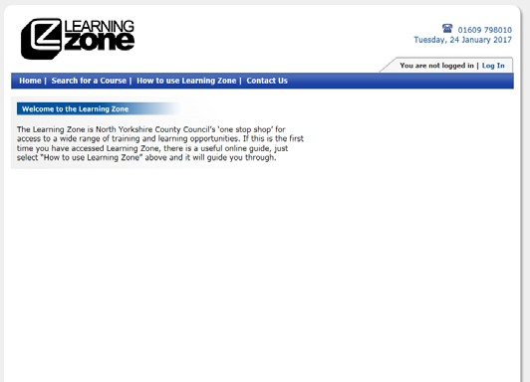Before you can start the learning you need to register with the NYCC Learning Zone. Follow the instructions below.
- Go to the learning zone web address: https://www6.northyorks.gov.uk/LZCS/home

- 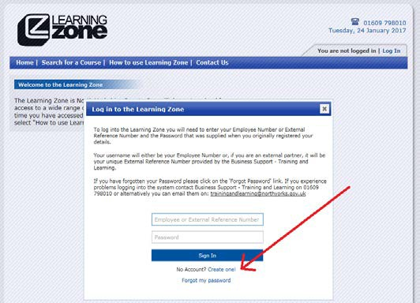Click on the Log In tab in the top right hand corner, and a login box appears. Since you don’t have an account, click “Create One!” near the bottom.

- 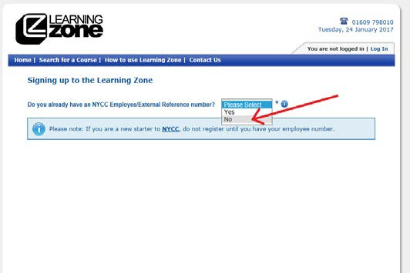As you are not a NYCC employee, select No
from the drop down box.

- 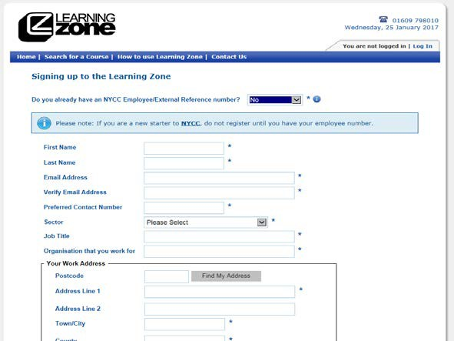You will see that a form now appears below.

- Notice that you only have to fill in the fields with *(asterisks).
Continue as follows.

First Name and Last Name
  - Email Address
This is important because your User name for the Learning Zone will be sent to you by email. If you do not have an email address, ask us for help.

Verify Email Address
Enter your email address again to make sure it is accurate!

Sector
From the drop down box, select “The Relevant Sector”

Job Title
Enter Your Job Title

Organisation that you work for
Enter the Organisation that you come under

Work Address
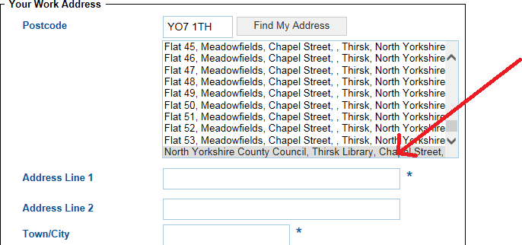Enter the postcode of the above Local Authority then click Find My Address. Look down the list of addresses that appear, then click when you find the address, as in this example:

When you click, it will automatically fill in the address. You can correct anything that’s come up wrongly by clicking in each box and changing what’s typed there.

Is the billing address the same as your work address? Tick the Yes box
  - Do you have a disability? Select Yes or No from the drop down box as appropriate
  - 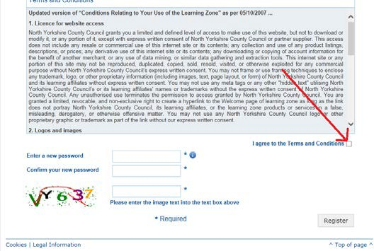Terms and Conditions Read the Terms and Conditions and tick the ‘I agree to the Terms and Conditions’ box.

Enter a new password and Confirm your new password
Decide on a password. It can be anything you want. The password MUST be between 7 and 15 characters long and contain at least 1 number, as well as a combination of capital and lower case letters (a-z, A-Z). Then in the second box, re-enter your chosen password to make sure you entered it accurately.

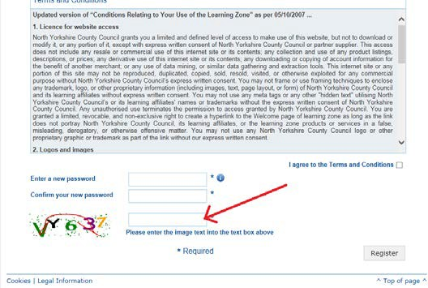Enter the characters in the image into text box
Into the box indicated below, type the coloured letters and numbers that appear slightly jumbled on the left.
This checks that you are a real human being. Make sure you enter characters as upper case or lower case as they appear in the image.

  - Click on Register.
  - 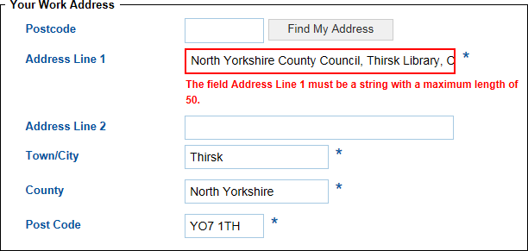If there is an error like this one:
That means that there is too much text in that box, you may need to look at ways to shorten the number of characters in the address.
You will need to type in the coloured letters and numbers again (they will be different). Then click Register again.

There may be other errors that come up highlighted in red. You will need to correct each one before your registration goes through.

  - 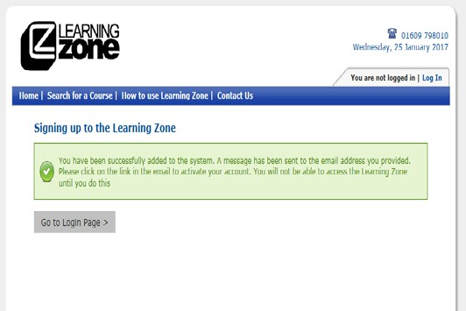When your registration is finished, you will see this screen:

- You’ve done it!! The Learning Zone will send you your username and a reminder of your password to your email address. In our experience you should receive the email within a few minutes. You will need to click on the link in the email to activate your Learning Zone account.

- Keep your username and password in a safe place - you will need it every time you log in to the Learning Zone.

- You will now be able to book onto the assigned courses, and download certificates. When you book on a course you will be asked to enter a code, if you do not have your organisation code please contact Training and Learning on 01609 798010, or email trainingandlearning@northyorks.gov.uk.

- If you experience any technical problems when using the Learning Zone, please telephone the support line on 01609 798010, or email trainingandlearning@northyorks.gov.uk.

