Over Arching Tweet
Would you stand by and watch hate, abuse or harassment? Or would you stand up and make it stop? Watch this video to learn how you can safely take a stand against hate and abuse and keep your community safe https://youtu.be/NNDZfZ7KYNs #HelpNotHateNY2021 #activebystander

Supporting Tweets for bystander
Have you witnessed a hate crime? You can be an ‘bystander’ by reporting such incidents to North Yorkshire Police on 101. To learn more watch https://youtu.be/NNDZfZ7KYNs #HelpNotHateNY2021 #activebystander

Active bystander intervention involves intervening before, during or after a situation where we witness inappropriate behaviours. To learn more https://youtu.be/NNDZfZ7KYNs #HelpNotHateNY2021 #activebystander

Monday 11th October
- How to be an active bystander
- What is a Hate Crime?
- What support is available?
- How do you report it?
NYCSP | Would you stand by and watch hate, abuse or harassment? Or would you stand up and make it stop? Watch this video to learn how you can safely take a stand against hate and abuse and keep your community safe https://youtu.be/NNDZfZ7KYNs #HelpNotHateNY2021 #activebystander  Have you witnessed a hate crime? You can be an ‘bystander’ by reporting such incidents to North Yorkshire Police on 101. To learn more watch https://youtu.be/NNDZfZ7KYNs #HelpNotHateNY2021#activebystander  Active bystander intervention involves intervening before, during or after a situation where we witness inappropriate behaviours. To learn more https://youtu.be/NNDZfZ7KYNs #HelpNotHateNY2021#activebystander  Have you been a victim of #HateCrime or #MateCrime? Contact North Yorkshire Police 101 or Supporting Victims on 01609 643100 or make a report online at https://www.supportingvictims.org/  #HelpNotHateNY2021 If you are in immediate danger contact the Police on 999.  It is #HateCrimeAwarenessWeek21. NY and COY are working together to stop hate #HelpNotHateNY2021. If you are a victim of #HateCrime, you can contact https://www.supportingvictims.org, call NYP 101 or if you are in immediate danger contact the police on 999
NYSCP | It is #HateCrimeAwarenessWeek21. Don’t stand for Hate Crime #HelpNotHateNY2021. If you are a victim of #HateCrime, you can contact https://www.supportingvictims.org, call NYCC on 01609 780780 or if you are in immediate danger contact the police on 999
NYSAB | Tweet 1:  Have you been a victim of Hate Crime or Mate Crime? Contact North Yorkshire Police 101 or Supporting Victims 01609 643100 or make a report online at https://www.supportingvictims.org/  #HelpNotHateNY2021 If you are in immediate danger contact the Police on 999.  Tweet 2:  This easy read guide provides important information on what #Hate Crime and #Mate Crime is and how you report it:  https://www.northyorkshire-pfcc.gov.uk/content/uploads/2016/09/Hate-crime-report-Easy-read.pdf  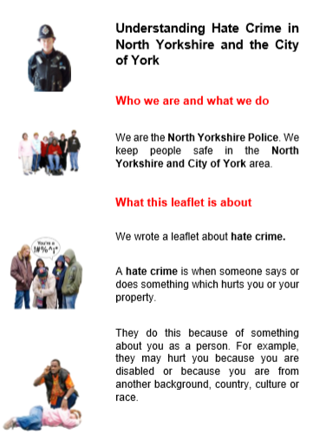  Tweet 3:  If you or someone you know has been the victim of #Hate Crime or #Mate Crime and have safeguarding concerns, contact North Yorkshire County Council Customer Service Centre on 01609 780 780 #HelpNotHateNY2021  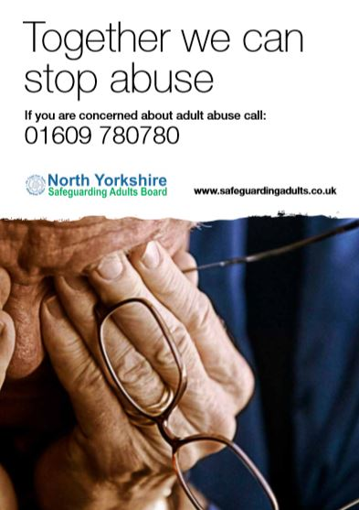  Resources from the North Yorkshire Learning Disability Partnership Board / Self Advocates will be shared via the NYSAB Twitter. Please share via your social media platforms
CYCSB | Hate crime is when someone commits a crime against you because of any perceived difference. Hate crime is against the law. #HelpNotHateNY2021  See the #CYSCP website for more information and how to report it:  https://www.yor-ok.org.uk/Safer%20Children%20York%202014/bullying.htm
Tuesday 12th October
- What is Mate Crime and how do you report it?
- Young people urged to play the KYMSGAME (Keeping Your Mates Safe) developed by the Youth Commission
- Highlight the services provided by Supporting Victims

NY CSP | Have you been a victim of #HateCrime or #MateCrime? Contact North Yorkshire Police 101 or Supporting Victims on 01609 643100 or make a report online at https://www.supportingvictims.org/  #HelpNotHateNY2021 If you are in immediate danger contact the Police on 999.  Tweet 2  This handy one-minute guide provides important information on what #MateCrime is and how you report it:  https://www.nypartnerships.org.uk/sites/default/files/Partnership%20files/Safer%20communities/Hate%20crime/Mate-Crime-OMG-2020-06-16.pdf  #HelpNotHateNY2021  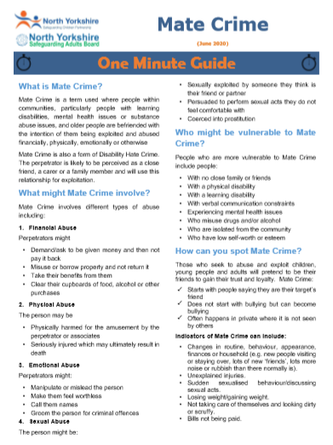
NYSCP | Don’t stand for #MateCrime #HelpNotHateNY2021. See our one minute guide at https://www.safeguardingchildren.co.uk/wp-content/uploads/2020/06/Mate-Crime-OMG-2020-06-16.pdf  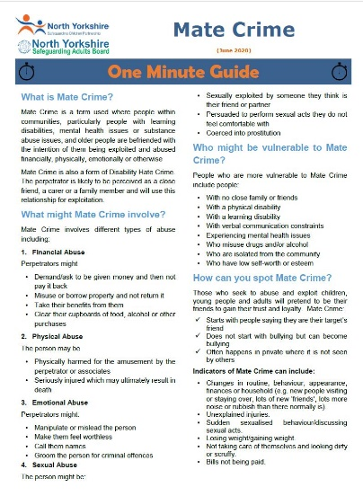
NY SAB | Tweet 1:  This handy one-minute guide provides important information on what Mate Crime is and how you report it: https://safeguardingadults.co.uk/wp-content/uploads/2020/06/Mate-Crime-OMG-2020-06-16.pdf  Tweet 2:  Have you been a victim of Hate Crime or Mate Crime? Contact North Yorkshire Police 101 or Supporting Victims 01609 643100 or make a report online at https://www.supportingvictims.org/  #HelpNotHateNY2021If you are in immediate danger contact the Police on 999  Tweet 3:  If you or someone you know has been the victim of Hate of Mate Crime and have safeguarding concerns, contact North Yorkshire County Council Customer Service Centre on 01609 780 780  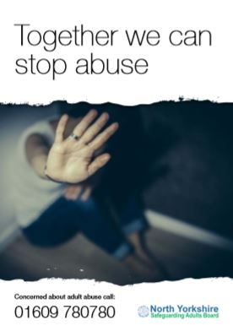  Resources from the North Yorkshire Learning Disability Partnership Board / Self Advocates will be shared via the NYSAB Twitter. Please share via your social media platforms
CYCSB | Mate crime happens when someone ‘makes friends’ with you and goes on to abuse or exploit that relationship. See the #CYSCP Bullying webpage for more information and how to report it:  https://www.yor-ok.org.uk/Safer%20Children%20York%202014/bullying.htm  #HelpNotHateNY2021
Wednesday 13th October
Hate Crime awareness webinar 10:00 – 11:00
Prevent Awareness webinar 11:00 – 12:00
- How to be an active bystander
- What is a Hate Crime?
- What support is available?
- How do you report it?
- Do you have a prevent concern?
- How to report a prevent concern

NYCSP | Tweet 1  Would you stand by and watch hate, abuse or harassment? Or would you stand up and make it stop? Watch this video to learn how you can safely take a stand against hate and abuse and keep your community safe https://youtu.be/NNDZfZ7KYNs #HelpNotHateNY2021  Tweet 2  Prevent concern? Call 101 or report anonymously on the Anti-Terror Hotline 0800789321. Partner agencies should follow existing safeguarding routes or call a NYP Prevent Officer for advice #HelpNotHateNY2021  Tweet 3  Prevent is about safeguarding and supporting those vulnerable to radicalisation #HelpNotHateNY2021. For more information, visit the ACT Early | Prevent radicalisation Or visit https://www.nypartnerships.org.uk/prevent
NYSCP | Want to know more about #HateCrime, see this video from Victim Support https://www.youtube.com/watch?v=1Mo2QCW7-eA #HelpNotHateNY2021
NYSAB | Tweet 1  Prevent is about safeguarding and supporting those vulnerable to radicalisation. For more information, the ACT Early | Prevent radicalisation #HelpNotHateNY2021  Tweet 2  If you need to make a Prevent concern for you or someone you know, talk to the police on 101. You can also contact the North Yorkshire safeguarding team for further advice on 01609 780 780 For more information visit the ACT Early | Prevent radicalisation #HelpNotHateNY2021
CYCSB | If you think an individual is exhibiting behaviour or making comments that suggest they may be involved in activity which could be linked to terrorism, you should report it, see the #CYSCP website:  https://www.saferchildrenyork.org.uk/prevent.htm  #HelpNotHateNY2021
Thursday 14th October
Train the trainer webinar: The All About Respect bystander programme
- How to be an active bystander
- If you witness a hate crime you can report it
NYCSP | 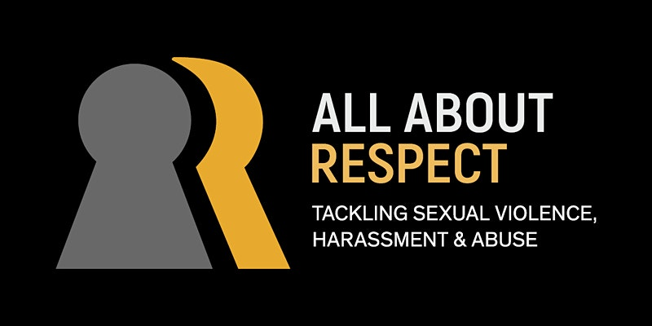  Tweet1  Would you stand by and watch hate, abuse or harassment? Or would you stand up and make it stop? Watch this video to learn how you can safely take a stand against hate and abuse and keep your community safe https://youtu.be/NNDZfZ7KYNs #HelpNotHateNY2021 #activebystander  Tweet 2  Have you witnessed a hate crime? You can be an ‘upstander’ by reporting such incidents to North Yorkshire Police on 101. To learn more watch https://youtu.be/NNDZfZ7KYNs #HelpNotHateNY2021#activebystander  Tweet 3  Active bystander intervention involves intervening before, during or after a situation where we witness inappropriate behaviours. To learn more https://youtu.be/NNDZfZ7KYNs #HelpNotHateNY2021#activebystander
NY SCP | Tweet1  Would you stand by and watch hate, abuse or harassment? Or would you stand up and make it stop? Watch this video to learn how you can safely take a stand against hate and abuse and keep your community safe https://youtu.be/NNDZfZ7KYNs #HelpNotHateNY2021 #activebystander  Tweet 2  Have you witnessed a hate crime? You can be an ‘upstander’ by reporting such incidents to North Yorkshire Police on 101. To learn more watch https://youtu.be/NNDZfZ7KYNs #HelpNotHateNY2021#activebystander  Tweet 3  Active bystander intervention involves intervening before, during or after a situation where we witness inappropriate behaviours. To learn more https://youtu.be/NNDZfZ7KYNs #HelpNotHateNY2021#activebystander
NY SAB | Tweet1  Would you stand by and watch hate, abuse or harassment? Or would you stand up and make it stop? Watch this video to learn how you can safely take a stand against hate and abuse and keep your community safe https://youtu.be/NNDZfZ7KYNs #HelpNotHateNY2021 #activebystander  Tweet 2  Have you witnessed a hate crime? You can be an ‘upstander’ by reporting such incidents to North Yorkshire Police on 101. To learn more watch https://youtu.be/NNDZfZ7KYNs #HelpNotHateNY2021#activebystander  Tweet 3  Active bystander intervention involves intervening before, during or after a situation where we witness inappropriate behaviours. To learn more https://youtu.be/NNDZfZ7KYNs #HelpNotHateNY2021#activebystander
CYCSB | Tweet1  Would you stand by and watch hate, abuse or harassment? Or would you stand up and make it stop? Watch this video to learn how you can safely take a stand against hate and abuse and keep your community safe https://youtu.be/NNDZfZ7KYNs #HelpNotHateNY2021 #activebystander  Tweet 2  Have you witnessed a hate crime? You can be an ‘upstander’ by reporting such incidents to North Yorkshire Police on 101. To learn more watch https://youtu.be/NNDZfZ7KYNs #HelpNotHateNY2021#activebystander  Tweet 3  Active bystander intervention involves intervening before, during or after a situation where we witness inappropriate behaviours. To learn more https://youtu.be/NNDZfZ7KYNs #HelpNotHateNY2021#activebystander
Friday 15th October
Safe Places Scheme in North Yorkshire
- What is the Safe Places scheme?
- How can vulnerable people affected by hate crime become members in both York and North Yorkshire?

NYCSP | Tweet 1  Have you been a victim of #HateCrime or #MateCrime? Contact North Yorkshire Police 101 or Supporting Victims on 01609 643100 or make a report online at https://www.supportingvictims.org/  #HelpNotHateNY2021 If you are in immediate danger contact the Police on 999.  Tweet 2  North Yorkshire Safe Places Scheme is for people who may need more help and support to feel safe in their local community #HelpNotHateNY2021 For more information visit https://www.northyorks.gov.uk/safe-places  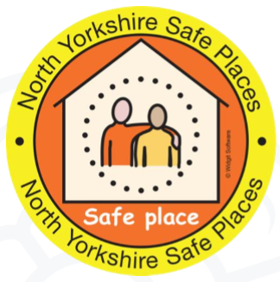  Tweet 3  If you or someone you know are a vulnerable adults who has been affected by #HateCrime and want to become a member of the North Yorkshire Safe Places Scheme you can phone: 03307 260260 or e-mail: safeplaces@spsdoorguard.com  Or visit https://www.northyorks.gov.uk/safe-places #HelpNotHateNY2021
NYSCP | Don’t stand for hate crimes, #HelpNotHateNY2021  https://www.youtube.com/watch?v=tdUUD7jcMVs  If you have been a victim of Hate Crime contact the Police on 101 or NYCC on 01609 780780.
NYSAB | Tweet 1  The Safe Places Scheme is community initiative that is nationally recognised. It is for people who may need more help and support to feel safe in their local community. For more information visit https://www.northyorks.gov.uk/safe-places #HelpNotHateNY2021  Tweet 2  If you or someone you know are a vulnerable adults who has been affected by Hate Crime and want to become a member of the North Yorkshire Safe Places Scheme you can phone: 03307 260260 or e-mail: safeplaces@spsdoorguard.com  For more information you can also visit https://www.northyorks.gov.uk/safe-places #HelpNotHateNY2021  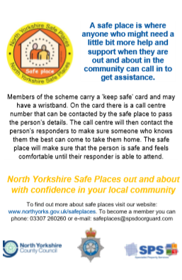  Resources from the North Yorkshire Learning Disability Partnership Board / Self Advocates will be shared via the NYSAB Twitter. Please share via your social media platforms
CYCSB | York’s Safe Places are located in libraries, cafes, shops and museums that are open to the public and accessible. They provide a safe and supportive space if someone who is vulnerable needs to ask for help while out and about.  https://www.yorkcvs.org.uk/safeplaces/  #HelpNotHateNY2021

