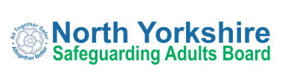

Annual Report 2020/21
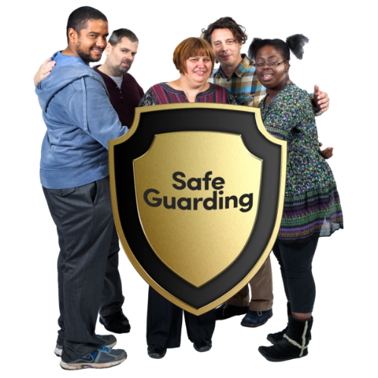

Easy Read Summary
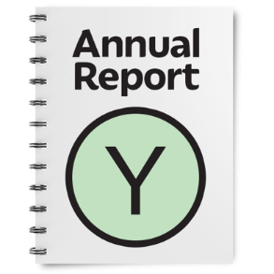 | This is the easy read summary of the annual report of the North Yorkshire Safeguarding Adults Board (NYSAB).
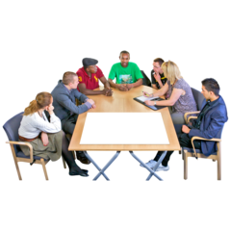 | This annual report tells you about the work that the NYSAB has done between 1st April 2020 – 31st March 2021.
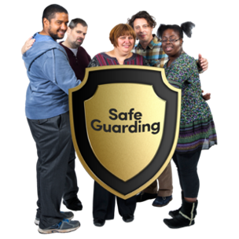 | The NYSAB works with other organisations in North Yorkshire to make sure that adults with care and support needs are kept safe.
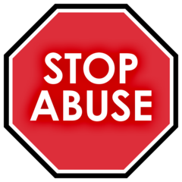 | Safeguarding means protecting people from abuse and neglect.
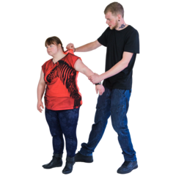 | Abuse is when someone does or says things that frighten you or cause you harm.  Neglect is when your care and support needs are not being met.
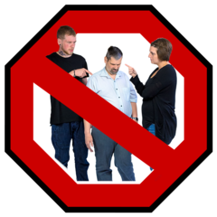 | Abuse and neglect are wrong.
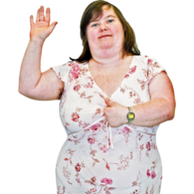 | People should be as independent as possible and make choices about how they want to live and still be safeguarded.
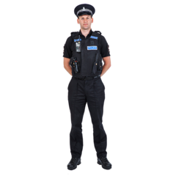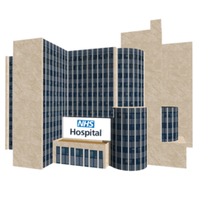  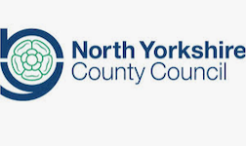  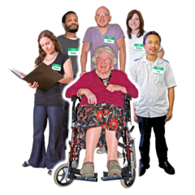 | The NYSAB is made up of lots of different organisations including the Police  Hospitals  North Yorkshire County Council  Health and care providers
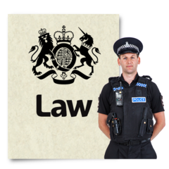 | The Board also has legal responsibilities – things they must do
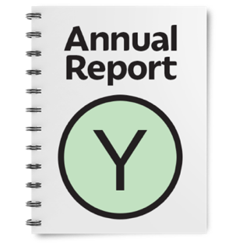 | One of these things is to write a report every year about what it has done. This is called an Annual Report.
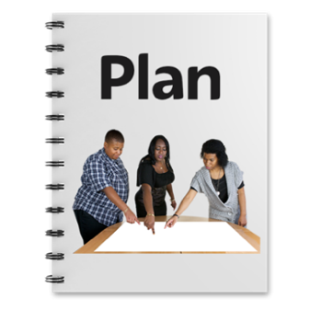 | The Board must also have a plan for what it will do for the next year to keep people safe.
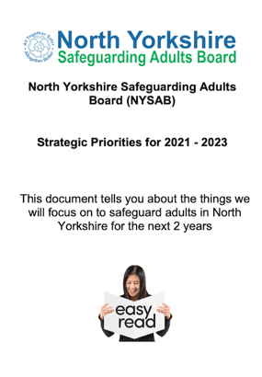 | You can find an easy read version and audio version of our plan for 2021 – 2023 on our website at https://www.safeguardingadults.co.uk/strategic-priorities
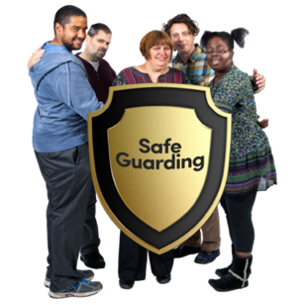 | All organisations have a duty to work together to keep people safe from abuse and neglect.
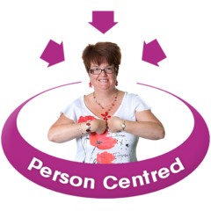 | We also want to make sure that adults who are abused or neglected are asked how they want to be kept safe in the future.  This is called ‘Making Safeguarding Personal’.  We want all of our partners to work this way too and tell us how they do this.

What the Board has done in 2020 / 21
Keeping People Safe During the Covid pandemic
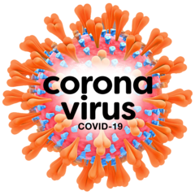 | This year the NYSAB and the organisations it works with have worked very hard to help people during the Covid pandemic.
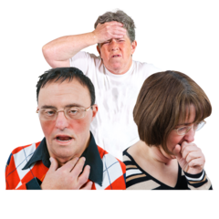  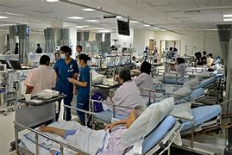 | Lots of people were very poorly because of Covid.  This meant hospitals and social care services were really busy.
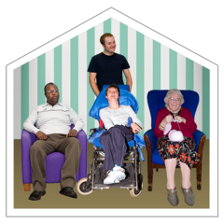 | For some this meant we had to change the way we cared for and supported people.
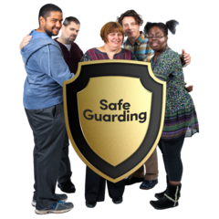 | Although there were changes it was still important that the people we care for and support were kept safe.
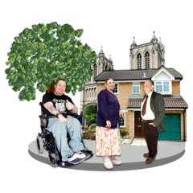 | We know that lots of people in communities looked out for their neighbours, friends and loved ones.
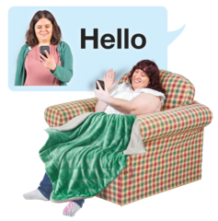  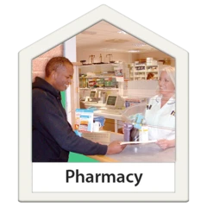  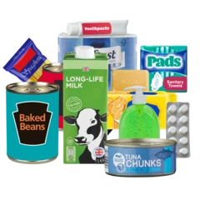 | They did things like:  - Do their shopping  - Collect medicine and prescriptions  - Take them to appointments  - Check on them to make sure they were okay.
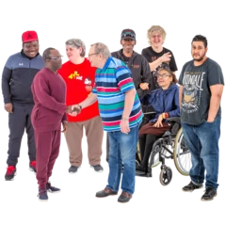 | This is a really kind thing to do.  Although the pandemic has been really hard, people have looked out for each other.
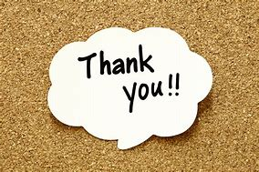 | We would like to say a BIG THANK YOU to everyone for looking after each other and making sure adults in North Yorkshire were kept safe.
What other things has the Board worked on in 2020 - 2021

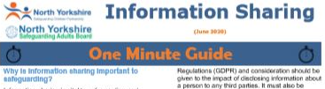  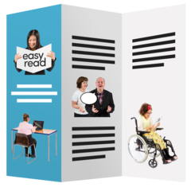  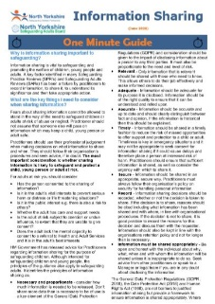 | We have made some One Minute Guides (OMGs).  These give information to professionals about different topics like information sharing.  We are looking at making accessible versions of these guides.
 | We carried out a safeguarding adult review about someone called ‘Anne’.
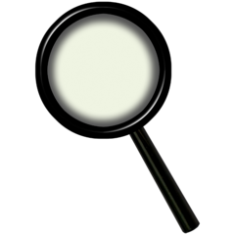 | A safeguarding adult review looks at what organisations could have done differently to stop someone from being harmed or dying.
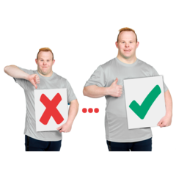  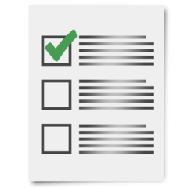 | The report made recommendations to the NYSAB and different organisations.  These recommendations tell us things we need to do and learn from to make sure other people are kept safe from harm.
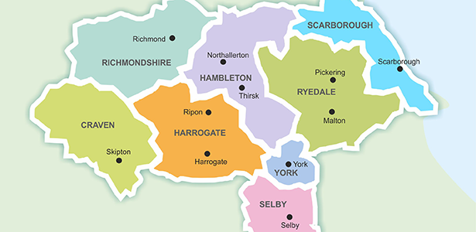  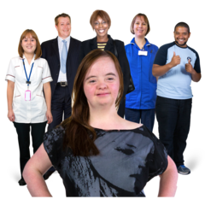 | At the beginning of 2021 we started to carry out an engagement project across North Yorkshire.  We have engaged with lots of people such as:  - Adults with care and support needs;  - Families, friends, carers and advocates;  - People who work in care and support like care home staff and residents;  - Local communities and people who are hard to reach
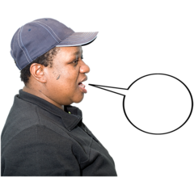  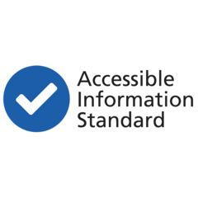 | We want to find out what people want to hear from us and how they want to hear from us.  But we also want to find out what people want to tell us and how they want to tell us.  We hope by engaging with lots of people we can do a number of things:  - Update the information we share with people so they know how to keep themselves and others safe  - Continue to look at ways we can work together to co-produce accessible information for all  - Make the way we engage with people across North Yorkshire better  - Listen to what people want and act on it
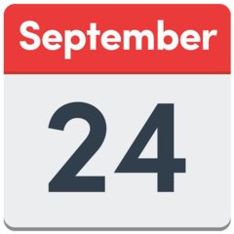  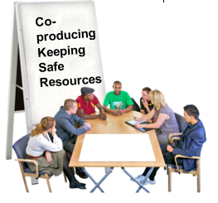 | This engagement work will finish in September 2021.  From the feedback people give us we will make some plans to improve the information we share and the way we engage.  We will work with people and communities across North Yorkshire to do this.

Safeguarding Week 2020
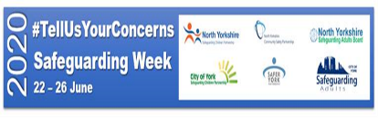 | Safeguarding Week took place in June 2020.
Because of COVID restrictions we couldn’t go out to meet people to talk about safeguarding.

Instead we shared lots of messages and information online and on social media.

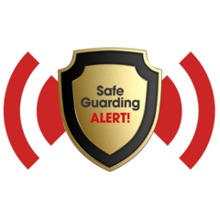 | People from the local authority, health, police and many others gave advice on what you should do if you or someone you know has been abused or neglected.
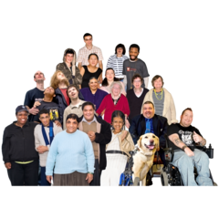 | Lots of people used the information we shared.  They said that they were very useful and there was a lot of helpful information to understand what to do to keep themselves and others safe.

What else did the North Yorkshire Safeguarding Adults Board do last year?
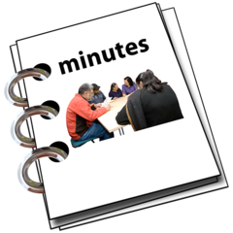 | We started to produce our Board meeting minutes in easy read format.  This way more people can access what the NYSAB are working on.  People told us they like the minutes in easy read format.  We hope this encourages other organisations to put make their minutes and information accessible too.
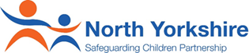  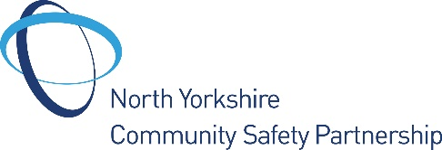 | We have worked really closely with the North Yorkshire Safeguarding Children Partnership and Community Safety Partnership.
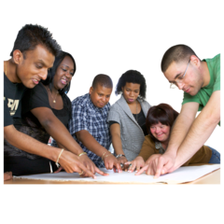 | Working together means we can share ideas and information with each other to help keep people safer in their areas.
What are we going to do in 2021 - 22
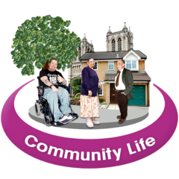 | We will continue to work closely with communities in North Yorkshire to keep people safe.
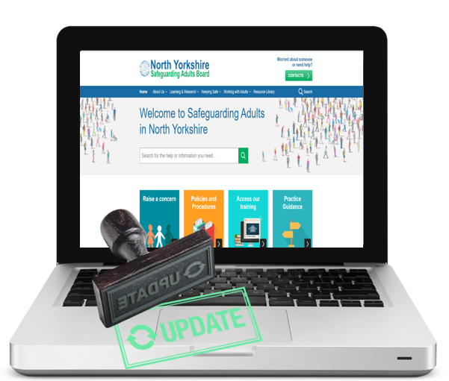 | We will be updating our website and keeping safe resources to make them more accessible.  We will be asking our partners to do the same and show us how they have done this.
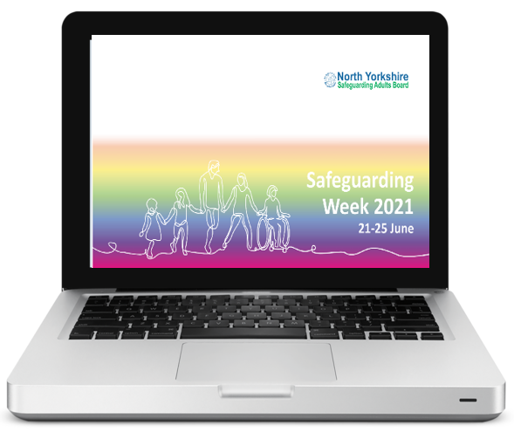 | We will host an online event for Safeguarding Week 2021 for professionals and members of the public.
We are going to look at developing training for members of the public.

We will also look at how self-advocates can help to co-produce this.

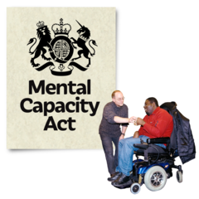 | We will be working with different groups in North Yorkshire to co-produce accessible information about the Mental Capacity Act and what that means for people.
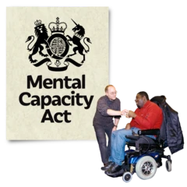 | The Mental Capacity Act is a law.  It puts some rules in place for people who are 16 years old or older and may not be able to make some decisions.  Examples of things they can’t decide may include:  - About where they live  - What support they may need  - How to manage their money
Dorset Advocacy have made a really helpful easy read guide about Liberty Protection Safeguards (LPS).

It also has information about the Mental Capacity Act.

You can find it here: https://www.dorsetadvocacy.co.uk/wp-content/uploads/2021/08/liberty-protection-Easy-Read.pdf

 | We will work with groups and communities to find new and accessible ways to share information with people to keep themselves and others safe from abuse and neglect.
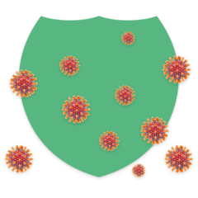 | We will be doing a lot of work to look at what we can learn from the coronavirus.  This will include supporting organisations and communities.
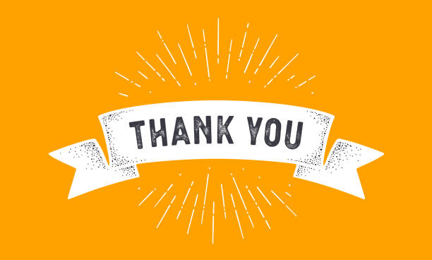 | We would like to say another BIG THANK YOU to everyone who has been involved with our work over the last year.
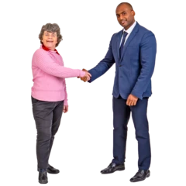 | We really look forward to working with you next year to continue to keep adults in North Yorkshire safe.

How to contact us about this report
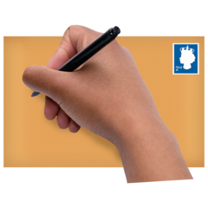  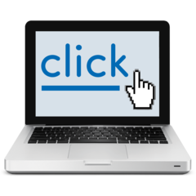 | You can write to us at: North Yorkshire Safeguarding Adults Board, North Block, Health and Adult Services, County Hall, Northallerton DL7 8DD  You can email us at: nysab@northyorks.gov.uk  You can visit our website at: www.safeguardingadults.co.uk
 | This easy read summary was made using Photosymbols

Copyright © 2021 North Yorkshire Safeguarding Adults Board

