This document tells you about the things we will focus on to safeguard adults in North Yorkshire for the next 2 years
North Yorkshire Safeguarding Adults Board (NYSAB)

Strategic Priorities for 2021 - 2023

Difficult words in this plan

We have done our best not to use difficult words in this document but some of the things we need to explain are hard to understand.

In this document difficult words look like this and you can find out what they mean here.

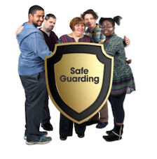 | Safeguarding is about working to make sure people are safe from harm and abuse.
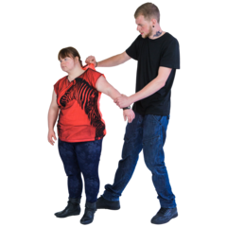 | Abuse is when someone hurts you or treats you badly.  Abuse can be done on purpose or by accident.  Abuse is never your fault.
 | Neglect is when someone who cares or supports you does not look after you properly and this causes you harm.
 | Principles are when people set out what is important and how things should be done.
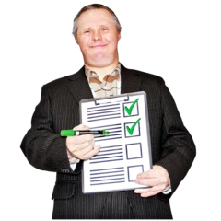 | Priorities are things that we need to do that are more important than others.
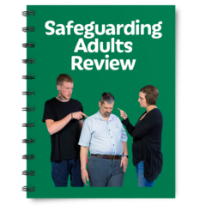 | Safeguarding Adult Review takes place when a person with care and support needs dies or has been seriously harmed through abuse or neglect.  A SAR is not about blaming organisations for doing something wrong.  A SAR is about learning about what we need to do to make things better.
 | Remember you can check back here when you find difficult words in our plan.
 | You can also use the North Yorkshire Learning Disability Partnership Board Word Bank.
 | The Word Bank tells you what lots of difficult words mean to help you understand information.
You can find the Word Bank here:

https://www.nypartnerships.org.uk/wordbank

North Yorkshire Safeguarding Adults Board (NYSAB)
What is the North Yorkshire Safeguarding Adults Board?

The Board is a group of people who work together to make sure that adults at risk in North Yorkshire are safe from harm, abuse and neglect.

People on the Board are from lots of different organisations.

The Board meet 4 times each year.

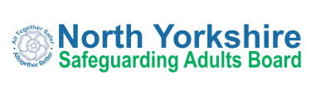  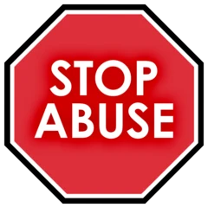 | What we want to achieve  We want people to be able to live safely and without harm in commununities which:  - do not allow abuse  - work together to stop abuse  - know what to do when abuse happens
What are strategic priorities

These are the key points that the Board wants to do over the next 2 years so people are safe from harm.

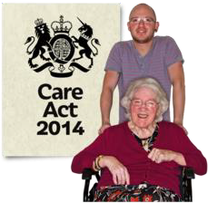 | Our 4 priorities are based on the the 6 principles from the Care Act 2014.  We think these principles are helpful and important.

What are the 6 Care Act Principles?

Principle 1 – Empowement

Empowerment is about making sure people have as many opportunities as possible to take control of their own lives.

Principle 2 – Prevention

Prevention is about doing something now to stop bad or difficult things happening in the future.

It is better to take action before things go wrong.

Principle 3 – Proportionality

Proportionality is a big difficult word.
It means giving enough help to keep people safe without going over the top.

Principle 4 – Protection

Protection is about supporting and representing people who are in need.

Principle 5 – Partnerships

Partnerships – this is when organisations join together so they can work on things for better results.

Principle 6 – Accountability

Accountability – this is about making sure everyone is working well and doing the things they should be doing.

Our Strategic Priorities

Priority 1

 | We want to work together with people who live and work in North Yorkshire to help keep people safe from abuse and neglect.
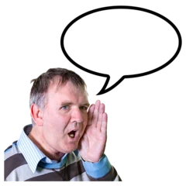  Speak up about abuse | We want to tell people three important things  - What abuse is  - How to speak up if you or someone you know is being abused  - How to report abuse
We also want people to tell us about their experiences.

We want to hear from people so we can listen to their ideas and experiences and make our services better.

By having good services this will help keep adults in North Yorkshire safe.
 | How we will do this
We will work together with people in North Yorkshire to talk about safeguarding.

This is called raising awareness.

Safeguarding is… | We will talk to people who live and work in North Yorkshire about what they can do to keep themselves and other people safe from abuse and neglect.
 | We will continue to co-produce information about safeguarding, abuse and neglect and share this with people.
 | We already have some easy read keeping safe books which tell people about abuse and safeguarding.
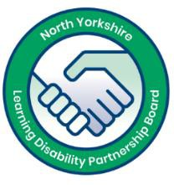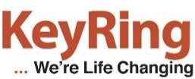 | These books were co-produced with the self-advocates and people told us they find them very helpful.
 | We have made these books in audio too so people can listen to the books.
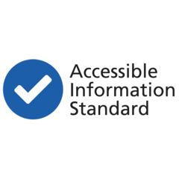 | We will ask other organisations to make their information accessible.
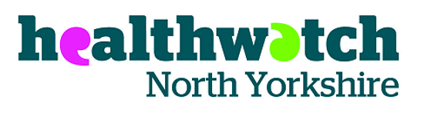 | We will work with Healthwatch to hear from people across North Yorkshire.
 | Healthwatch are an organisation who listens to people about their experiences with health and social care services.
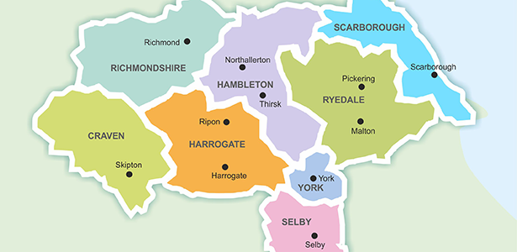 | We also have local groups across North Yorkshire in  - Hambleton and Richmondshire  - Harrogate and Craven  - Scarborough  - Selby  These groups are called Local Safeguarding Partnerships (LSPs).  Their role is to look at the important safeguarding issues in their areas.

Priority 2

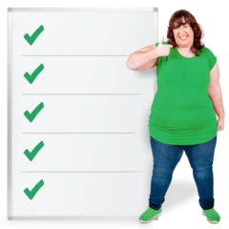 | Organisations in North Yorkshire need to follow rules and guides to make sure they can care for and support people in North Yorkshire in a safe way.
POLICIES AND PROCEDURES | These rules and guides are called policies and procedures.
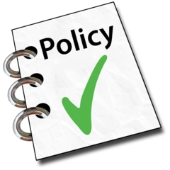 | We need to have excellent policies and procedures for organisations to follow so that we can keep adults safe.
 | How we will do this
We need to make sure that people are following the rules and guides.

We will ask our partners and organisations how they use the policies and procedures to keep adults safe.

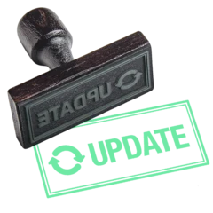 | Sometimes we will need to update our policies and procedures.  This means making them better.  We will look at our policies and procedures regularly and see what needs to be improved.
 | We also do this when we hear back from people who use our services.
Sometimes we need new policies and procedures.

We will work with our partners and people who use our services to make new policies and procedures.

 | We will share these with people on our website and talk to people about them.
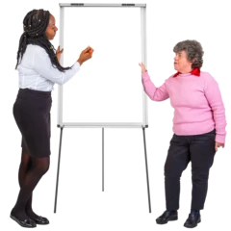  New  Policy | We will give training to people who work and volunteer in organisations so that they can understand the new policies and procedures.
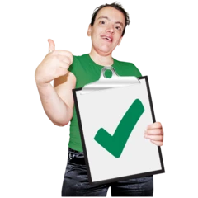 | We will always review our work to make sure it’s right.  This means checking the work people do to make sure it is making a difference.  We will also talk to people who work in and use our services to get their feedback.

Priority 3

 | Working together with other organisations helps us stop people being abused and neglected.
 | When we work together we can also make sure that organisations are doing the things they said they would to stop abuse.
 | How we will do this
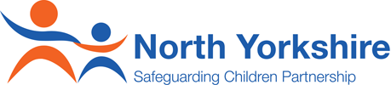  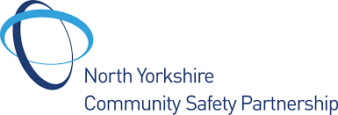 | We will work together with the North Yorkshire Safeguarding Children Partnership and the North Yorkshire Community Safety Partnership.
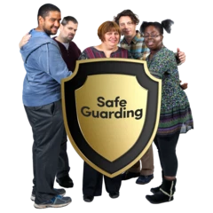 | Together we will work on important topics to raise awareness and keep people in North Yorkshire safe.
 | We will work with our partners to carry out safeguarding adult reviews.
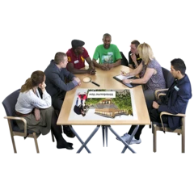  SAFEGUARDING ADULT REVIEW MEETING | As part of the safeguarding adult review organisations come together to see what they could have done differently to stop harm or to stop someone from dying.
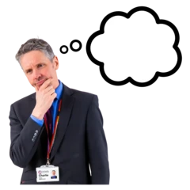  ?  Reviewer | A person called an independent reviewer will look at the case and review all of the information relating to the person who has died or been harmed.
Recommendations | When they have done this they will put what they have found out into a report and make something called recommendations.  Recommendations are things that the independent reviewer thinks that some or all of the agencies should do to make sure something like this does not happen again.
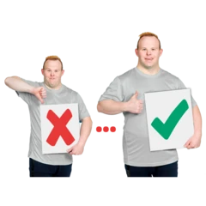 | We will ask our partners to tell us what changes they have made to make things better.

Priority 4

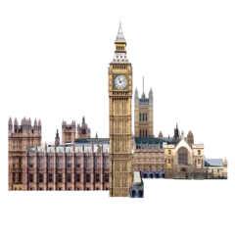  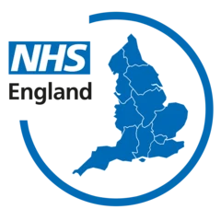 | Sometimes changes are be made by organisations like  The government and  The NHS
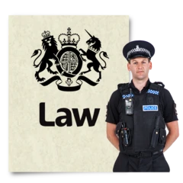  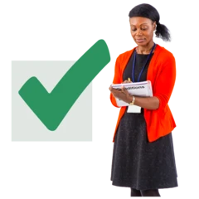 | These changes might be things such as:  - A new law  - A big review of a law to make it better  - Changes to the way we keep adults safe
When they make changes to health and social care the North Yorkshire Safeguarding Adults Board might need to make changes to.

This makes sure we are doing what other organisations want us to do to keep people safe.

 | How we will do this
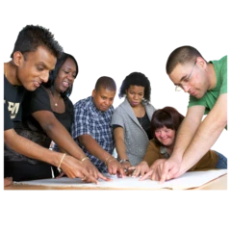 | When something changes we will work with other organisations to make a plan.  This plan will set out what we need to do and any changes we need to make to the way we work.
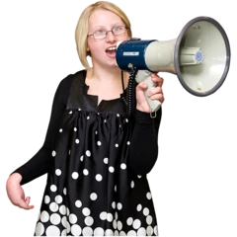 | When there are big changes we will tell people in North Yorkshire what these means for them.
 | Even when things change our job is to continue to keep people safe in North Yorkshire.

How to contact us about this document

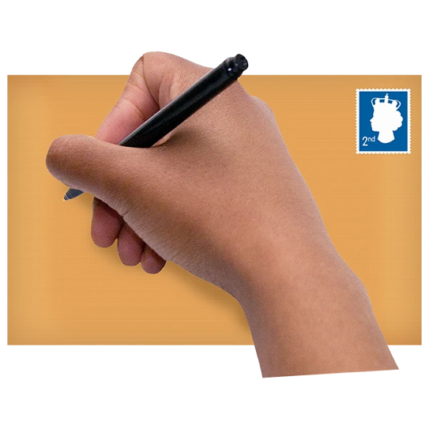 | You can write to us:  North Yorkshire Safeguarding Adults Board, Health and Adult Services, North Block, County Hall, Northallerton, DL7 8DD
You can email us:
nysab@northyorks.gov.uk

You can visit our website:
www.safeguardingadults.co.uk

You can follow us on Twitter
www.twitter.com/NYSAB1

 | This easy read guide was made using Photosymbols

Copyright © 2021 North Yorkshire Safeguarding Adults Board

