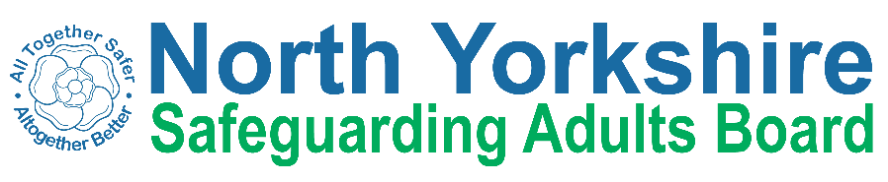

North Yorkshire Safeguarding Adults Board Full meeting minutes
 | Item
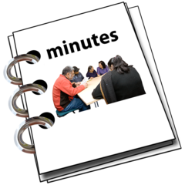 | These are the minutes for the North Yorkshire Safeguarding Adults (NYSAB) Board meeting on Wednesday 23rd June, 2021
 | This meeting took place as a video conference
This is because of coronavirus

The Government asked everyone to work from home and not have face to face meetings
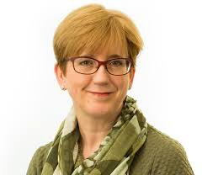 | 1. Welcome and Introductions  Sue Proctor, the Chair of the Board, welcomed everyone to the meeting.
Sue reminded everyone that todays meeting was being recorded.

This is part of the Safeguarding Week 2021 campaign.
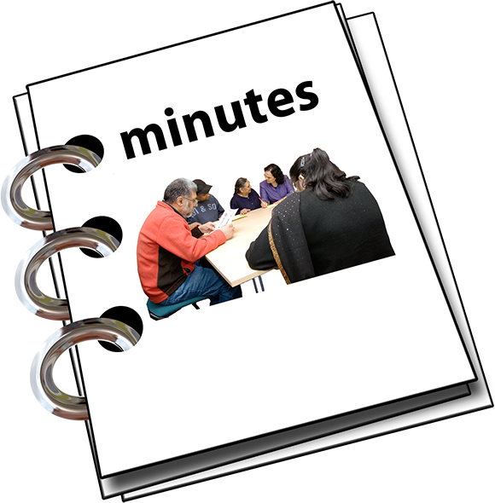 | 2. Previous meeting minutes  Everyone was happy with the minutes from the previous NYSAB meeting in March
3. Action log
The action log is a list of all of the things that members of the NYSAB have promised to do
 | Sue Proctor asked for updates on some of the actions of the log.
 | Most of the actions will be completed by the next Board meeting in September
 | It was agreed that action 2020 /15 can be closed

4. Response and Recovery to Covid-19
Sue Proctor asked for and additional updates to what is already in the Executive report.

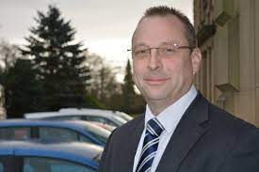 | Allan Harder gave an update on behalf of North Yorkshire Police.
Risk assessments were put in place regarding visiting people who are vulnerable.

The police continued to visit these people whenever it was required

 | There was a review of the risk assessments to see what worked well and what didn’t work well.
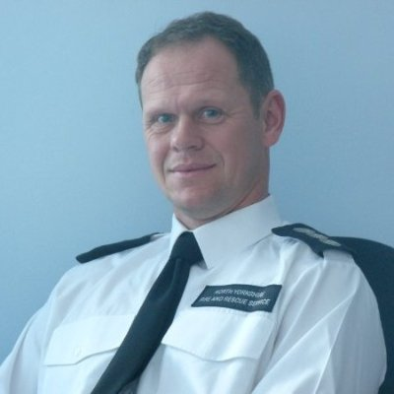 | Dave Winspear gave an update on behalf of North Yorkshire Fire and Rescue
 | Dave told the Board that the Covid-19 pandemic had given them lots of opportunities
Staff have been provided with training on child exploitation
Child exploitation is a type of abuse. When a child or young person is exploited they’re groomed by being given things, like gifts, drugs, money, status and affection.
This is usually in exchange for carrying out a criminal activity, known as Child Criminal Exploitation or performing sexual activities, known as Child Sexual Exploitation.

Dave told the Board that the next training course will be on PREVENT and dementia.

PREVENT is part of the government’s plan to stop people who are vulnerable to becoming terrorists or supporting terrorism.

A terrorist is someone who uses violence and threats to scare governments, countries and the people who live there.

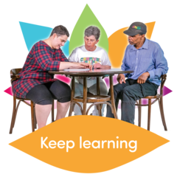 | A lot of learning has been delivery by the safeguarding team.  The training has been about the fire service so far.
 | Dave said they would also like to make the training available for other people who work in the fire service.
 | He said he is pleased how the fire service have managed their safeguarding responsibilities to keep people in North Yorkshire safe.
He also said the fire service has worked well in partnership with other organisations.

He would like this to continue and will look at how the fire service can continue to work in partnership.

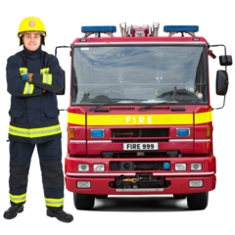 | He would like to encourage partners to request support from the Fire Service.
ACTION
The NYSAB team will talk to Dave and Hannah Oakley about the training the fire service offer and look to see if it could be offered to other partners.

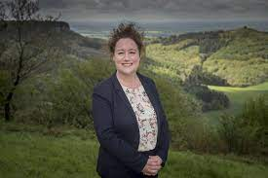 | Louise Wallace gave an update on behalf of Public Health
 | She told the Board that most of the Covid cases are among younger people.
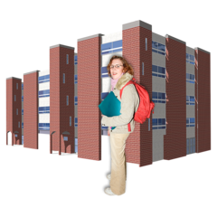 | The outbreaks have taken place in places like schools and colleges.
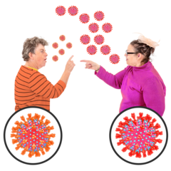 | Louise told the Board that people are still catching the virus in the community and in households.
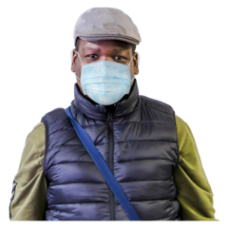  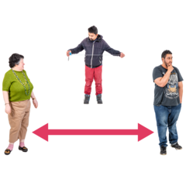 | She said that it is important that people get the vaccine.  She said that people should continue to wash their hands,  wear a face mask,  and keep their distance especially inside.
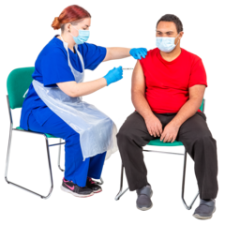 | The public health team are working hard to make sure everyone has access to the vaccine.  This includes people who are homeless.
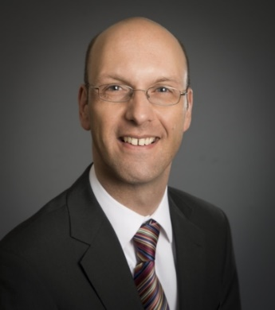 | Richard Webb gave an update on behalf of Health and Adult Services at North Yorkshire County Council
He told the Board that the number of safeguarding referrals is stable.

There has been a big increase in the number of people who need a mental health assessment.
 | A mental health assessment is a meeting to find out what help and support a person needs for their mental health.
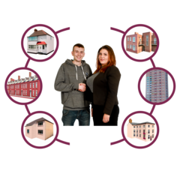  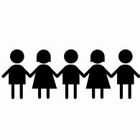 | Richard told the Board that there are some issues with housing.  There are also more complicated children’s cases
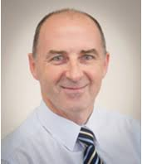 | Tony Clark is the Chief Executive of Richmondshire District Council.  He gave an update on behalf of the borough and district councils
He said there were no issues with homelessness and housing yet.
But this is expected.
Tony thinks there will need to be more focus on housing now.

Leisure facilities have opened up.

These will now be monitored again now they have re-opened
Action
Invite Dr Shacklock and Colin Dales, Chair of the Chief Housing Office Group, to the Board meeting in September to discuss the housing and homelessness situation in North Yorkshire.

 | Sue Peckitt gave an update on behalf of North Yorkshire Clinical Commissioning Group (CCG)
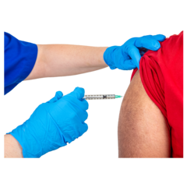 | The deadline to give people their first does of the Covid vaccine is 19th July.
Some vaccine clinics in North Yorkshire have had translators working in them.

Translators support people who may not speak or understand English and they may need things explained to them in the language they use to communicate.

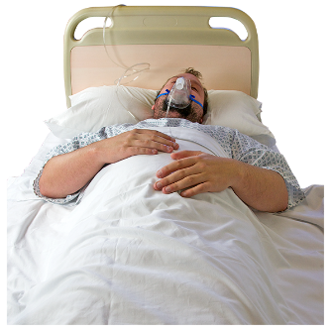 | Christine Pearson told the Board that more people are in hospital with Covid in North Yorkshire.
 | Katrina Uttley gave an update on behalf of Bradford and Craven CCG
There has been an increase in the number of people accessing Primary Care

Primary Care includes GP doctors and some community services who will offer advice.

Katrina told the Board that GPs and Nurse Practitioners have been doing their training online.
The feedback has been really positive.
 | Bradford District and Craven CCG continue to advise people to get their Covid vaccine.
 | Sarah Turner gave an update on behalf of Bradford Hospitals Foundation Trust
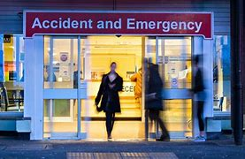 | Sarah told the Board that the accident and emergency (A&E) departments at the hospitals are very busy.
Airedale Hospital now has an Independent Domestic Violence Advocate (IDVA)
An IDVA supports and helps people who may be experiencing domestic abuse.
The IDVA at Airedale Hospital has had a very positive impact on patients.

 | Karen Agar gave an update on behalf of Tees, Esk and Wear Valleys Foundation Trust (TEWV)
Karen agreed with others that there has been an increase in the number of people needing mental health services.

She also highlighted the impact of the pandemic on people working at TEWV and other settings.

They are physically and mentally exhausted.

Sue Proctor said this has been discussed at the Executive and Board before. It is something that the Board are very aware of.
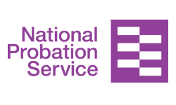 | Louise Johnson gave an update on behalf of the National Probation Service (NPS)
The main thing Louise wanted to update the Board on was that the National Probation Service and Community Rehabilitation Services will come together for 25th June 2021

The National Probation Service and Community Rehabilitation Services support and supervise people who have been in prison when they go back in to the community.
It will make communication much easier and simpler.
It will also make working together stronger.

It will also make safeguarding a high priority.

A priority is something that is more important that other things.

Louise also told the Board that a new accommodation plan has been launched.

This will help improve how quickly organisations respond to situations and the people they support who may be homeless.

 | James Parkes gave an update on behalf of the North Yorkshire Safeguarding Children Partnership.
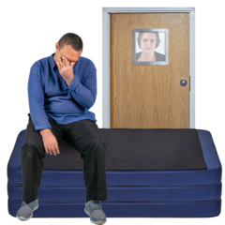 | James agreed with the comments other Board members had made about mental health.
He told the Board that lots of work had been done around hidden harm.

The NYSCP did a campaign where they asked people in local communities to signpost people to services and support if they were worried about a child or young person.

James thanked partners for the joint working.
He also thanked partners for looking out for children and their families.
5. Report from Executive
The report from the Executive was noted

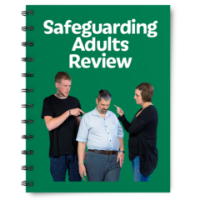 | Louise told the Board that the Learning and Review group had been working hard on the Safeguarding Adult Review (SAR) policy.
A safeguarding adult review is a process that happens when someone has died or has been seriously harmed because of abuse or neglect

It is often called a SAR.

The reason we have SARs is so we can identify lessons that can be learnt.

This means lots of different agencies and organisations working together to learn why things went wrong.

The review will tell them what actions they need to take so they can improve to make sure things like this don’t happen again.

A SAR is about learning.

It is not about blaming people or organisations

 | The new SAR policy is very clear on what a SAR is for and what it is not for.
 | There is also information about how families and relatives will be involved in the SAR process, if they want to be.
 | It also outlines the process of a SAR so people know what happens during the review.
The SAR policy will be reviewed by the
Learning and Review group in January.

The Executive will then review the policy in May 2022.

The Board approved the SAR policy.
ACTION

Helen Hart will give an update to the Board in December about how the Independent Domestic Violence Advocates (IDVAs) are working out in Bradford District and Craven CCG.

6. NYSAB Strategic Priorities 2021-23

The new strategic priorities were noted.

Sheila told the Board that some things had been added to the priorities.

 | Priority 3 includes now includes reviewing the recommendation around housing from the ‘Anne’ SAR
 | Priority 4 now includes learning from others.
 | Sheila explained that the priorities will be reviewed as part of the Development Day.
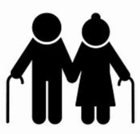 | Richard asked if we should include something specific about supporting older people and younger people.
 | He also asked if we could have a plain English version of the priorities for the public.
 | Sue and the Board agreed to both of Richard’s suggestions.
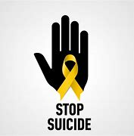 | James asked if suicide prevention should be included in the priorities
 | It was agreed that suicide prevention would be added to priority 3 which is about partnership working.
 | The Board agreed the strategic priorities.
Actions

Sheila will update the priorities to include the areas the Board discussed.

Laura will put the strategic priorities into a plain English document for the public.

7. Delivery Plan
Sheila presented the SAB risk register to everyone.
A delivery plan tells everyone what goals the NYSAB wants to achieve over a year.
 | Sheila told the Board that there were still challenges around the Local Safeguarding Partnerships groups (LSPs)
 | Some of these challenges have been because people have not been able to attend or be involved due to the pandemic
A meeting between Sue Proctor and the LSP Chairs will take place in September.

They will discuss the role and arrangements for the LSPs.

 | Sue will feedback to the Board when this meeting has taken place.
8. Risk Register
The risk register was noted.
A risk register lists all of the things that could cause problems for the NYSAB when they work through their delivery plan
Each risk is given a colour
Red is for an action that has a lot of risk and needs a lot of work
Amber is for an action that doesn’t have a lot of risk but still needs work
Green is for an action that has no risk.
Green risks can sometimes be taken off the register.
The risk for communication and engagement work is red.

This is because the Board thought there was a lot of risk because we haven’t been able to engage how we wanted because of the pandemic.

 | Sue said that she thought the engagement and communication work had been excellent.
She said we have done it differently because of the pandemic but we have still done a lot of work.

She said that the risk should be changed to amber.

The Board agreed with this.
Sue suggested that the risk about partners engaging and taking part in the Board is changed from red to amber.

Partners have engaged a lot with the work of the Board and its work.

The Board agreed to this.

9. Mental Health-Related Demand as a Result of the Pandemic

It was agreed that this item would be discussed at the NYSAB Development Day in November.
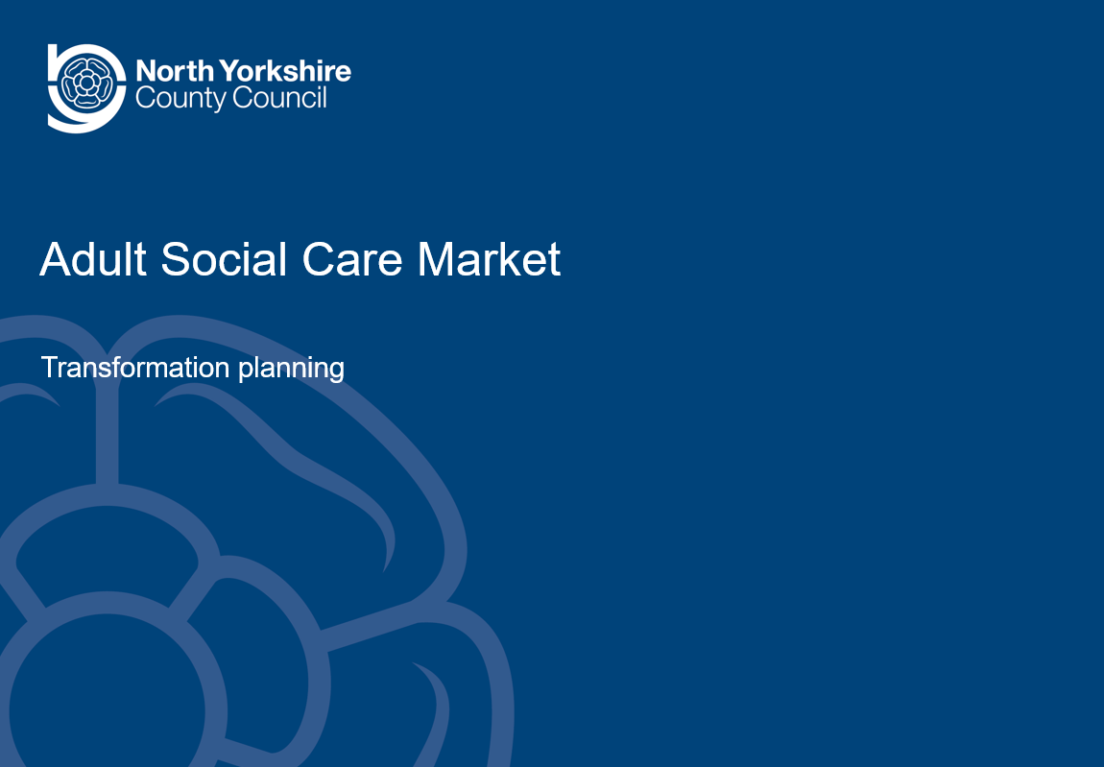 | Item 10 – Care Market Sustainability  Abi Barron, Head of Countywide Commissioning at NYCC gave a presentation on Care Market Sustainability.
The recording of this presentation can be found here on the NYSAB website:

https://safeguardingadults.co.uk/wp-content/uploads/2021/06/NYSAB-meeting-Item-10-Care-Market-Sustainability-23-06-21.mp4
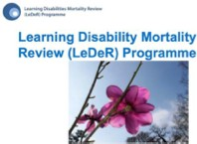 | Item 11 – LeDeR Position Statement  The position statement was noted.  Christine Pearson highlighted the following parts from the report:
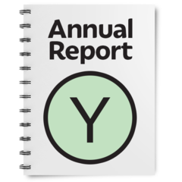 | The LeDeR annual report is complete and will come to the Board in September
All of the reviews on the old system were completed by the end of March

Christine told the Board that that there is a new national policy for LeDeR reviews

 | This means from September 2021 LeDeR reviews will be open to all people with autism and not just people with a learning disability and autism.
Sue Proctor said that we should review deaths of adults with other conditions.

Other conditions such as Attention Deficit Hyperactivity Disorder which is often called ADHD.

These are sometimes called neuro-diverse conditions.
Other examples include:

- Dyspraxia
- Dyslexia
- Autism and;
- Tourette’s Syndrome

By not reviewing deaths of adults with neuro-diverse conditions we have a gap in our knowledge.

Action
Sue Peckitt talk to NHS England colleagues about the possibility of reviewing the death of adults with ADHD and other neuro-diverse conditions
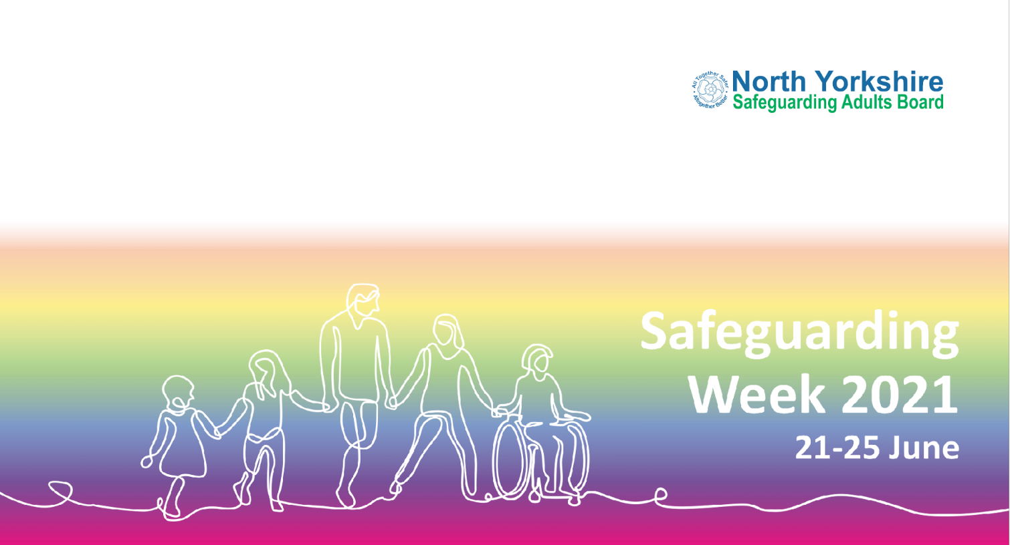 | Item 12 – Current Issues  Sue Proctor asked Sheila and Laura if they would like to update the Board on the activity around Safeguarding Week
Laura told the Board that engagement with the campaign had been brilliant.

She also said people did a very good job before the campaign to promote it

Laura told the Board that it was important people continue to raise awareness after Safeguarding Week.

She asked that they support all other awareness raising campaigns and activity throughout the year.

Sheila said this year we have had much more time to plan.

Sheila said a big thank you to Laura for all of her work and enthusiasm on Safeguarding
Week

Sue Proctor said thank you to Laura and thank you to Allan Harder and Clare Burborough for all of the work they did for safeguarding week.

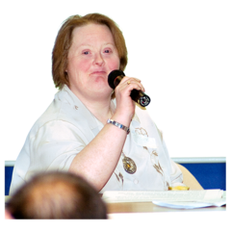 | Allan Chairs the Safeguarding Week planning group.  Clare organizes communications with her colleague Maeve Chappell.
 | Sue said although the campaign took place on line it still felt real because people had been very creative.

Independent Chair | North Yorkshire Police
Sue Proctor | Allan Harder
North Yorkshire County Council | North Yorkshire Fire Service
Richard Webb | Dave Winspear
Louise Wallace
Sheila Hall
Abigail Barron | Health Trusts and CCGs
Aurelie Redpath | Sue Peckitt (NY CCG)
Sarah Abram | Katrina Uttley (BD&C CCG)
Laura Watson | Christine Pearson (NY CCG)
Joseph Smith | Karen Agar (TEWV)
North Yorkshire Safeguarding  Children Partnership (NYSCP) | Sarah Turner (Bradford NHS FT)
James Parkes
 | Borough and District Councils
Services | Tony Clark (Richmondshire)
Louise Johnson (Probation)
Caroline O’Neill (Community First Yorkshire)
Apologies
Annette Anderson, Olwen Fisher, Helen Hart, Elizabeth Moody, Chris Jones-King, Erin Outram, Ashley Green

