Training Courses and Online Learning
Private, Voluntary and Independent Sectors

April 2022 – March 2023

If you have any questions or require any further support with any information contained within this booklet, please contact Training and Learning; 01609 798010 or trainingandlearning@northyorks.gov.ukContents
- Introduction
- Target Audience
- How to book Classroom Training
- Cancellation and Non-attendance charge
- Course Index
- Classroom Courses
- Online-Learning Courses
- How to self-register for a Learning Zone login and How to get an organisation subscription Code

Introduction
The training advertised in this booklet is for those working within North Yorkshire in the Private, Voluntary and Third Sector Organisations.
Target Audience
The following training is specifically for small and medium- sized businesses and non-profit organisations working within the Adult Social Care Sector in North Yorkshire.
How to book Classroom training
To request a place on a training course or to check dates and locations please log onto the NYCC Learning Zone.
If you are not registered on the NYCC Learning Zone, please see APPENDIX 1 page 13
Cancellation and Non- Attendance Charge
Training and Learning have a cancellation charge of £50 per person, *per course to all external partners accessing training. This will apply to those delegates that do not turn up on the day and those persons cancelling their place on a course with less than 1 weeks’ notice. If a substitute attends this charge will not apply.
*For courses of more than one days duration a charge will be made for each day not attended

Course Index
Training Event Index:
- Deprivation of Liberty Safeguards (DoLS) – Registered Managers / Deputies / Team Leader
- Intermediate Mental Capacity Act 2005
- Mental Capacity Act: Complex Decision Making Part 1 for Experienced Practitioners and Managers
- Mental Capacity Act Complex Decision Making Part 2: Best Interests decisions and Best Interest meetings
- Moving and Handling Training Basic Introduction
- Moving and Handling Leads Training
- Moving and Handling Reablement
- Safeguarding Adults Raising a Concern
- Safeguarding Adults Level 2 Safeguarding Concerns Manager
- Safeguarding Champions Raising a Concern
- Safe Handling of Medicines – Residential Care
- Safe Handling of Medicines – Domiciliary Care
- Supporting Individuals (age 16+) to make decisions within the Mental Capacity Act
Online-Learning Index:
- Autism Awareness
- Autism and Communication
- Autism and Mental Health
- Back care refresher – for those whose role includes the moving and handling of children and adults
- Deprivation of Liberty Safeguards (DoLS)
- Dementia Awareness
- Equality and Diversity Essentials
- Fire Awareness for Residential Care
- Food Safety & Nutrition in the Care Sector
- LGBT Awareness - Meeting the needs of older lesbian, gay, bisexual and transgender people using Health & Adult Services
- Mental Capacity Act
- Covid-19 and Personal Protective Equipment
- Safeguarding Adults under the Care Act
- Safe Handling of Medication Domiciliary Care
- Safe Handling of Medication Residential Care
- Sepsis Awareness

Learning Zone Registration Instructions

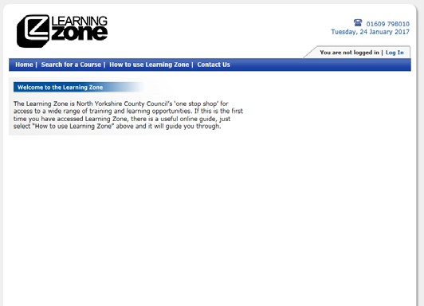
Before you can start any learning you need to register to use the Learning Zone. To do this please follow the instructions below.
Go to the Learning Zone web address:
https://www6.northyorks.gov.uk/LZCS/home

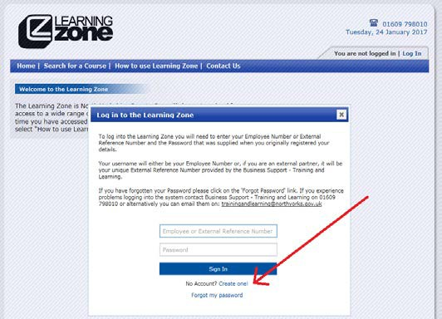
Click on the Log In tab in the top right
hand corner, and a login box appears.
Since you don’t have an account,
click “Create One!” near the bottom.

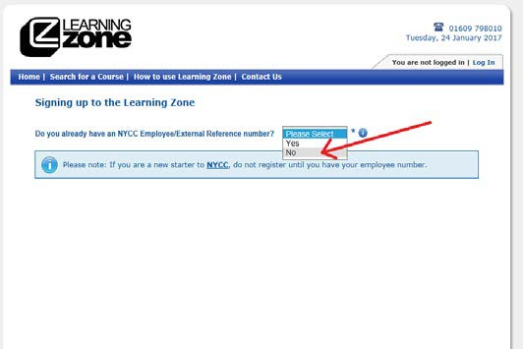
As you are not a NYCC employee, select No
from the drop down box.

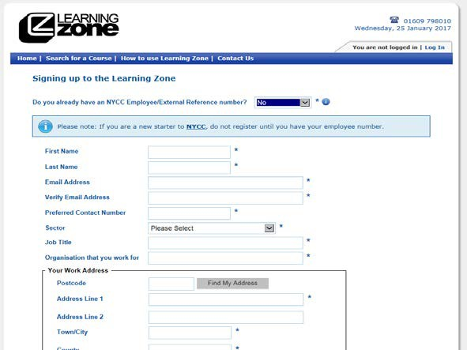
You will see that a form now
appears below.

Continue as follows.
First Name and Last Name
Email Address - This is important because your User name for the Learning Zone will be sent to you by email. If you do not have an email address, ask us for help.
Verify Email Address
Sector - From the drop down box, select “The Relevant Sector”
Job Title - Enter Your Job Title
Organisation that you work for - Enter the Organisation that you come under
Work Address - Enter the postcode of the above Local Authority then click Find My Address. Look down the list of addresses that appear, then click when you find the address, as in this example:
When you click, it will automatically fill in the address. You can correct anything that’s come up wrongly by clicking in each box and Changing what’s typed there.
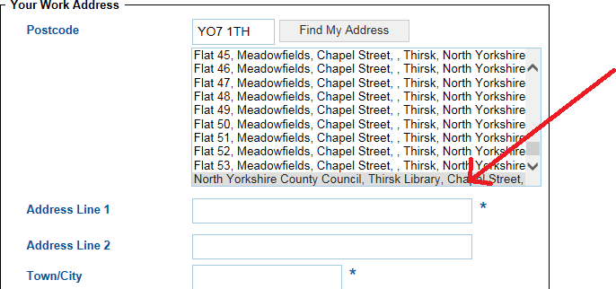

Is the billing address the same as your work address? Tick the Yes box
Do you have a disability? Select Yes or No from the drop down box as appropriate

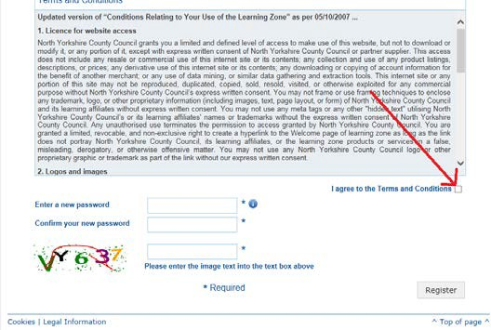
Terms and Conditions Read the
Terms and Conditions and tick the
‘I agree to the Terms and Conditions’
box.

Enter a new password and Confirm your new password
Decide on a password. It can be anything you want. The password MUST be between 7 and 15 characters long and contain at least 1 number, as well as a combination of capital and lower case letters (a-z, A-Z). Then in the second box, re-enter your chosen password to make sure you entered it accurately.

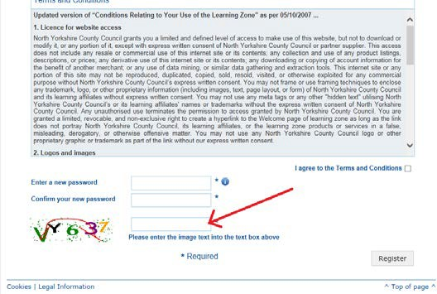
Enter the characters in the image into text
box indicated below, type the coloured
letters and numbers that appear
slightly jumbled on the left.

Click on Register.

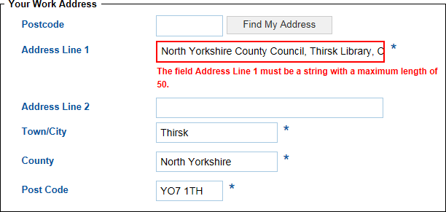
If there is an error like this one:
That means that there is too much text in
that box, you may need to look at ways
to shorten the number of characters in the
address.

You will need to type in the coloured Letters and numbers again (they will be different!)
Then click Register again.
There may be other errors that come up highlighted in red. You will need to correct each one before your registration goes through.

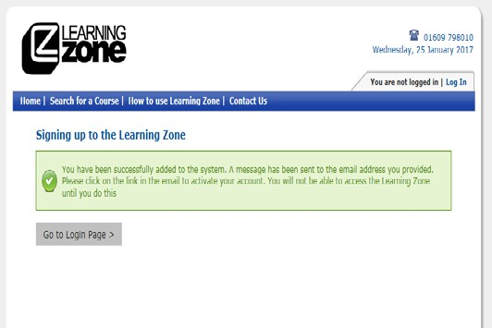
When your registration is finished,
you will see this screen:

You have now registered for a Learning Zone account.
The Learning Zone will send you your username and a reminder of your password to your email address. In our experience, you should receive the email within a few minutes. You will need to click on the link in the email to activate your Learning Zone account.
Keep your username and password in a safe place - you will need it every time you log in to the Learning Zone.
To access the training outlined above please enter your unique organisation subscription under ‘Activate Training Here’.
Please note this code is unique to the setting and must not be shared with any other providers.
You will now be able to book onto the assigned courses, and download certificates. When you book on a course you will be asked to enter a code, if you do not have your organisation code please contact Training and Learning on 01609 798010, or email trainingandlearning@northyorks.gov.uk.
If you experience any technical problems when using the Learning Zone, please telephone the support line on 01609 798010, or email trainingandlearning@northyorks.gov.uk.

