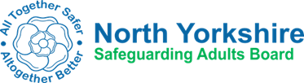

Dear
Re: Name: DOB/DOD: Address:
I am writing to inform you that the North Yorkshire Safeguarding Adults Board has decided that a Safeguarding Adult Review will be undertaken. It will investigate and review the involvement of agencies into the health and social care support received by xx prior to her/his death.
Safeguarding Adult Reviews are undertaken when a vulnerable adult dies or is seriously harmed and abuse or neglect is suspected and there are lessons to be learned about the way agencies have worked together to prevent similar deaths or injuries in the future. A Safeguarding Adult Review looks at how local agencies and organisations have worked together to provide services and is completely separate to any investigation being undertaken by the police or Coroner.
If your agency has had involvement you are likely to be required to be involved in the Safeguarding Adult Review. Your agency may be required to submit documentation and nominate a representative to sit on the Safeguarding Adult Review Panel, or alternatively you may be asked to participate in a Case Group or Review Group. This will all be explained once we have the information.
I look forward to hearing from you shortly to enable the Safeguarding Adult Review Panel to be set up.

Yours sincerely

Independent Chair
North Yorkshire Safeguarding Adults Board

