**SAFEGUARDING ADULTS REVIEW (SAR)**

**Decision Support Guidance**

**Introduction**

There is a need to apply and demonstrate a consistent approach to decision making in relation to Safeguarding Adults Reviews notifications. This decision support guidance has been developed specifically to be used by the SAR subgroup when considering SAR notifications.

**The Care Act 2014**

The Care Act 2014, which came into force in April 2015, created a new legal framework for Adult Safeguarding. This included outlining the circumstances in which Safeguarding Adults Boards (SABs) must arrange a Safeguarding Adults Review (SAR). The Care Act further placed a duty on all Board members to contribute to the undertaking of such reviews.

The purpose of undertaking a SAR is to determine what the relevant agencies and individuals involved in the case might have done differently that could have prevented harm or death. This is so that lessons can be learned from the case and those lessons applied to future cases to prevent similar harm occurring again. The Care and Support Statutory Guidance issued under the Care Act by the Department of Health also suggests that SARs may be used to explore examples of good practice where this is likely to identify lessons that can be applied in future practice.

**Criteria for Safeguarding Adults Review**

The Care Act 2014, Section 44 requires that Safeguarding Adults Boards (SABs) must arrange a Safeguarding Adults Review (SAR) when an adult in its area with needs for care and support (whether or not the local authority has been meeting any of those needs):

* an adult in the NYSAB area has needs for care and support (whether or not the local authority was meeting any of those needs).

and

* either dies, and the NYSAB knows or suspects that the death resulted from abuse or neglect (whether or not it knew about or suspected the abuse or neglect before the adult died)

Or

* does not die but the NYSAB knows or suspects that the adult has experienced significant harm.

and

* There are concerns about how agencies worked together to safeguard the adult

The Care Act also states that SABs ‘are free to arrange a SAR in any other situations involving an adult in its area with needs for care and support‘.

**Serious Types of Abuse**

The following table indicates the types of abuse that are considered to be serious in nature and relevant to decision making in relation to SARs.

|  |  |  |  |
| --- | --- | --- | --- |
| **Types of Abuse** |  |  | |
| Discriminatory | • | Being refused access to essential services. | * Hate crime resulting in attempted murder/murder |
| Domestic Abuse | • | Permanent harm or death due to a lack of response to alleged abuse  domestic abuse | * Honour based violence * Please also refer to other categories of abuse; physical, neglect and sexual * Female Genital Mutilation (FGM) |
| Financial | • | Misuse/misappropriation of property or possessions of benefits by a person in a position of trust or control. | |
|  | • | Adult denied access to his/her own funds or possessions. | |
|  | • | Fraud/exploitation relating to benefits, income, property or will. | |
| Modern Slavery | • | Incidents of modern slavery resulting in serious injury or death | |
| Neglect and Acts of Omission | • | Ongoing lack of care to the extent that health and well-being deteriorate significantly, for example: pressure wounds, dehydration, malnutrition | |
|  | • | Failure to arrange access to life saving services or medical care | |
| Organisational | • | Staff using their position of power over adults in their care | |
|  | • | Over-medication and/or inappropriate restraint used to manage behaviour | |
|  | • | Widespread consistent ill-treatment | |
| Physical | * Inexplicable marking on a number of occasions |  | * Grievous bodily harm/assault with or without weapons * Inexplicable fractures/injuries * Inappropriate restraint |
| Psychological/ Emotional | • | Denial of basic human rights/civil liberties in a care/ health setting Vicious/personalised verbal attacks | |
| Self-Neglect | • | Permanent harm or death due a lack of response to reported and/or suspected self-neglect | |
| Sexual | • | Sex in a relationship characterised by authority inequality or exploitation | |
|  | • | Sex without consent (rape) | |
|  | • | Sexual acts against adults as listed in the Sexual Offences Act 2003 | |

**Multi-Agency Working**

When considering a SAR notification (SAR01) the SAR subgroup will need to establish if there were failings from a multi-agency or single-agency perspective. It is important that consideration is given to the increasingly complex landscape of the commissioning and provision of services.

**Safeguarding Adult Review (SAR) - Decision Making Process**

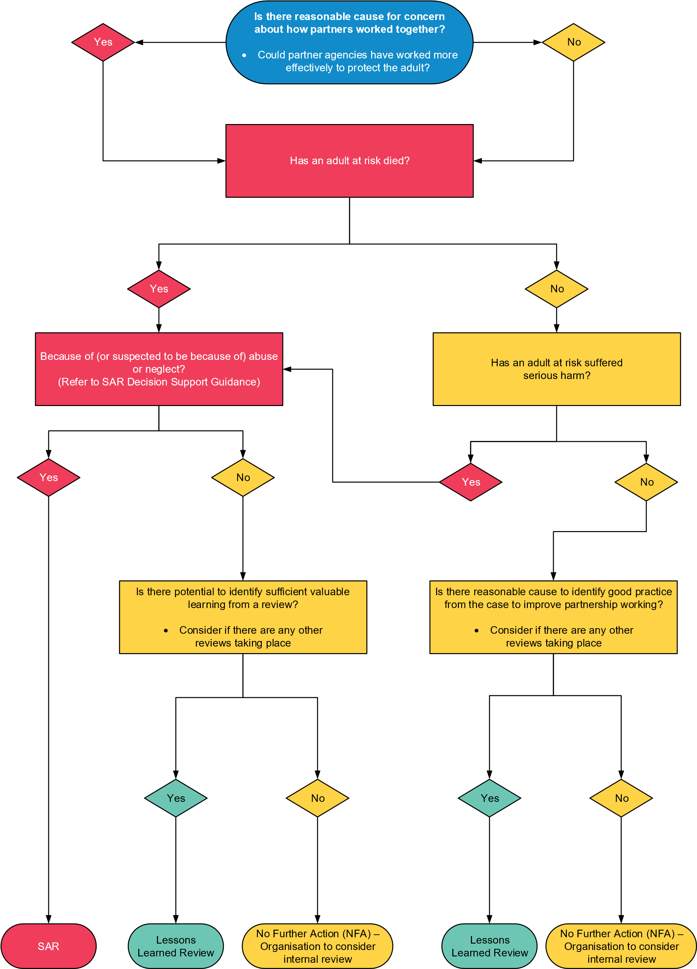

**Types of Review and Methodologies**

The Safeguarding Adults Board should weigh up what type of review process will promote effective learning and improvement to practice. The following principles should be applied when making this decision:

* The approach taken to review a case should be proportionate according to the scale and level of complexity of the issues being examined
* Reviews of serious cases should be led by individuals who are independent of the case under review
* Professionals should be involved fully in reviews and invited to contribute their perspectives without fear of being blamed for actions they took in good faith
* Families should be invited to contribute to reviews. They should understand how they are going to be involved and their expectations should be managed appropriately and sensitively
* The Board should aim for completion of a SAR within a reasonable period of time and in any event within six months of initiating it, unless there are good reasons, for example because of potential prejudice to related court proceedings.

**MENU OF OPTIONS FOR SAR METHODOLOGY**

The menu of SAR methodologies set out below includes the following five options:

A Systems analysis

B Learning together

C Significant incident learning process

D Significant event analysis/audit

E Appreciative inquiry

On the following pages, a process map of each methodology is provided, along with key features and advantages and disadvantages to assist decision-making. Links are provided to identified available models, which can be used for the most part to download tools and guidance in order to conduct a SAR according to the methodology.

The menu is not an exhaustive list. The SAR Panel members should use its collective experience and knowledge to recommend the most appropriate learning method for the case (including hybrid approaches).

**Option A: Systems Analysis**

|  |  |
| --- | --- |
| **Key features** |  |
| * Team/investigator led * Staff/adult/family involved via interviews * No single agency management reports * Integrated chronology | * Looks at what happened and why,   and reflects on gaps in the system to identify areas for change |



Themes, solutions and achievable recommendations identified → SAR report

Order contributory factors by importance/impact

Analysis to identify contributory factors (service user/ team/management/systems/organisation conditions)

Identify Care/ Service Delivery Problems (specific actions/omissions/slips/lapses in judgement by staff/ volunteers)

Determine the chronology/ story of the incident

Identify and gather relevant data (eg documents, interviews, records, logs etc.)

Choose investigator-led or reviewing team-led model.

Agree interface with SAR panel.

|  |  |
| --- | --- |
| **Advantages** | **Disadvantages** |
| * Structured process of reflection * Reduced burden on individual agencies to produce management reports * Analysis from a team of reviewers may provide more balanced view * Managed approach to staff involvement may fit well where criminal proceedings are ongoing * Enables identification of multiple causes/contributory factors and multiple causes * Range of pre-existing analysis tools [available](http://www.nrls.npsa.nhs.uk/resources/collections/root-cause-analysis/) * Focusses on areas with greatest potential to cause future incidents * Based on thorough academic research and review * RCA tried and tested in healthcare and familiar to health sector SAPB   members. | * Burden of analysis falls on small team/ individual, rather than each agency contributing its own analysis via a management report. May result in reduced single agency ownership of learning/actions * Staff/family involvement limited to contributing data, not to analysis * Potential for data inconsistency/ conflict, with no formal channel for clarification * Unfamiliar process to most SAPB members * Trained reviewers not widely available * Structured process may mean it’s not light-touch * RCA may be more suited to single events/incidents and not complex multi-agency issues |

**Option B: Learning Together**



Underlying system patterns identified and “challenges to the Board” (not recommendations)

Key practice episodes identified, and analysed to identify contributory factors

“Narrative of multi-agency perspectives” produced (not a chronology)

In depth discussion with case group (includes staff/adult/family)

Data and information gathered and reviewed, including via 1:1 conversations with staff/ family (not interviews)

One or two lead reviewers, and a case group identified and prepared. Interface with SAR panel agreed

Research questions rather than fixed terms of eference are identified



|  |  |
| --- | --- |
| **Advantages** | **Disadvantages** |
| * Structured process of reflection * Reduced burden on individual agencies to produce management reports * Analysis from a team of reviewers and case group may provide more balanced view * Staff and volunteers participate fully in case group to provide information and test findings * Enables identification of multiple causes/contributory factors and multiple causes * Tried and tested in children’s safeguarding * Pool of accredited independent reviewers available, and opportunity to train in-house reviewers to build capacity * Range of pre-existing analysis tools available | * Burden of analysis falls on small team/ individual, rather than each agency contributing its own analysis via a management report. May result in reduced single agency ownership of learning/actions * Challenge of managing the process with large numbers of professionals/ family involved * Wide staff involvement may not suit cases where criminal proceedings are ongoing and staff are witnesses * Cost – either to train in-house reviewers, or commission SCIE reviewers for each SAR * Opportunity costs of professionals spending large amounts of time in meetings * Unfamiliar process to most SAPB members * Structured process may mean it’s not light-touch |

**Option C: Significant Incident Learning Process**



Final “recall day” to evaluate how effectively the learning has been implemented

Overview report finalised →

SAR report

“Recall day” convened to discuss emerging findings with staff/adult/family involved

Overview report drafted

“Learning day”, with front line staff/adult/ family, discusses the case based on shared written material

Data/materials gathered from individual agencies, through a management report

Review team identified and interface with SAR panel agreed

|  |  |
| --- | --- |
| **Key features** |  |
| * Team/investigator led * Staff/adult/family involved via interviews * No single agency management reports * Integrated chronology | * Multiple learning days over time * Explores the professionals’ view at the time of events, and analysis of what happened and why |

|  |  |
| --- | --- |
| **Advantages** | **Disadvantages** |
| * Flexible process of reflection – may offer more scope for taking a light- touch approach * Transparently facilitates staff and family participation in structured way: easier to manage large numbers of participants * Has similarities to traditional SCR approach, so more familiar to most SAPB members * Agency management reports may better support single agency ownership of learning/actions * Trained SILP reviewers available and opportunity to train in-house reviewers to build capacity | * Burden on individual agencies to produce management reports * Opportunity costs of professionals spending large amounts of time in learning days * Wide staff involvement may not suit cases where criminal proceedings are ongoing and staff are witnesses * Not been widely tried or tested, nor gone through thorough academic research/review |

**Option D: Significant Event Analysis**

|  |  |
| --- | --- |
| **Key features** |  |
| * Team/investigator led * Staff/adult/family involved via interviews * No single agency management reports * Integrated chronology | * Multiple learning days over time * Explores the professionals’ view at the time of events, and analysis of what happened and why |



Workshop agreed actions written up by facilitator → SAR report

Workshop asks what happened, why, what’s the learning and what could be done differently

Facilitated workshop analyses data

Factual information gathered from range of sources

Facilitator and panel of adult/family/staff involved in the case identified

Terms of reference/ objective agreed

|  |  |
| --- | --- |
| **Advantages** | **Disadvantages** |
| * Light-touch and cost-effective approach * Yields learning quickly * Full contribution of learning from staff involved in the case * Shared ownership of learning * Reduced burden on individual agencies to produce management reports * May suit less complex or high-profile cases * Trained reviewers not required * Familiar to health colleagues | * Not designed to cope with complex cases * Lack of independent review team may undermine transparency * Speed of review may reduce opportunities for consideration * Not designed to involve the family * Staff involvement may not suit cases where criminal proceedings are ongoing and staff are witnesses |

**Option E: Appreciative Inquiry**



Recognition phase – each agency shares good practice internally and endorses practice highlighted from their agency

Strategy phase – whole panel meets to agree how to share the findings with the SAPB → SAR report

Report of discussion sent to manager of each contributing agency

Celebration phase – whole panel discussion to hear from practitioners on what works, including adult’s/family views

Meeting between facilitator and adult/family member to ascertain adult’s/family views

Discovery phase – appreciation of best work done and system conditions making innovative work possible

Terms of reference/objectives agreed. Panel of staff involved in the case identified and a facilitator

|  |  |
| --- | --- |
| **Key features** |  |
| * Panel led, with facilitator * Staff involved via panel. Adult/No family involved via meeting single * No chronology/management reports | * Aims to find out what went right and what works in the system, and identify changes to make so this happens more often |

|  |  |
| --- | --- |
| **Advantages** | **Disadvantages** |
| * Light-touch, cost-effective and yields learning quickly – process can be completed in 2-3 days * Staff who worked on the case are fully involved * Shared ownership of learning * Effective model for good practice cases * Some trained facilitators available * Well-researched and reviewed academic model * Model understood fairly widely | * Not designed to cope with ‘poor’ practice/systems ‘failure’ cases * Adult/family only involved via a meeting * Speed of review may reduce opportunities for consideration * Model not well developed or tested in safeguarding. |

