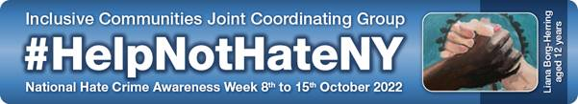

**What is Hate Crime Awareness Week?**

**Hate Crime Awareness Week** is a national weekof action to encourage local authorities, key partners and communities affected by **hate crime** to work together to tackle local **hate crime** issues.

The York and North Yorkshire Inclusive Communities Joint Commissioning Group (IC JCG) will utilise this week, **Monday 10th October – Friday 14th October**, to promote and raise awareness in the following areas:

* ***What is a Hate Crime? What is misogyny?***
* ***How to report a hate crime and misogyny***
* ***What local support services and projects are available?***

This is supported by the Safeguarding Adults Boards, Safeguarding Children’s Partnerships and Community Safety Partnerships across North Yorkshire and City of York.

As part of this campaign, **#HelpNotHateNY** has been developed for use during Hate Crime Awareness Week 2022. Misogyny is to be the agreed theme for this year’s campaign with the #**LetsEndMisogyny** being the supportinghashtag**.**

Key messages will be circulated via North Yorkshire Safeguarding Children’s Partnership and twitter account.

* <https://www.safeguardingchildren.co.uk/>
* North Yorkshire Safeguarding Children Partnership: **@NYSCP1**

**Online Training available for professionals**

As the theme this year is on misogyny we are running a variety of webinars delivered by IDAS, North Yorkshire Youth and North Yorkshire Police to help upskill professionals throughout Hate Crime Awareness Week. For more information and to book onto the webinars visit [Hate Crime Awareness Week 10th-14th October 2022 | North Yorkshire Partnerships (nypartnerships.org.uk)](https://nypartnerships.org.uk/HCAW2022)

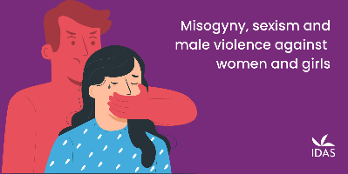

**Resources available to Education settings:**

**North Yorkshire Youth: Wake-Up Call** is **free** and available to 24 Secondary schools across North Yorkshire and York. Wake-Up Call looks at pre-Prevent work with young people at risk of being radicalised, committing a hate crime or showing negative racial behaviour. The purpose of Wake-Up Call is to develop a counter narrative in young people so they feel more equipped at challenging hate crime and also become ambassadors within their schools. See below as an example of what positive outcomes can be achieved through this course: <http://www.risedale.org.uk/Pages/Wake-Up-Call.aspx>

If you would like to access this course or know more about it please contact **Clare Yates, Delivery Manager, North Yorkshire Youth on** [**clare@nyy.org.uk**](mailto:clare@nyy.org.uk)

**2North Yorkshire Police School Liaison Team**

The School Liaison Team is available to deliver the following sessions in person, or alternatively they can provide schools with full lesson plans and resources **“Embrace our differences” - a celebration of the ways we are all different and special.** This session is available throughout term time not only during Hate Crime Awareness Week. Any requests can be sent to [**SchoolTeam2@northyorkshire.pnn.police.uk**](mailto:SchoolTeam2@northyorkshire.pnn.police.uk)

**The North Yorkshire Youth Commission** are offering ‘Big Conversation’ workshops on both *Discrimination* and *Gender Violence and safer streets*. The workshops include a range of interactive activities including quizzes, debates, and group discussions, as well as an opportunity for young people to share their own experiences and ideas for positive change. We are able to be flexible with workshop delivery and can run sessions in sizes of 1-to-1 up to full classes. We can tailor workshops to fit specific needs and are offering the sessions for ages 10+

To book a session for your young people, or to find out more please contact Emily Blavins: [**emily@leaders-unlocked.org**](mailto:emily@leaders-unlocked.org)**"**

**Useful information**

The updated ‘**Guidance for managing prejudice based incidents and hate crime’** can be found via <https://cyps.northyorks.gov.uk/equalities-and-diversity> and incidents can be reported to the LA via the reporting link <https://consult.northyorks.gov.uk/snapwebhost/s.asp?k=146952740744>

**For more information and resources on Hate Crime and misogyny please visit the following websites:**

* All About Respect: Active Bystander or upstander Hate Crime <https://allaboutrespectysj.wordpress.com>
* <https://educateagainsthate.com/blog/posts/hate-crime-awareness-week/>
* <https://www.ltai.info/>
* <https://www.supportingvictims.org/>
* <https://nationalhcaw.uk/>
* <https://hatecrime.campaign.gov.uk/>
* <https://enough.campaign.gov.uk/>
* <https://www.isthisok.org.uk/>

