 | What is misogyny?
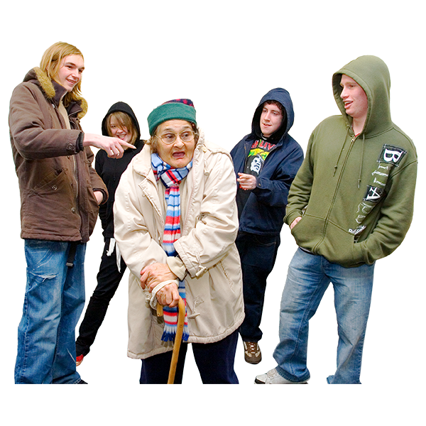 | Misogyny is when someone hates a person because they are a woman or girl.  Misogyny is not OK.
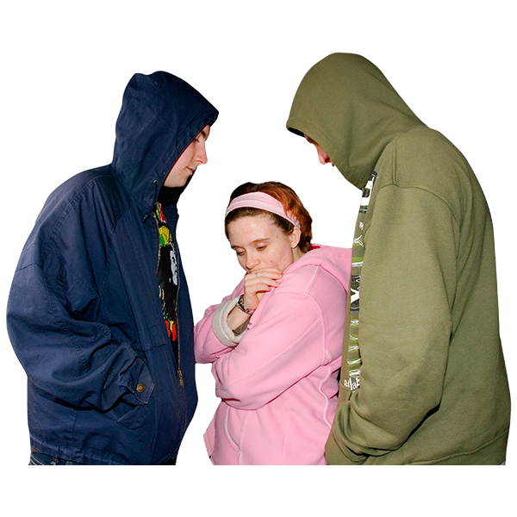 | When someone commits a crime because of misogyny it is a hate crime.  A hate crime is when someone targets you because of your disability, race, sexuality, religion, gender or people who are transgender.
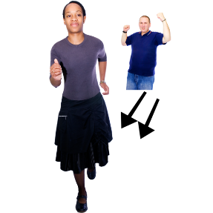  You’re a *%#&$  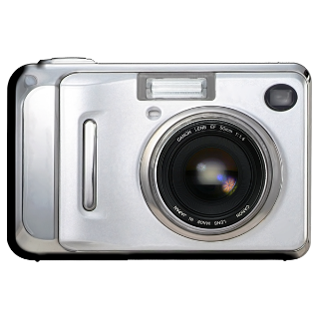  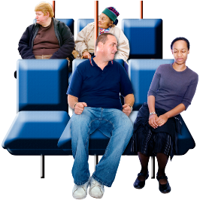 | Some examples of misogyny include:  - following you  - verbal abuse like calling you names or shouting sexual words at you  - behaving in a threatening way and making you feel scared  - sexually attacking you  - showing you their private parts without your permission  - touching you without your permission  - upskirting. This is when someone takes photos up your skirt without your permission
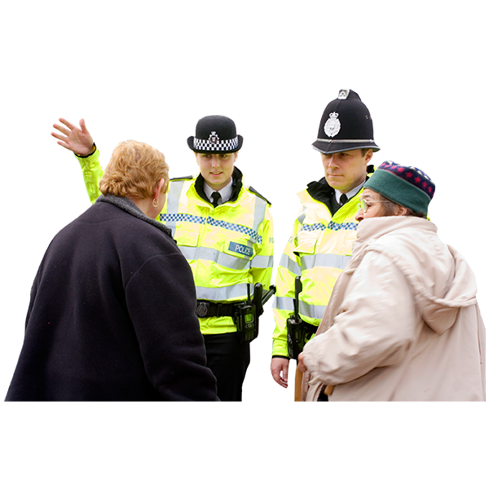 | What can be done about it?  Misogyny is a hate crime. You should report it to the police and they will help you.
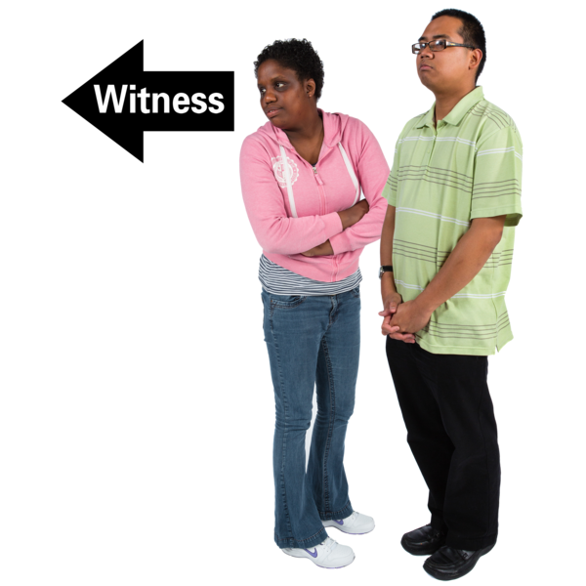 | You can also report a misogyny hate crime if you see it happening to someone else.
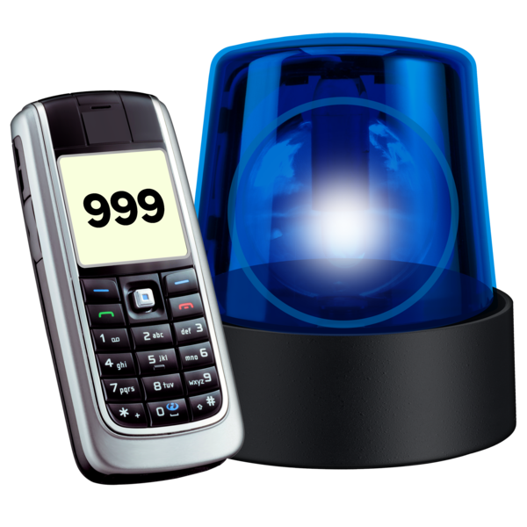 | Is it an emergency?  Does it feel like the situation could get violent very soon or is someone in danger right now? If so, call 999.  If you have a hearing or speech impairment, you can use our textphone service 18000. You can also text us on 999 if you have already registered with the emergency SMS service.  If it is not an emergency, you can report hate crime by  - calling 101  - reporting it on the North Yorkshire Police website. Go to https://www.northyorkshire.police.uk and search for report hate crime.
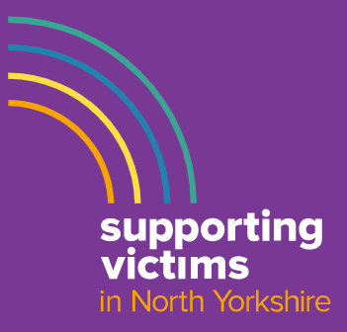 | If you don’t want to speak to the police, you can contact other organisations for help:  Supporting Victims  Call 01609 643100  Open Monday – Friday 9am – 5pm  or search online for ‘Supporting Victims North Yorkshire’ for help via the website.
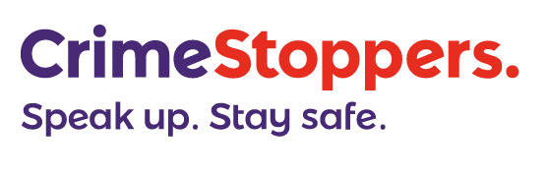 | Crimestoppers  Call anonymously on 0800 555 111  or report via the Crimestoppers website any time day or night.
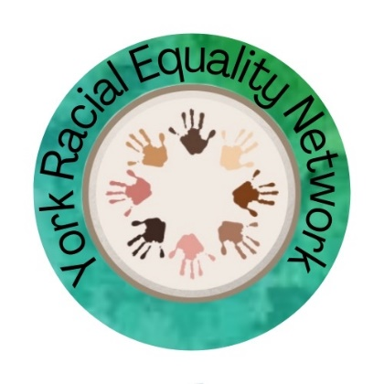 | York Racial Equality Network Independent support for victims of race hate crime. You can talk to them and they won’t tell anyone else. Or they can help you contact the police.  Call 07704 120722  Or email info@yren.co.uk
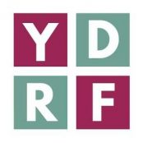 | York Disability Rights Forum wants action to stop hate crime. The forum wants to increase reporting and to help disabled people access support.  You can email: hello@ydrf.org.uk  Or call 01904 326781 to leave a voicemail.
True Vision is a website where you can report hate crime online. It send your report to your local police force.

The website address is
www.Report-it.org.uk
Tell MAMA is a national project
They support victims of anti-Muslim hate. Call 0800 456 1226
or search the internet for ‘Tell MAMA’ for other ways to contact them.

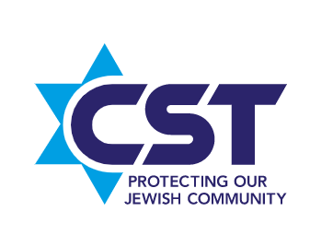 | Community Security Trust (CST) is a charity that helps British Jews who are victims of hate crime.  Call the national emergency number: 0800 032 3263  Or search ‘Community Security Trust’ online for more information.
Galop is a national charity.
It gives advice and support to LGBT+ people.
Call the LGBT+ Hate Crime Helpline on 020 7704 2040.
Or search ‘Galop’ online for more information.
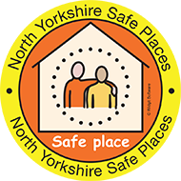 | Safe Places Scheme  A Safe Place is somewhere you can go if you need help when you are out in the community.  You can become a Safe Places member to get a ‘Keep safe’ card to carry with you.  Look for the logo in libraries and other buildings when you are out and about.  Show your Keep Safe card to a member of staff and they will ring your contact  www.northyorks.gov.uk/safeplaces  To join, ring 03307 260260 or email: safeplaces@spsdoorguard.com
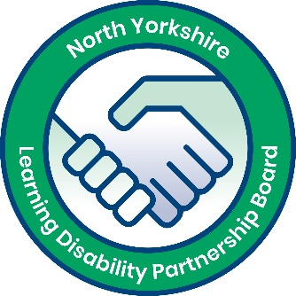 | North Yorkshire Learning Disability Partnership Board worked with North Yorkshire Police to make this leaflet

