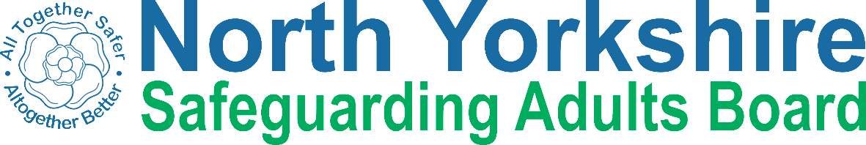

Keeping safe from abuse

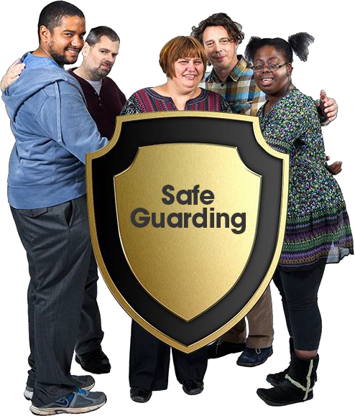

Book 1. What is abuse?

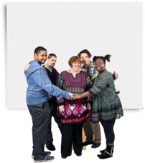 | Everybody has a right to be safe from abuse. This book has been written to help you understand abuse and to stay safe.
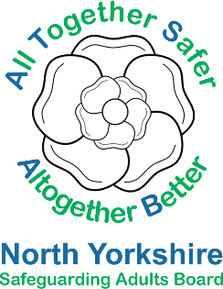 | It was made by the North Yorkshire Safeguarding Adults Board.
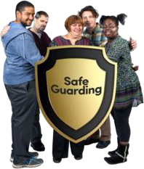 | Safeguarding is about everyone working together to make sure people are safe.
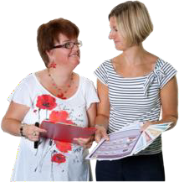 | This book has information about different types of abuse. You can read it alone or with someone to support you.

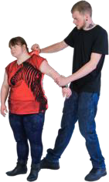 | Abuse is when someone hurts you or treats you badly.
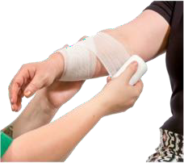 | Abuse can be done on purpose or by accident.  Abuse is never your fault.
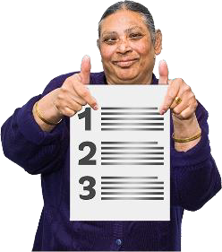 | There are different types of abuse.  This book has information about some of the different types of abuse listed in the Care Act.
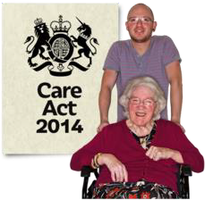 | The Care Act is a law that says how organisations must work together so people are safe from abuse.
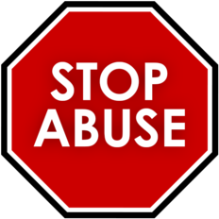 | Remember, abuse is never OK.  If you or someone you know is being abused, tell someone you trust.
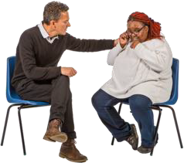 | There are details of people you can talk to at the back of this book.

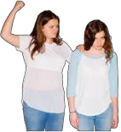 | Physical abuse is when someone hurts you or part of your body.
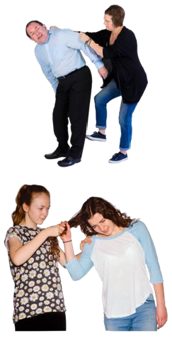 | Physical abuse could be:  - Punching, hitting or kicking  - Biting, scratching or slapping  - Grabbing roughly or pushing  - Pulling hair
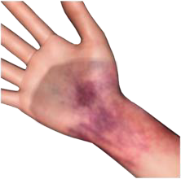 | Signs of physical abuse could be:  - bruises  - burns  - cuts  - broken bones
 | It can also be if you are given the wrong medication, too much medication or not enough medication.

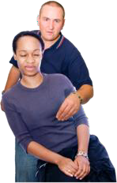 | Sexual abuse is when someone forces you to have sex or touches you or speaks to you in a sexual way when you  do not want them to.

Examples of sexual abuse

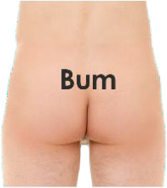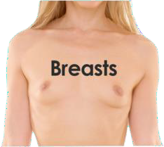 | Someone touches your body or private parts in a sexual way when you do not want them to.  Someone makes you touch their private parts.
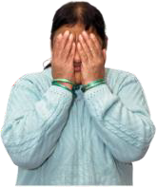 | Someone makes comments about you or your body that make you feel uncomfortable or scared.
 | Someone makes you have sex or do a sexual thing when you do not want to.
 | Shows you pictures or videos about sex that you don’t want to see
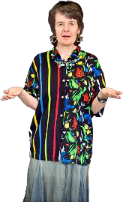 | The other person might be a stranger. It might be someone you know, including your partner. It is still not OK.

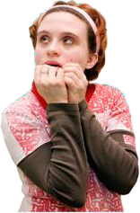 | Emotional abuse is when people do or say things which make you feel bad or scared.  This is also called psychological abuse.

Examples of emotional abuse

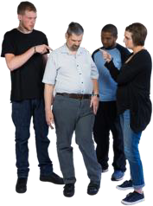 | Bullying, calling names or laughing at you.
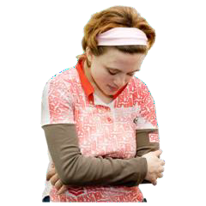 | Being treated like a child.
 | Being threatened or made to do things you don’t want to do.
 | Being left alone or ignored on purpose.

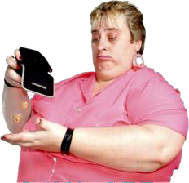 | Financial abuse is when someone uses your money or your things without your permission.

Examples of financial abuse

 | Stealing your money or your things.
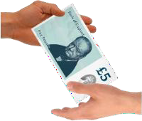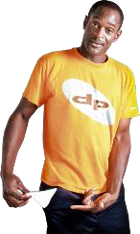 | Borrowing your money or things but not giving them back.
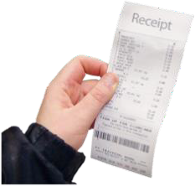 | Someone makes you pay for their things - like lunch or drinks.
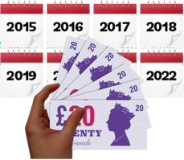 | Someone taking control of your money without your permission.  This includes taking your benefits or changing your will.

Neglect is when someone who is meant to support you does not support you properly.

Examples of neglect

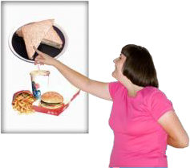 | Not giving you enough food or drink
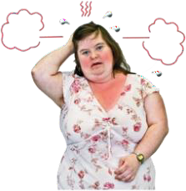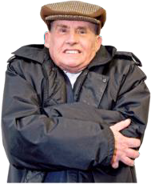 | Not supporting you to stay warm or cool.
 | Giving you the wrong medication, even if it is an accident.
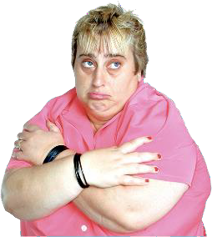 | Leaving you on your own for a long time when you need support.

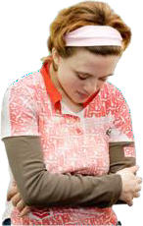 | Self-neglect is when you do not look after yourself properly and this causes you or someone else harm.

Examples of self-neglect

 | Not eating enough food or eating too much of the wrong kind of food.
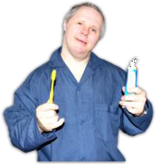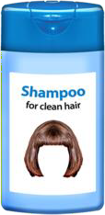 | When you don’t have a wash, shower or a bath or brush your teeth regularly.
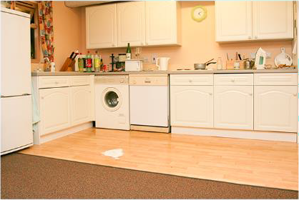 | Living in a very dirty home and never cleaning or tidying up. This includes people who have pets and do not clean up their poo.
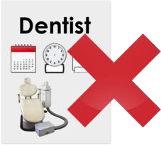 | Not going to the doctors or dentist when you need to go.

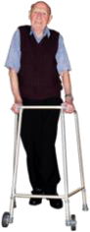
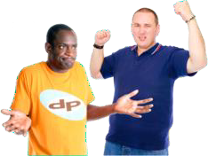 | Discrimination is when someone treats you differently or unfairly because you are different to them.
People may treat you differently because of your:
- age
- gender or sexuality
- disability or health condition
- race or religion

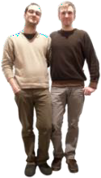
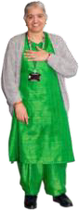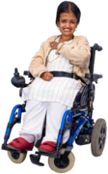Examples of discrimination

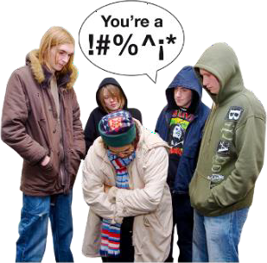 | People calling you names or saying nasty things about you because of who you are. This might be in person or  behind your back or on the internet.
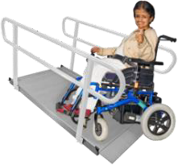  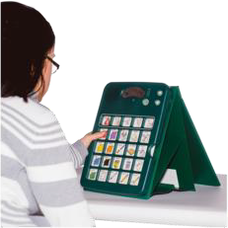 | Not getting the support you need to do things like everyone else, for example use of a ramp.  Or a communication aid.

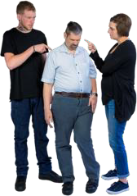 | Organisational abuse is when people or services paid to look after you do not do their job properly. This can also be called institutional abuse or systemic abuse.

Examples of organisational abuse

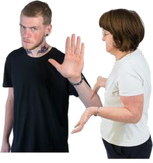 | When staff make all the rules and you have no choice about:  - where you live and who you live with  - when you get up or go to bed  - what you can eat and when
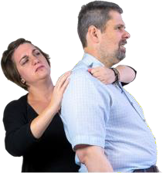 | When staff don’t know how to support you properly or do their job
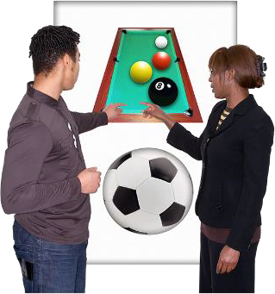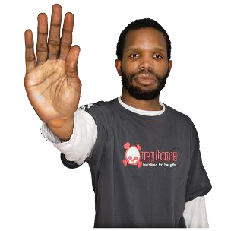 | When there are no social, recreation and entertainment activities or when you have to do the same activities all the time with no choices.

Domestic abuse is when you are abused in your home by someone who is
- a family member or
- someone you are or have been in a relationship with
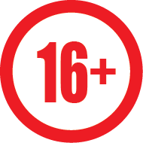 | The law says that the person abusing you  must be aged 16 or over for it to be called domestic abuse.
 | Domestic abuse can include lots of the other types of abuse in this book including emotional, physical and financial.
 | Someone controlling your money and what you can buy.
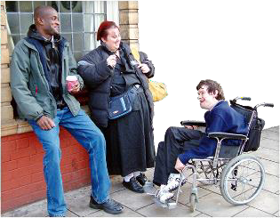 | Someone might stop you from seeing your friends, family, pets or other people outside your home.
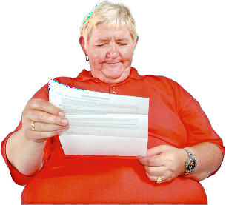 | Someone might open your mail and read  your private letters including your emails and social media without your permission.

Modern Slavery is when someone has control over you and makes you work for them without pay.

Examples of modern slavery

 | Having no control about your life, where you live and what you can do.
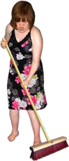 | Having to work long days in bad conditions
 | Being punished if you don’t work.
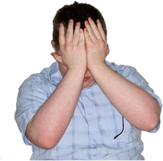 | Being too scared to leave or tell anyone.

 | In this book we have talked about types of abuse in the Care Act. This is a law that says how organisations must work together so people are safe from abuse.
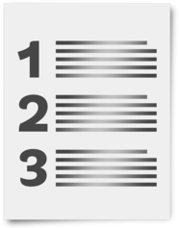 | There are also other types of abuse that you might have heard about.
Hate Crime is when someone does something to you or attacks you because of who you are.

They might attack you because of your gender, your race, your disability or something else.
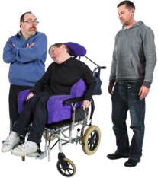 | Mate Crime is when someone pretends to be your friend so they can take advantage of you.  This includes stealing your money, eating your food or using your house.

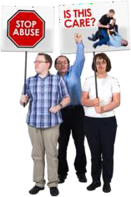 | Remember, abuse and neglect is never ok.
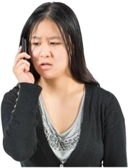 | If you or someone you know is being abused, tell someone you trust.
This could be:
- Someone in your family
- A friend
- A carer or support worker
- A social worker
- An advocate
- The police
- A nurse or doctor
- Someone from a charity like Age UK, Mencap or Mind
- Someone from the Care Quality Commission
- Someone you work with
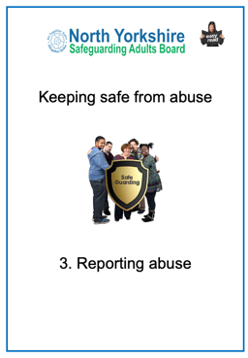 | Keeping Safe from Abuse Book 2 ‘Speaking up about abuse’ has information about how to tell someone about abuse. Book 3 ‘Reporting abuse’ has information about  what happens when you report abuse.

Contact details

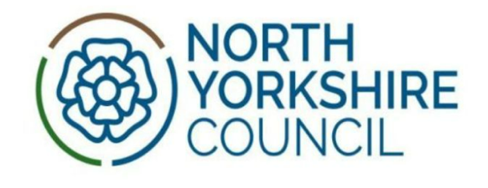 | North Yorkshire Council  Telephone: 0300 131 2 131
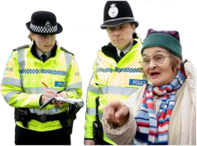 | North Yorkshire Police  For emergencies call 999. To talk to someone call 101.
Thank you!
Thank you to everyone who helped us make this book including:

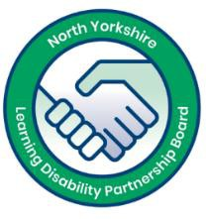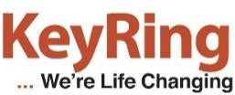 | KeyRing self-advocates from the North Yorkshire Learning Disability Partnership Board.
 | Inclusion North www.inclusionnorth.org
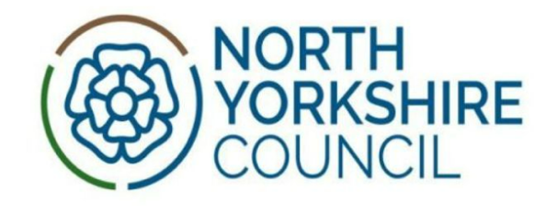 | North Yorkshire Council Health  and Adult Services
Copyright © 2019 North Yorkshire Safeguarding Adults Board

