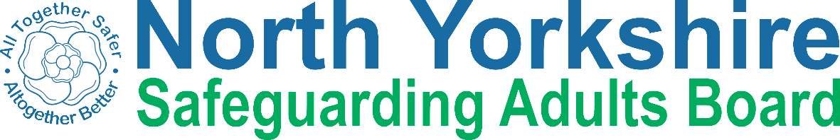

Keeping safe from abuse

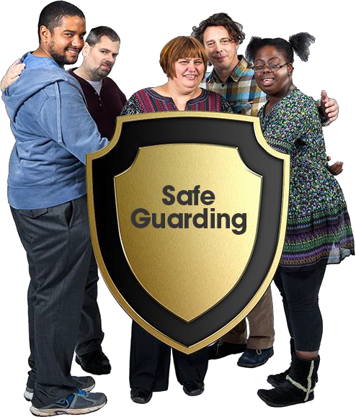

3. Reporting abuse

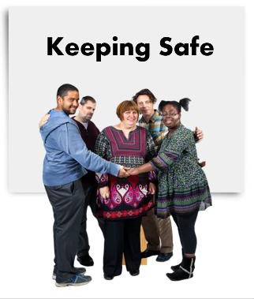 | Everybody has a right to be safe from abuse. This book has been written to help you understand abuse and to stay safe.
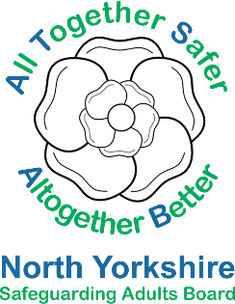 | It was made by the North Yorkshire Safeguarding Adults Board.
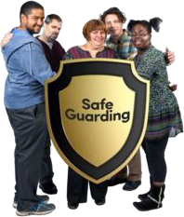 | Safeguarding is about everyone working together to make sure people are safe.
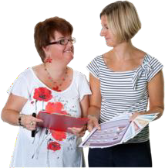 | This book has information about what happens when you report abuse.  You can read it alone or ask someone to support you.

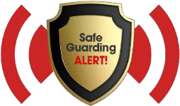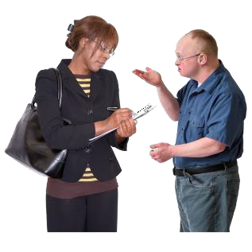 | You can report abuse yourself.
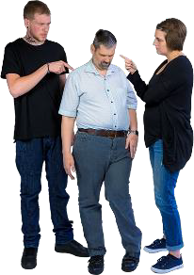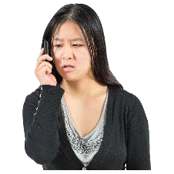 | You can report abuse if you think it is happening to someone else.
 | You can ask someone you trust to report abuse for you.
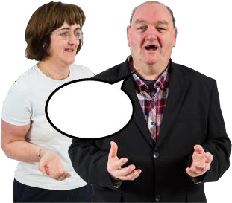 | You can ask an advocate to help you report abuse.  An advocate is an independent person who supports people to have a voice and may help a person to get the support they  need.

is happening

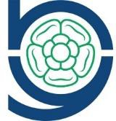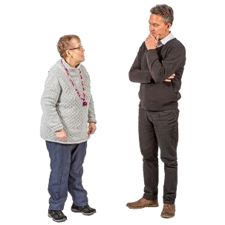 | They will listen to you.
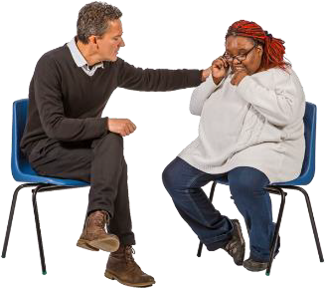 | They will take you seriously.
 | They will ask questions to make sure that you or the person you are worried about are safe.
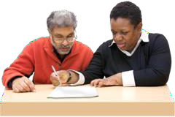 | They will ask questions to help everyone decide what needs to happen next.

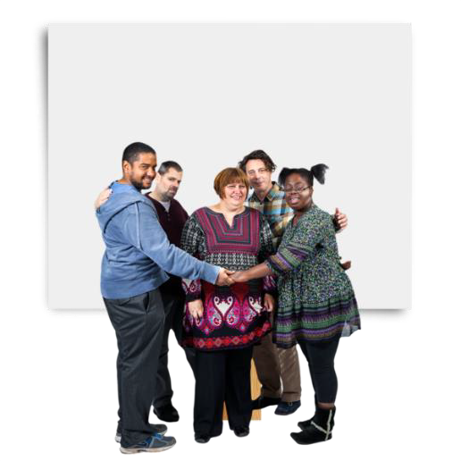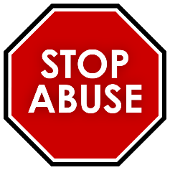

Is this a safeguarding issue?
Some things you might say to the Council are:

- I want to feel safe
- I want the abuse to stop
- I want help to protect myself
- I want the abuser to stay away
- I want to feel more confident
- I want to be involved in what happens next

 | The information you give will help the Council to know if this is a safeguarding issue.
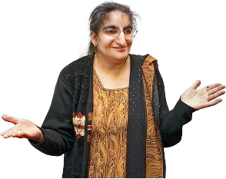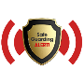 | If it is a safeguarding issue they will ask you what you want to happen next.
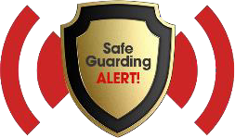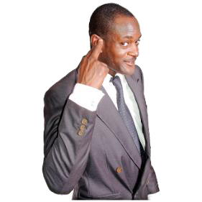 | If it isn’t a safeguarding issue, the Council will still listen to you and help you.

 | Once the Council has enough information they may start an enquiry.
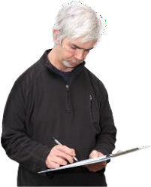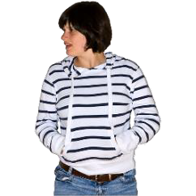 | An enquiry is about:  - finding out what happened  - looking for information and evidence  - talking to people involved
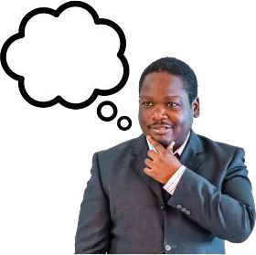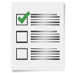 | The enquiry helps the Council decide if anything can be done to support you and who will do it.
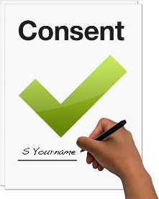 | The Council will ask if it is okay to talk to other people about what has happened.
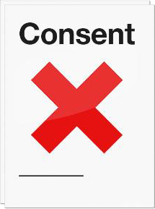 | They may talk to other people without asking you if it is okay if they are worried that other people may be unsafe.
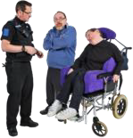 | They might speak to the police and ask them for their help.

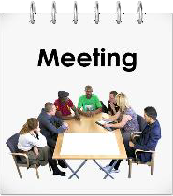 | You decide how much you want to be involved in talking to people or going to meetings.
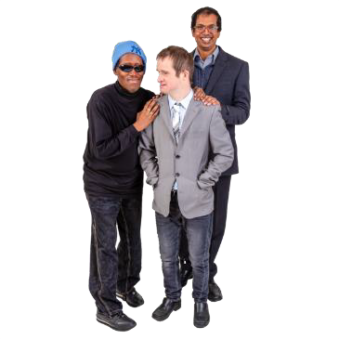 | You can bring someone with you – this could be someone from your family, or a friend or an advocate.
 | You can ask at any time if you don’t understand something.
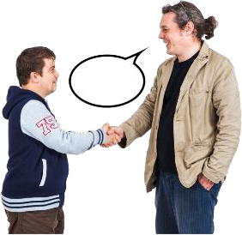 | You can ask someone you trust to go to meetings instead of you.

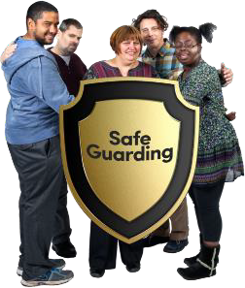 | There may be other people there whose job it is to help you stay safe.
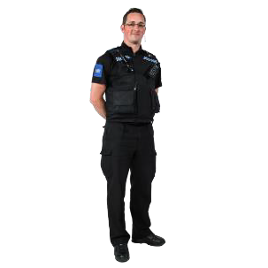 | This might include a social worker, a support worker, an advocate, or a police officer.
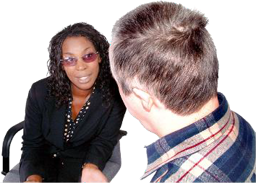 | Everyone will listen to you.

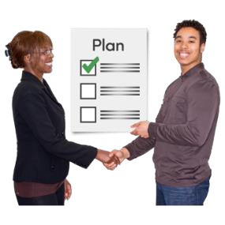
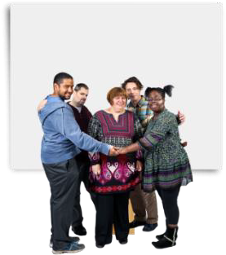Your Keeping Safe Plan

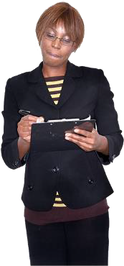 | When everyone agrees what needs to happen next it will be written down in a Keeping Safe Plan.
Keeping Safe | This is a list of things you would like to happen to help keep you safe.
Keeping Safe Plan | The Keeping Safe Plan lets everyone else know what you want to happen and make sure it is working.
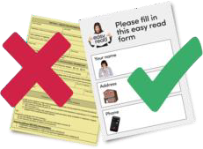 | It should be in a format you can use and understand.
 | You will be asked if you want to speak to someone about the support you are getting or might need.

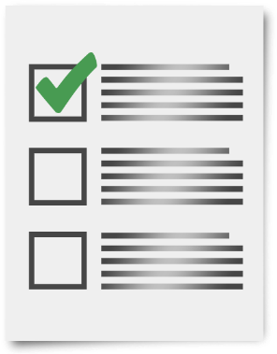 | When everything that was agreed has been done, the enquiry will finish.
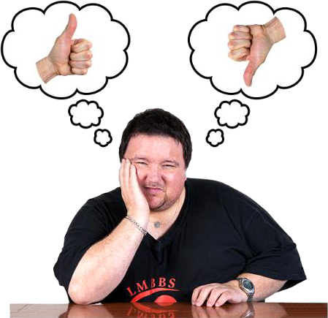 | You can say if you are happy and feel safer, or if you think something else needs to happen.
 | If you have been abused the Council may also give you information and advice about other people and organisations who can help you.
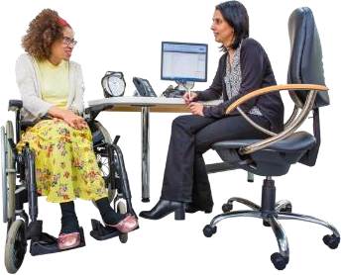 | This might include talking to counsellors, doctors and other people so you feel better.

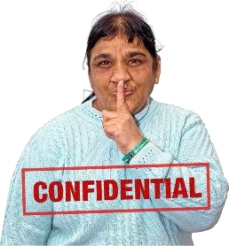 | Information about you is kept private and will not be shared with anyone who doesn’t need to know.
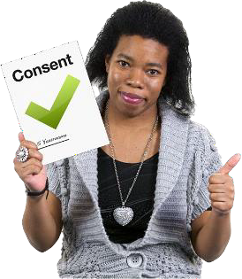 | If the Council does have to share private information with others to keep you safe they will ask you if it is okay first.
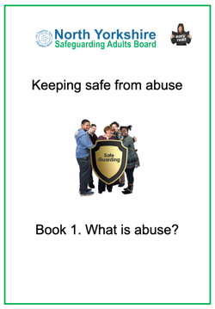 | There is more information in the other Keeping Safe books.  Book 1 is ‘What is abuse?’ and Book 2 is ‘Speaking up about abuse.’

Contact details

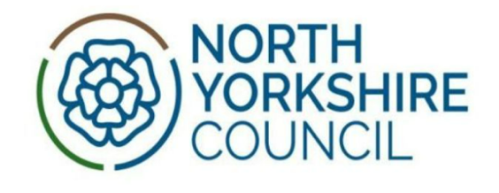 | North Yorkshire Council  Telephone: 0300 131 2 131
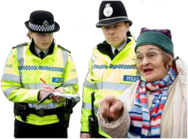 | North Yorkshire Police  For emergencies call 999. To talk to someone call 101.
Thank you!
Thank you to everyone who helped us make this book including:

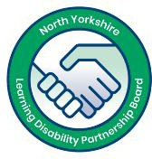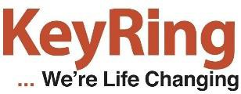 | KeyRing self-advocates from the North Yorkshire Learning Disability Partnership Board.
 | Inclusion North www.inclusionnorth.org
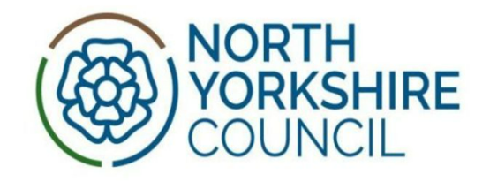 | North Yorkshire Council Health  and Adult Services.
Copyright © 2019 North Yorkshire Safeguarding Adults Board

