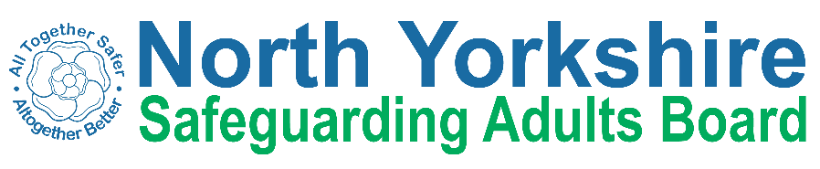

North Yorkshire Safeguarding Adults Board Summary of meeting minutes
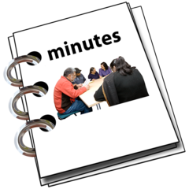 | This is a summary of the minutes for the North Yorkshire Safeguarding Adults (NYSAB) Board meeting on Wednesday 21st September.
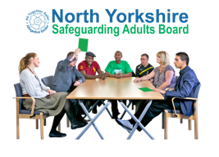 | This meeting was face to face and took place at the Forum in Northallerton.
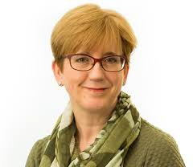 | Welcome and Introductions  Sue Proctor, the Chair of the Board, welcomed everyone to the meeting.
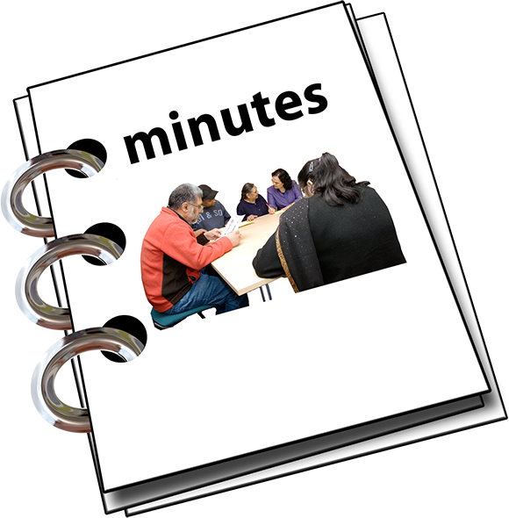 | Previous meeting minutes  Everyone was happy with the minutes from the previous NYSAB meeting in June.
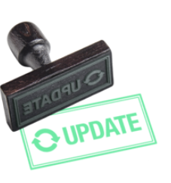  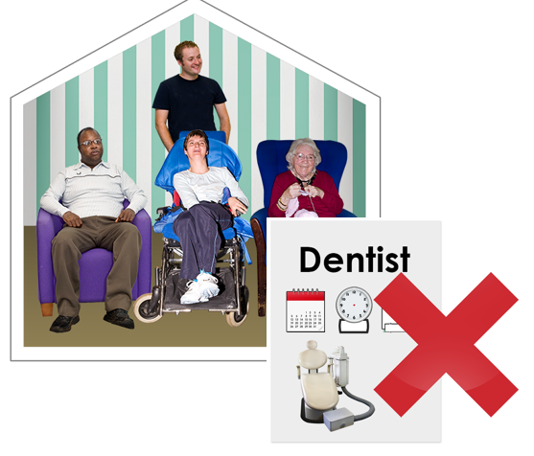 | Action log  The action log is a list of all the things that members of the NYSAB have promised to do.  Partners updated on the actions they have carried out.  There is difficulty in providing dental services in care homes.  This is because there is a shortage of NHS dentists.
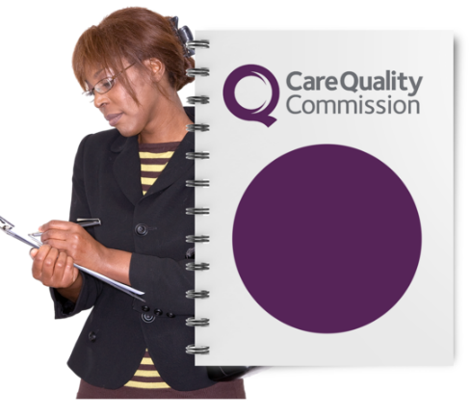  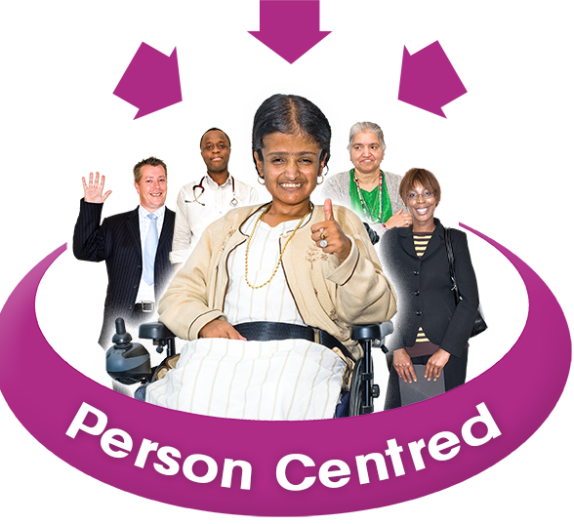 | Care Quality Commission annual visit  The Care Quality Commission (CQC) is an organisation that checks to make sure there are good health services and good social care for adults in England.  They check services run by care providers, health services, local councils and voluntary organisations.  CQC inspections should give a better view of:  - The quality of care that is given to people  - People’s experiences of care  - What is important to people in the services they use
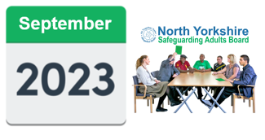 | How the Safeguarding Adults Board will work  One Safeguarding Adults Board meeting per year will be face to face and the next one will in September 2023.
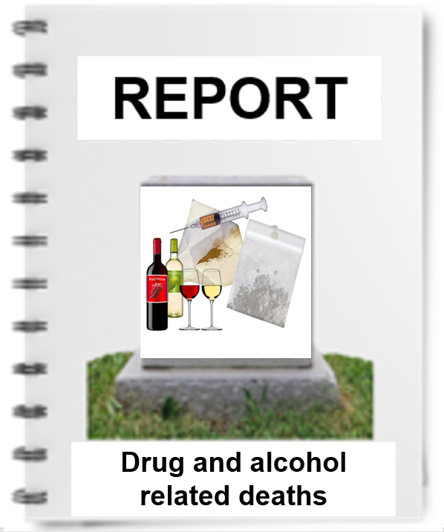 | A report about drug and alcohol related deaths for will be discussed at the Executive meeting in November.
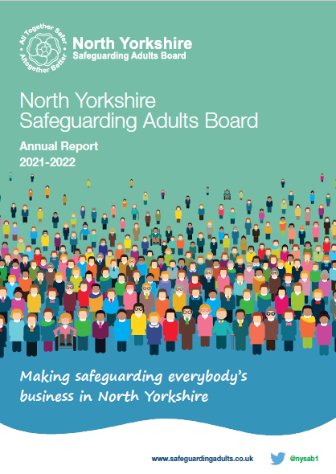 | The NYSAB Annual Report for 2021 - 22 is complete.  An easy read version of the report will be published on the NYSAB website
Delivery Plan
The delivery plan was noted.
The Board agreed it was positive to see all the work and actions that have been completed.

Risk Register
The risk register was noted.
A risk register lists all the things that could cause problems for the NYSAB when they work through their delivery plan.
Each risk is given a colour.
Red is for an action that has a lot of risk and needs a lot of work.
Amber is for an action that doesn’t have a lot of risk but still needs work.
Green is for an action that has no risk.
Green risks can sometimes be taken off the register.

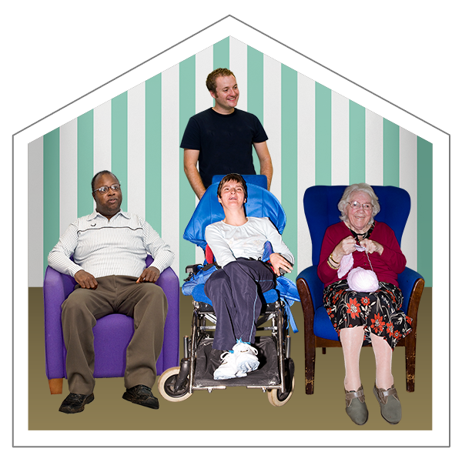 | Care market  The cost of providing nursing and residential care has increased.  This means that it is likely that the costs will increase for people who need care in their own homes too.
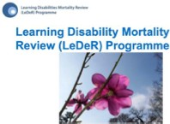 | Report on lives and deaths of people with learning disability (LeDeR report)  The Board read a report about the lives and deaths of people with a learning disability that had happened in the past year.  The lives and deaths of Autistic adults with no learning disability have been included for the first time.
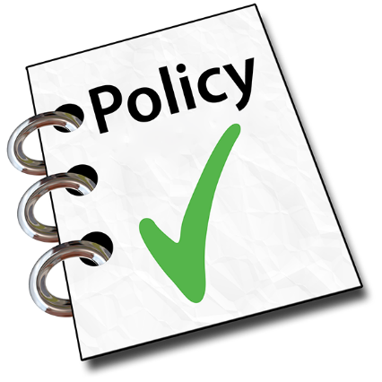  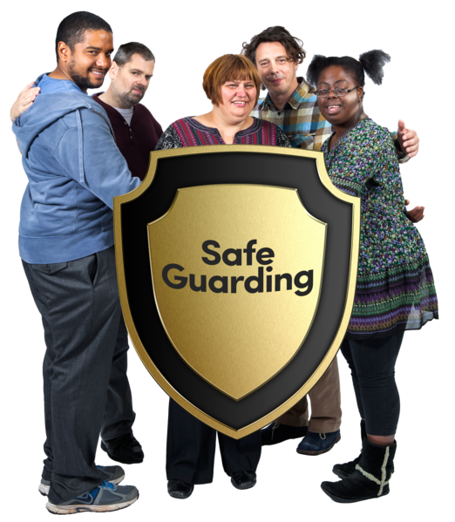 | Safeguarding policies and procedures in North Yorkshire  The Board received a report on a system that would help with updating safeguarding policies and procedures.  This system is called TriX  TriX could be used by lots of organisations in the county to help them to safeguard adults.  The Board approved the purchase of TriX.
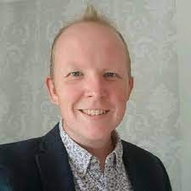  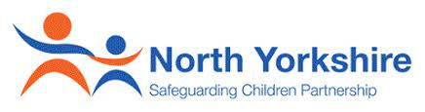  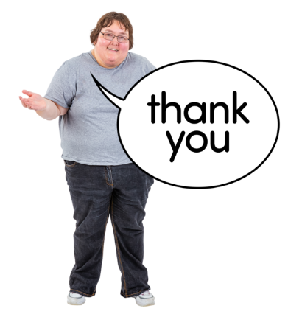 | Any other business  This was James Parkes, North Yorkshire Safeguarding Children Partnership’s manager’s last meeting.  Hannah Ellingworth will be the new Partnership Manager for NYSCP.  Members of the Board thanked James for his work with the NYSAB and wished him luck in his new job.  Sue thanked all members for their continued hard work.

Independent Chair | North Yorkshire Police
Sue Proctor | Mike Walker
North Yorkshire County Council (NYCC) | North Yorkshire Fire Service
Louise Wallace | Thomas Hirst
Chris Jones-King
Jo Boutflower
 | Health Trusts and NHS Integrated Care Boards
NYSAB Team | Karen Agar (TEWV NHS Foundation Trust)
Aurelie Redpath | Sue Peckitt (Humber and North Yorkshire Health and Care Partnership)
 | Christine Pearson (Humber and North Yorkshire Health and Care Partnership)
North Yorkshire Safeguarding  Children Partnership (NYSCP) | Emma Nunez (Harrogate District NHS Foundation Trust)
James Parkes
 | Borough and District Councils
Services | Tony Clark (Richmondshire)
Joseph Howard (Probation)
 | Independent Care Group (ICG)
 | John Pattinson

Apologies | Presenters
Rachel Bowes, Emma Dixon, Caroline O’Neill, Olwen Fisher, Christine Pearson, Helen Day and Richard Webb | Hannah Brown (NYCC),  Nicola Webb (NYCC)

